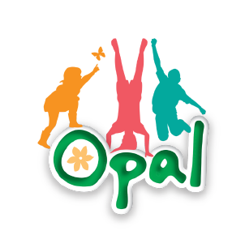
Outdoor Play and Learning
7th May 2024

Dear Parent/Guardian,

As you may already be aware, we are currently trying to upgrade our outdoor provision for play. We are working with OPAL College who specialise in outdoor play and learning.
OPAL College is dedicated to supporting schools around the world to ensure every child has an amazing playtime every day.
Many schools across the UK have used OPAL to promote outdoor play and learning. We hope that this will help improve our children’s well-being, develop skills such as communication and language and will help to improve their play, imagination and creative skills.

We are going to be working across both key stages so all the children in school with have access to high quality outdoor play and learning. As we begin to introduce more equipment and opportunity for exploration in the outdoors we will try our best to ensure that risks are managed appropriately. With this in mind, the opportunity for children to explore, problem solve and gain fundamental skills comes with a small chance of risk for example, chalk on clothes, minor accidents such as slips and falls. Through these experiences the children are learning to be resilient and take calculated risk in their play.

We would be really appreciate your support in this as we begin this journey. We will continue to provide the high level of supervision and care to all of our children.

Please feel free to visit the Opal website to find out more, outdoorplayandlearning.org.uk

If you do have any questions or concerns, please do not hesitate to contact us via the school office and ask to speak to Mrs Whitaker, Miss Hines, Mrs Little or Mrs Breen.

Kind Regards

Mrs A Whitaker Miss J Hines
Head Teacher Assistant Head Teacher/Play Lead

"OPAL is one of the most impactful transformations on children's lives that we've seen in the UK in the last 10 years- not just in schools, not just in education but just as a way of making a positive difference in children's lives...I'm in awe actually." Tim Gill former Director of Play England

