

HOLY TRINITY C of E Primary School
Year 4’s Homework Grid Autumn Term 1
email: p.crowther@holytrinitycofe.lancs.sch.uk
Please email photographs to the address above
INSTRUCTIONS:  - Choose any one box per week and complete the homework.  - Complete one page in your multiplication booklet AND mark this with an adult at home using the answers.  - Hand your homework book and multiplication booklet in every Thursday. | Topic: RE/Big Question – What makes you, YOU?  Write a list of ideas or a poem all about yourself and then illustrate.  Maths: Times Table 10 minute weekly workout (one workout per week) | Topic: History – Black History Month (October)  Black History Month was founded to recognise the contributions African, Caribbean people and black people have made to society. Choose a famous black person from the UK and create a fact file about them and their contributions.  Maths: Times Table 10 minute weekly workout (one workout per week)
Topic: English/RE – Prayer & Bible Verse  Write out the class prayer and Bible verse in your neatest, joined handwriting and illustrate.  Dear Lord,  Will you guide us at Holy Trinity School,  To help all the children learn and improve?  Dear Lord, guide the teachers to show us the way,  For success and improvement day after day.  Amen  ‘To love the Lord God with all your heart and with all your soul and with all your might.’ Deuteronomy 6:5.  Maths: Times Table 10 minute weekly workout (one workout per week) | Topic: Art/Science – Design and create a poster to encourage people to save electricity. Can you come up with a catchy slogan?    Maths: Times Table 10 minute weekly workout (one workout per week) | Topic: History/Design Technology – Roman landmark  Research any Roman landmark and then make a model of it.  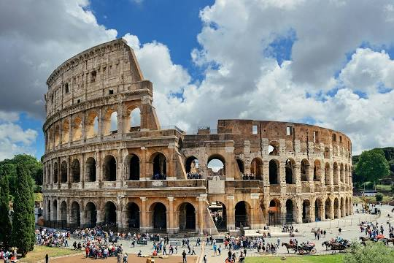  Maths: Times Table 10 minute weekly workout (one workout per week)
Topic: PE – Warm up for gymnastics.  Create a warm up exercise plan of five exercises to prepare our bodies for a gymnastics lesson. Draw/write the plan.  Maths: Times Table 10 minute weekly workout (one workout per week)   | 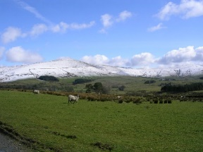  Topic: RE – Psalms ‘I lift up my eyes to the hills’  Look at the picture and answer the following questions.  - What do you see as you look up to the hills?  - Talk about what the hills look like, size, shape, colours, etc.  - How do you feel when you look at the hills?  - Write a prayer shouting praise to God.  - In Psalm 121 the psalmist writes that he looks up to the hills for strength and help from the Lord.  - Why would looking at the mountains give someone strength from God?  Maths: Times Table 10 minute weekly workout (one workout per week) | Topic: Art – Roman mosaics.  Create a mosaic of your own using materials of your choice.  Maths: Times Table 10 minute weekly workout (one workout per week)  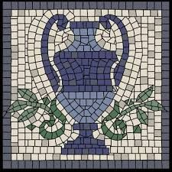
Topic: Design Technology – Italian cooking  Find a traditional Italian recipe and make it for tea, e.g. pasta dish, homemade pizza, tiramisu, etc. Add a photograph to your book.    Maths: Times Table 10 minute weekly workout (one workout per week) | Topic: History – The Roman Empire  Research some ‘Did you know?’ facts about a country that used to be under Roman rule in the Roman Empire. Write them neatly in your book.  Maths: Times Table 10 minute weekly workout (one workout per week) | Topic: PSHE – Valuing Differences  Define the word respect and create an eye-catching poster to demonstrate ways of showing respect to others' differences.  Maths: Times Table 10 minute weekly workout (one workout per week)

