Holy Trinity C of E Primary School
Science Policy

Vision statement
Holy Trinity CE Primary School is striving to be a fully inclusive School that serves our local community. Through the love of Jesus Christ, we are preparing our children to be future caring, responsible citizens in a diverse society. Our children will be given every opportunity to grow spiritually, academically, socially and to achieve their full potential within a safe, happy, Christian school family. John 10 V 10 ‘Life in all its fullness’

Mission statement – Growing and learning in Christ through faith, family and friendship



Scientists at Holy Trinity investigate, question and explore!



At Holy Trinity, we endeavour to make learning an exciting adventure for all our children. We want all our pupils to achieve their full potential and ensure that they are fully prepared for the challenges that lie ahead in their secondary education and the world of work.

Our Intent
We thrive to give the children here at Holy Trinity a wide and ranged science curriculum to challenge them and meet their needs. We focus on embedding a love of science and the world around them. We believe it is essential to be taught processes, methods, knowledge and uses of science. Through a broad and balanced curriculum we provide our children with wider opportunities and make links to other subjects. We ensure that the ‘Working Scientifically’ skills are built-on and developed throughout the children’s time with us at Holy Trinity so that they learn to confidently use equipment, conduct experiments, build arguments and explain concepts whilst continuing to ask questions and be curious about their surroundings.
Throughout the whole school, from EYFS to Key Stage 2, we give the opportunities to build on their fundamental scientific knowledge and concepts where the children are encouraged to recognise the power of explanation and develop a sense of excitement and understanding of the scientific world.

Through our planning, we provide and encourage problem solving opportunities that allow children to find out for themselves through first-hand experience. Children are encouraged to ask their own questions and are given opportunities to use their scientific skills and research to discover the answers. Curiosity is celebrated within the classroom. Planning involves teachers creating engaging lessons, often involving high-quality resources to aid understanding of conceptual knowledge. Teachers use precise questioning in class to test conceptual knowledge and skills.

We build upon the learning and skill development of the previous years. As children’s knowledge and understanding increases, and they become more proficient in selecting and using scientific equipment, in collating and interpreting results, they become increasingly confident in their growing ability to come to conclusions based on real evidence and to articulate these in a range of ways.

At Holy Trinity, we understand that children are naturally very curious and we encourage them to be inquisitive throughout their time with us. We believe science encompasses the acquisition of knowledge, concepts, skills and positive attitudes. We encourage our children to foster a healthy curiosity about our universe and promote respect for the world around us.

Our Approach to Science

- ICT is used widely in science. Children are given opportunity to practise skills and enhance their presentation using carefully chosen software, as well as the internet. ICT equipment is used for enquiry work, including microscopes, video, digital cameras for capturing images and activities and data logging.
- In our topic based approach, we use cross curricular links wherever possible. Science relates especially well to curriculum subjects such as, English, Mathematics, ICT, Design & Technology and P.E.
- Scientists at Holy Trinity, investigate, question and explore.

Our Science Vision
At Holy Trinity, we strive to give the children the best opportunities and experiences during their time with us. Science at Holy Trinity is inclusive for all the children and is something that all children can enjoy. We encourage the children to ask their own questions and to have big conversations. Children at Holy Trinity are encouraged to use scientific vocabulary, confidently, independently and are motivated to use their science learning in other subjects. We work together with parents, carers and visitors to give the children life skills in science that they can connect with their life outside of school. Scientists at Holy Trinity investigate, question and explore.

Skills
- Give our children a background in science and help them develop practical scientific skills.
- Develop skills of investigation including, observing, measuring, predicting, experimenting, communicating, explaining and evaluating.
- Become familiar with scientific terms and vocabulary and become confident when using these independently.
- Develop the use of ICT in investigating and recording.
- Enable our children to become successful communicators.
- To enhance reading, writing and maths core skills through the study of science.

Working Scientifically
The national curriculum (2014) specifies that children in each group should start to work scientifically to support their understanding of nature, process and methods in science. Working scientifically should be embedded within the content of biology, chemistry and physics, with a focus on scientific enquiry so that children can learn to use a variety of approaches to answer relevant scientific questions. At Holy Trinity, we encourage children to improve, build on and embed their scientific enquiry each lesson and give them opportunities to ‘observe over time’, ‘pattern seek’, ‘identify, classify and group’, ‘research using secondary resources’ and ‘carry out comparative and fair testing’.
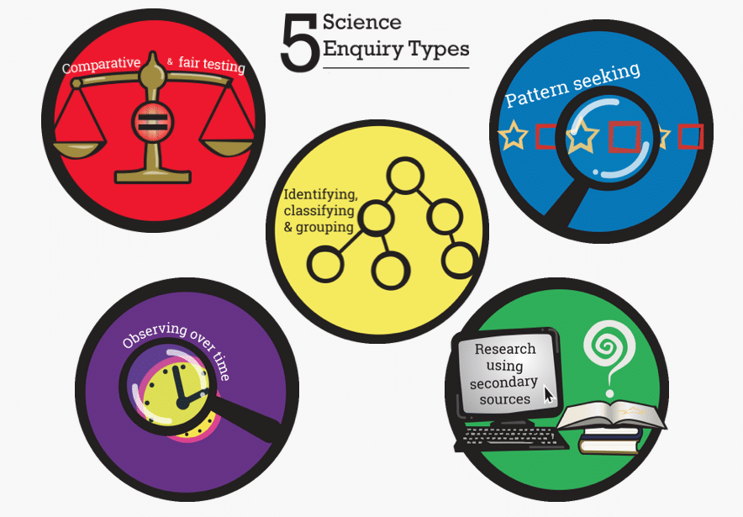
Fig 1: https://seerih-innovations.org/enquiringscience4all/
Our Science Principles at Holy Trinity
All classes in EYFS, Key Stage One and Key Stage Two use our Science Principles during their science lessons. Recently developed by our staff team and with help from our school council, our science principles are a great way to encourage the children to think about exactly what they are learning in their science lessons. Each class have a pair of Super Scientists who take on more responsibly during their science lesson during that half term.

Our Science Principles
Science is good when…
- We ask big questions and have big conversations.
- We use different types of enquiry when working scientifically.
- We can relate our learning to our own lives.
- We use scientific vocabulary confidently.
- We are so inspired and motivated in science and we continue use to our learning after our lesson.
- Learning takes place outside as well as in the classroom.

Early Years Foundation Stage

Children in EYFS are encouraged to learn through making sense of their physical world and their community. Children are given the opportunity to explore, observe and found out about people, places, technology and the environment.
Following the new EYFS Framework 2021, guidance/documentation suggests that children ‘explore the natural world around them. They make observations and draw pictures of animals and plants, know some similarities and differences between the natural world around them and should also explore contrasting environments and understand some important processes and changes in the natural world.’ During the academic year, activities are planned specifically to help children achieve these objectives but the continuous provision allows regular opportunities for children to explore, develop their vocabulary and curious

Science in Key Stage One

The national curriculum states that during their time in Key Stage One children should have opportunities to explore and investigate the following areas:
- Working scientifically
- Plants
- Animals, including humans
- Everyday materials and uses
- Seasonal changes
- Living things and their habitats

Year 1 | Year 2
Plants (Common names) | Living things and their habitats
Animals, including humans (Humans: Basic structure and senses) | Animals (Animals survival and growth)
Every day materials | Uses of everyday materials
Every day materials | Health – Animals including humans (Grow & staying healthy)
Animals (Basic structure) | Health – Animals including humans (Grow & staying healthy)
Plants (Theme continued throughout the year) | Plants (Growing plants)

Science in Key Stage Two

Children in lower key stage two should be encouraged to broaden their scientific view of the world around them. The national curriculum suggests that they should do this through exploring, discussing, testing and developing their ideas. Children should observe and make decisions about scientific enquiry and draw conclusions. Key vocabulary should be shown to the children to give opportunities for them to read and write scientific terminology.

Building on their skills from lower key stage two, the main focus of science in upper key stage two is to enable pupils to develop a deeper understanding of a wide range of scientific ideas. The children should be encouraged to explore, discuss their ideas, asking their own questions and developing their working scientifically and scientific enquiry skills.

Year 3 | Year 4 | Year 5 | Year 6
Plants (Functions of plants parts and growth) | Living things and their habitats (Biodiversity & classification) | Living things and their habitats (Life cycles) | Living things and their habitats (classification)
Light (Shadows and Reflective surfaces) | Animals including humans (Teeth and Digestion) | Earth & Space | Evolution and inheritance (adaptations)
Animals including humans (Skeletons and Movement) | Material Properties | Forces (Friction and air resistance) | Animals including humans (Circulatory system and exercise)
Health & Nutrition | Material Changes (States of Matter) | Properties and changes of materials (Testing material properties) | Animals including humans (Keeping healthy, diet and lifestyle)
Forces & Magnets | Sound | Properties and changes of materials (Reversible changes) | Light (Light and astronomy)
Rocks | Electricity | Properties and changes of materials (Irreversible changes) | Electricity
Planning

Teachers throughout EYFS, KS1 and KS2 include their science planning within their long term planning every half term. Medium term planning is created to break down the half termly learning into manageable weekly lessons with clear learning objectives. Weekly planning is then completed by individual teachers and outlines in detail the learning objectives, the learning taking place, resources, organisation, scientific enquiry and means of assessment. Science is taught for two hours per week at Holy Trinity at Key Stage 2.

Science serves as a main subject for many of the topics in all year groups throughout school; this ensures that science is a high profile subject in our school. Teachers planning for topics ensure that biology, chemistry and physics are taught during the year.

Resources

Holy Trinity is well resourced with scientific equipment. Resources are located in both Key Stage One and Key Stage Two. A list of resources can be found with the scientific equipment and is reviewed regularly.

Monitoring and Evaluation

The science subject leader will monitor science in the school throughout the year and will feed back to the staff and the link governor, this will include;
- Work sampling/book scrutiny
- Planning monitoring
- Learning walks
- Staff questionnaires
- Pupil voice interviews

Assessment and Recording

Teachers assess the children’s work after every science lesson following the school’s marking and feedback policy, ensuring that the children are given positive feedback and a next step to further their learning.

Teachers input science attainment levels into the Lancashire Tracker at the end of every term. This is monitored by the Head teacher and the Science subject leader. By the end of each key stage, pupils are expected to know, apply and understand the matters, skills and processes specified in the relevant programme of study.

Reports are sent to parents at the end of every academic year, describing each child’s attainment in science.
Review date Autumn Term 2026

