English  Narrative: Novel as a Theme – The Nowhere Emporium  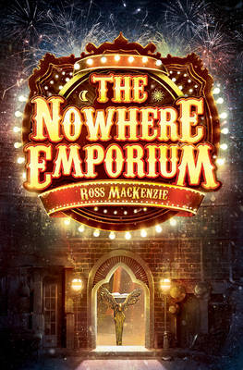  Fiction: Narrative based on a model text with innovated plot structure.  Poetry: Free verse  Guided Reading  A range of fiction, non-fiction and poetry texts  Grammar, Punctuation & Spelling  Ideas taken from The Talk Writing and Spelling Shed. |  | 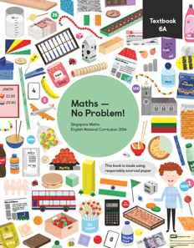  Mathematics  Maths No Problem  Chapter 1 – Numbers to ten Million  Chapter 2 – Four operations on whole numbers
History
The Viking and the Anglo-Saxon struggle for the Kingdom of England.

BHM- Matin Luther King and the Transatlantic Slaves linked to Lancashire

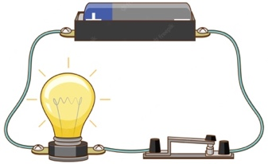  Science  Electricity  To design and make a working burglar alarm. |  |   Religious Education  Life as a journey  In what ways can life be compared to a journey?  In what ways does having faith give meaning and purpose to the journey of life? |  | PE    Team Building – OAA
Art - A portrait of a Viking Soldier Music- Charanga: Happy
Computing - Coding

Pilgrimage |   
Cell | 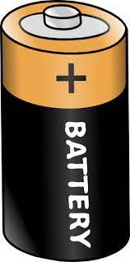
Emporium | 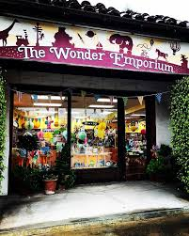
Outlaw | 
Segregation | 

