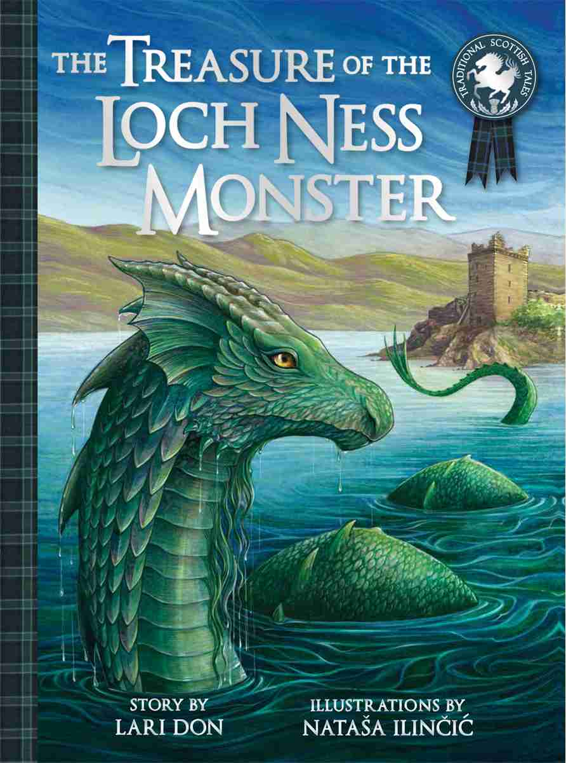  English  Bridging Unit  The Loch Ness Monster  Guided Reading  Fiction and Non-Fiction books and texts:  Gulliver’s Travels  Grammar, Punctuation & Spelling  - Use commas to mark clauses in complex sentences (using Y3 skill – using a range of conjunctions)  - Explore, identify and use Standard English verb inflections for writing e.g. We were instead of we was. I was instead of I were, I did instead of I done. She saw it instead of she seen it.  - Use paragraphs to organise writing in non-fiction texts.  - Proofread to check for errors in spelling, grammar and punctuation.  Handwriting  - Use the diagonal and horizontal strokes that are needed to join letters and understand which letters, when adjacent to one another, are best left un-joined increase the legibility, consistency and quality of their handwriting [for example, by ensuring that the down strokes of letters are parallel and equidistant; that lines of writing are spaced sufficiently so that the ascenders and descenders of letters do not touch]. |  |  |  | Mathematics  Maths No Problem! New Edition  Numbers to 10,000  Counting in 100s and 25s  Counting in 1000s  Counting in 1000s, 100s, 10s & 1s  Using place value  Comparing and ordering numbers  Making number patterns  Rounding 4-Digit Numbers to the Nearest 1000  Rounding 4-Digit Numbers to the Nearest 10 or 100  Rounding Numbers to Estimate  Addition and Subtraction Within 10,000  Finding sums  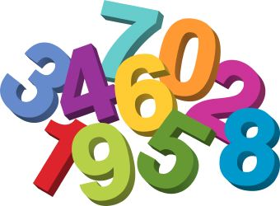  Adding without renaming  Adding with renaming  Adding using mental strategies  Finding differences  Subtracting without renaming  Subtracting with renaming  Subtracting Using Mental Strategies  Solving Word Problems  Multiplication Tables Check  Preparation activities
History - The Roman Empire and its Impact on Britain & Boudica  - To use sources to ask questions  - To explore who Boudica was from different sources of evidence.  - To find out about historically significant people and events  - To write about a historical event –  What effects did the Roman Invasion have on Boudica and the Iceni tribe?  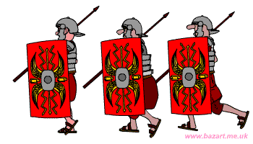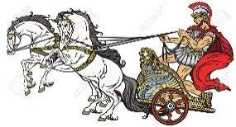 |  | 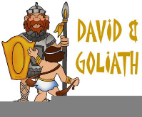  Religious Education  Unit 4.1: God, David and the Psalms  - What values do you consider to be important?  - Who inspires you?  - What are the qualities of a good King?  - What is God like?  Class Bible Verse: ‘To love the Lord God with all your heart and with all your soul and with all your might.’  Deuteronomy 6:5. |  |  |  | Science – Electricity  We will be learning to:  - Identify common appliances that run on electricity  - Construct a simple series electrical circuit, identifying and naming its basic parts, including cells, wires, bulbs, switches and buzzers  - Identify whether or not a lamp will light in a simple series circuit, based on whether or not the lamp is part of a complete loop with a battery  - Recognise that a switch opens and closes a circuit and associate this with whether or not a lamp lights in a simple series circuit  - Recognise some common conductors and insulators, and associate metals with being good conductors
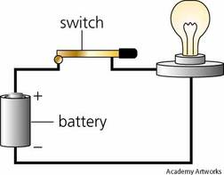
Art - Drawing
- Different grades of pencil, help you to achieve variations in tone.
- Variations in tone allow you to create shadows and reflections.
- By implementing pencil, crayon, chalk, pastels, pens allow you to create shading and texture.
- Using different medias allows you to create mood and atmosphere into your drawing.
- Using different drawing implements allows you to create texture into your drawing.

Music: Learning how to play the keyboard taught by Lancashire Music Service
Spanish: Catch up Unit 1
PSHE: Valuing Difference
PE: Session 1 (Tuesday) OAA - Team Work & Problem Solving
Session 2 (Wednesday) Invasion Games – Rugby 2
Computing: Online Safety & Coding

Below is some key vocabulary that will help your child to understand what we are going to be learning about this half term. Please read the words with your child, find out and talk about what the words mean.
Key Vocabulary for this Half Term
soldier | shield | settlement | ancient
Boudica | sword | empire | villa
chariot | emperor | Iceni Tribe | consequence
Celts | Rome | migration | invasion

