ENGLISH  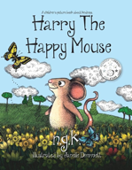  Talk 1- Harry the Happy Mouse. The children will be exploring the book Harry the Happy Mouse.  End Outcome:  - Innovated poem based on a structure  - Innovated story based on a plot pattern  - An information poster based on an animal |  | MATHS    The children having lots of practical opportunities to explore number using concrete apparatus before transferring this knowledge  to more abstract questions.  Units covered this half term:  - Numbers to 10.  - Number Bonds  - Addition within 10 |  | SCIENCE  The children we will be learning about ‘Animals, including humans.’ They will identify and name common animals and their structures. They will also begin to understand the difference between a carnivore, herbivore and omnivore.  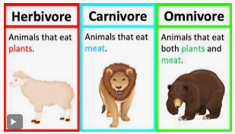
RE    Unit 1.1 Harvest- The children will be exploring the question ‘How can we help those who do not have a good harvest? ‘. They will be finding out about harvest round the world.  Unit 1.2 Creation- The children will be exploring the question ‘What is your favourite things in creation? They will explore what people of Muslim and Hindu faith believe about how the world was created. |  | HISTORY  The children will be exploring the life of a significant person, Neil Armstrong, and looking at his place in History.    During Black History Week they will be learning about Rossa Parks who fought for racial equality. |  | ART    The children will be exploring. and experimenting with drawing skills this term. Our explorations will accumulate in a portrait drawing of Neil Armstrong.
PE  FMS-The Great Outdoors OAA  FM- Baseline-Lost and Found |   COMPUTING  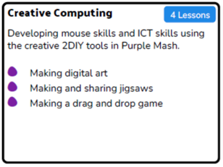  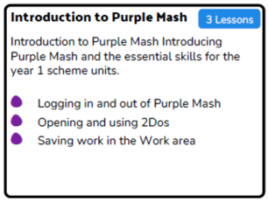 |  | MUSIC  We will be completing the Charanga Unit- Hip Hop ‘Hey You!’- Rehearsing songs to perform. Playing simple instruments.   |  | PHSE  Valuing Differences  We will talk about the differences between teasing and bullying.  

explorers  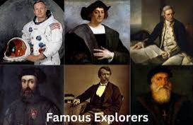 | Moon  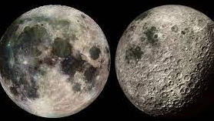 | Apollo 11  
Reptiles  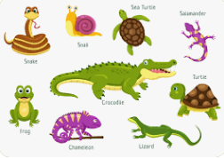 | Amphibians  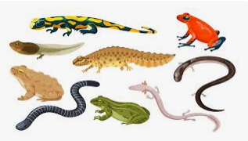 | Birds  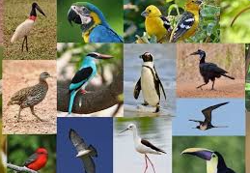
Mammals  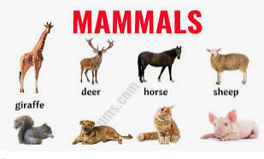 | Fish  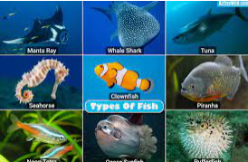 | Crops  

