
Curriculum Overview 2025/2026 Autumn 1 Year: 3
Holy Trinity CE Primary School Theme: Colourful Characters Teacher: Mrs Fleming
Our Class Bible verse is: Do to others what you want them to do to you.
English:

In our first English unit, we will be focusing on the lovable bear, Paddington.
‘A Bear Called Paddington’ by Michael Bond is our class novel and we will develop our extended writing skills, creating a narrative based on a model text with innovated plot structure.
Using the knowledge learnt about London through Paddington’s adventures, we will also create a newcomer’s information leaflet/guide to London.
We will also use the novel as a means to develop other forms of writing, to study grammar and punctuation, and to further develop reading comprehension skills.
Handwriting and spellings will continue to develop, with an early focus on correct pen grip and letter formation, and on the year 3 spelling list and high-frequency words.

Maths:
We are continuing to use our scheme in mathematics called Maths No Problem.
Throughout our first half term we will be looking at:
- number and place value, reading writing and ordering numbers.
- mental calculations, strategies for addition and subtraction.
- written addition and subtraction, formal written method.
In addition, there will be a continued focus on the development of multiplication tables through consistent practice.



Science: Light
We will study different sources of light, how shadows are formed and their properties.
We will study how light is reflected from surfaces, how light from the sun can be dangerous, when shadows are formed, and even learn the patterns and sizes of shadows change!


Topics
History – Ancient Civilisations
PSHE – Valuing Difference
Music – Charanga
Art – Drawing Skills
Spanish - Hola
PE: Games – Rugby and OOA
Our PE days are Tuesdays and Thursdays. We will be developing attacking and defending strategies in Rugby and teamwork and problem solving in OOA.
Religious Education: Harvest
This RE unit will involve an exploration of the following questions:
How do we celebrate Harvest?
Why do we celebrate Harvest?
What do we celebrate at Harvest?
When do we celebrate Harvest?
Who celebrates at Harvest?
How is the Harvest festival
celebrated around the world?
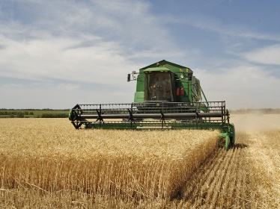
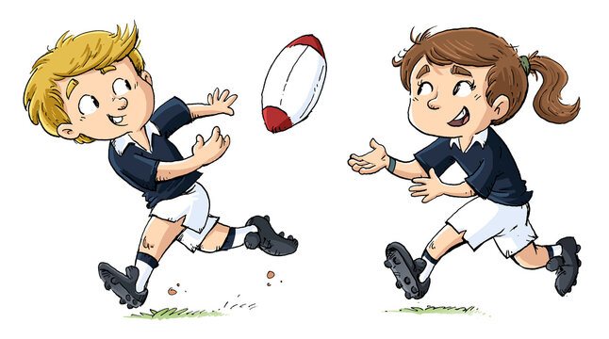

Vocabulary for Autumn 1
Here is some key vocabulary that will help your child to understand what we are going to be learning about this half term. Please read the words with your child and talk about what the words mean.

light | Hola | addition | Harvest
dark | adjectives | subtraction | evaluation
Adios | nouns | exchange | risk
reflection | Place value | civilisation | pitch

