


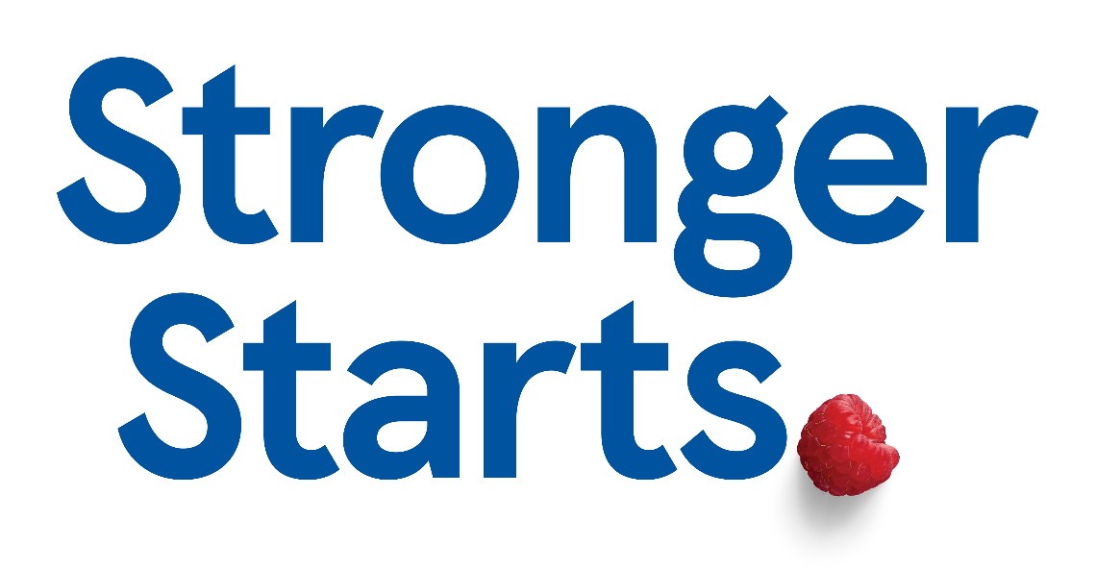

We are delighted to announce that we have been
selected to take part in Tesco Stronger Starts fund. We are bidding for a cash boost towards our OPAL play equipment. Voting will start from the first week in October 2025 and run until mid January 2026. Please vote for us in store using the coins provided—we need your help!!
You can vote for us in the following stores:
Tesco Burnley Extra BB11 2HE
Tesco Express Reedley BB10 2PA
Tesco Express Brunshaw BB10 3JB
Tesco Padiham BB12 8DQ
EVERY VOTE COUNTS!!

