English- Traditional Tales with a Twist  We will continue to follow the Read, Write, Inc. scheme to learn our Set 1, Set 2 and Set 3 sounds. We will also have ‘Talk’ English lessons where we will be reading and writing about a variety of Fairy Tales and of course we will be talking about them, retelling them and acting them out. Please help your child by reading and enjoying as many fairy tales at home to support them in their learning.  Our home reading books are changed every Monday and Thursday. We ask that you read the home reading books 3 times to help increase your child’s fluency.  Our class library day is every Wednesday.  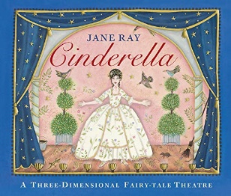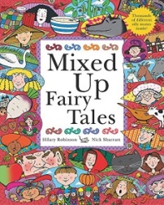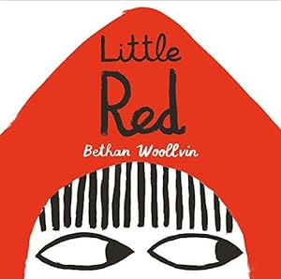 |  | Mathematics (Maths No Problem)  Chapter 4: Multiplication and division of 2, 5 and 10  This includes looking at different ways of sharing and grouping before investigating the links between multiplication and division and odd and even numbers.  Chapter 5: Length  This chapter helps children to get a better understanding of how to measure length (m and cm) and progress to measuring in real-life contexts.  Chapter 6: Mass  This chapter includes measuring mass in the contexts of kilograms and grams. They will learn to read a scale, compare weights and solve word problems relating to mass.

Science  In Science we will identify and compare the suitability of a variety of everyday materials, such as wood, metal, plastic, water, rock, paper and cardboard for particular uses. We will investigate if any materials can be changed by squashing, bending, twisting and stretching. Ultimately the children will learn that materials have different properties.  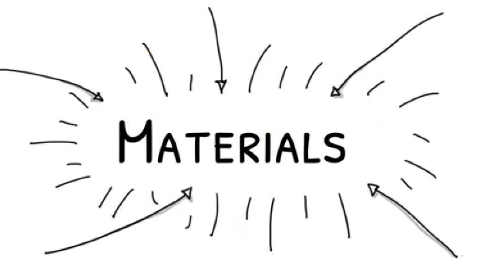 |  | Religious Education  Why was the birth of Jesus such Good News?  In RE we will look at the story of Christmas from the perspective that it was good news then and now. We will be looking at how God speaks through prophets and dreams and in the nativity story his main mode of communication is through the angels.  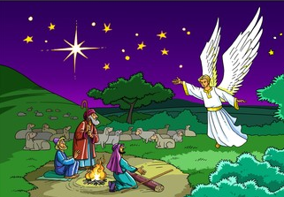 |  | Geography-  Alice Springs including the 7 continents and 5 oceans  Qu: Why do oceans matter?  We will be naming and locating the world’s seven continents and five oceans. We will then move on to learn about Alice Springs in the continent of Australia. We will be exploring why Alice Springs is geographically significant and comparing it to Burnley.  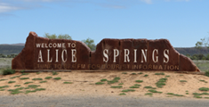

PE (taught by Mr. Little on a Tuesday and Friday)- FMS- Catching and Bouncing a Ball /Gymnastics Activities.

PSHE – National Anti-Bullying Week~ What is bullying? What to do about bullying and unsafe secrets.
We will also be discussing ‘Rights and Respect’.

Art & Design - We will be making Christmas cards and crafts.

- DT- Sewing- Making pouches- learning to sew! The children will learn to sew a running stitch with regular-sized stitches and understand that both ends must be knotted. They will then decorate their pouch using the materials provided.

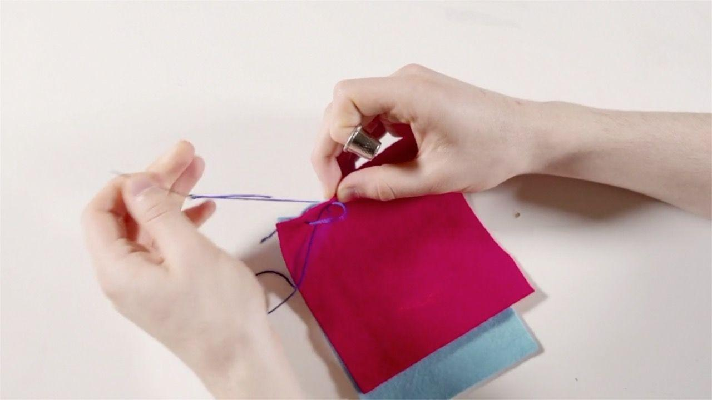

Music - Practising and rehearsing songs for EYFS and KS1 Nativity performance.

Computing – Online Safety. We will also be learning about simple spreadsheets.

Dates for your diary:
Swimming Pool- WC 3rd November and 10th November  Odd Socks Day- Monday 10th November  Children in Need- Friday 14th November | Nativity- Tuesday 9th December  Christmas Jumper Day- Friday 11th December  Advent Service @ St Matthews –Tuesday 16th December (1:30)  Christmas Disco- Tuesday 16th December  Taz (Children’s Entertainer)- Thursday 18th December

Vocabulary for Autumn 2
Please take some time to read these key words. They will help your child to understand what we will be learning this term.
running stitch  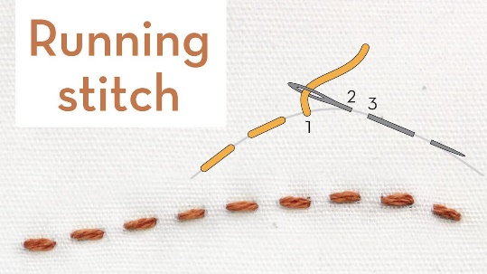 | needle and thread  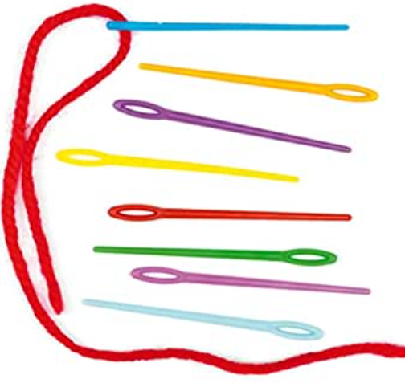 | template  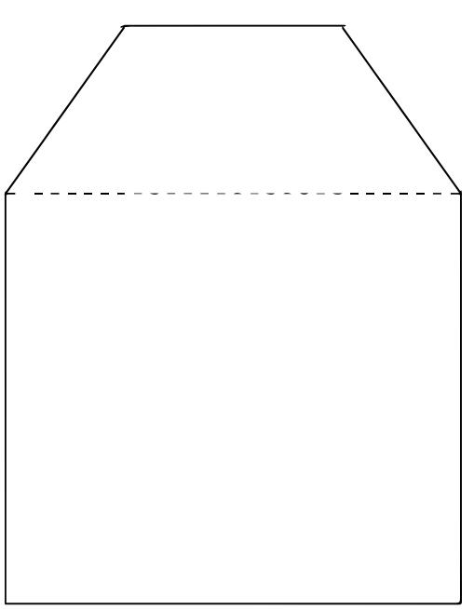
Alice Springs  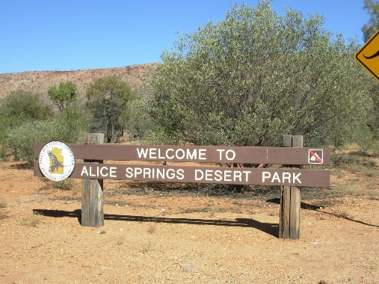 | Desert biome  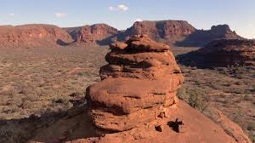 | Great Barrier Reef  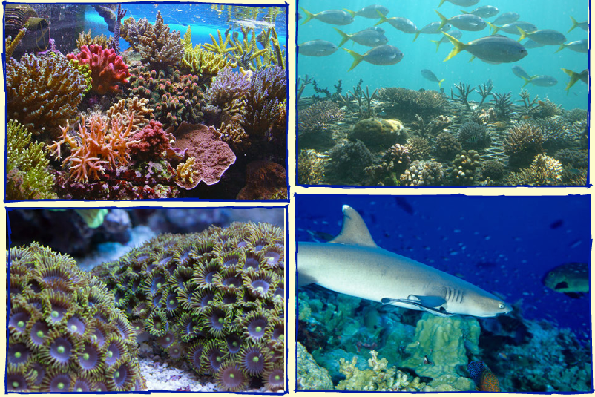
Length  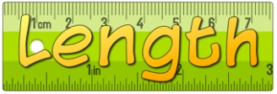 | Mass  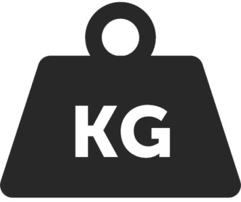 | E-Safety  

