Literacy – Word Reading, Comprehension and Writing |  |  | Mathematics – Numbers and Numerical Patterns
This term, we will continue to revise the Set 1 speed sounds each day during our Read, Write Inc sessions. We will also be working hard on using ‘Fred Talk’ to help us to blend our sounds together to make words. An extra challenge this term is going to be to try and write down some of our words independently.   |  |  | We will be continuing to use Maths No Problem Foundations! This term we will be exploring counting and the composition of numbers to 5 and will deepen our understanding of numbers to 10.  
Personal, Social and Emotional Development | Religious Education – Special Places |  |  | Physical Development
This half term, we will consider how we can make a difference. We will identify how we can care for our home, school and special people. We will also talk about how we can make an impact on the natural world.  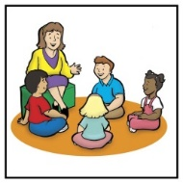 | In our R.E. learning, we will be talking about our special people and why people think that Jesus is special. We will be exploring the Christmas story and the birth of Jesus. We will also be getting ready for our Christmas Nativity – ‘A Wriggly Nativity’!  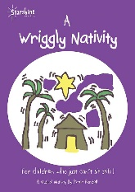 |  |  | Our P.E. lessons are taught by Mr Little. We have P.E twice a week on a Wednesday and Friday.  Please make sure your child has the correct P.E. kit in school. P.E. kits will be sent home each term to be washed.  This term, the children will be exploring gymnastics and will continue to build on their fundamental movement skills.  
Lead Subjects
Science – Understanding the World |  | Design and Technology – Expressive Art & Design
In Science this half term, we will be learning all about materials. We will think about what a material is and why they are used for many different things. We will be asking our own questions and investigating to find out the answer.  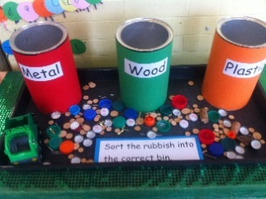 |  | We will be exploring and becoming familiar different types of fruits and vegetables and their differences in texture, taste and appearance. We will also be practising our fine motor skills to help us to chop and prepare vegetables to make our own soup.  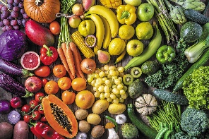

Remember you can email homework activities to mrsgscholes@holytrinitycofe.lancs.sch.uk
Vocabulary for Autumn 2 - Please take some time to read these key words. This will help your child to understand what we will be learning this term.
material  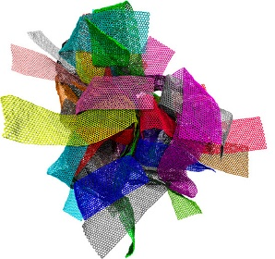 | rough   | smooth  
Mary and Joseph  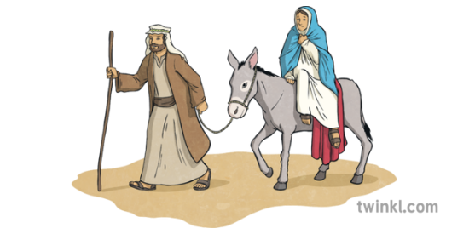 | Christmas   | soup  
feelings  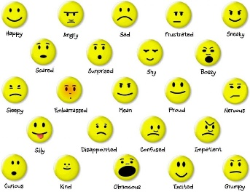 | vegetables  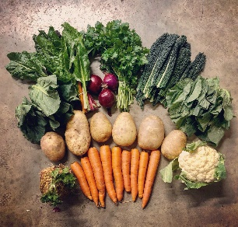 | cutting  

