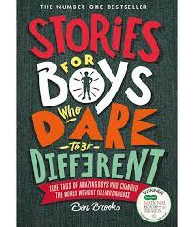  English  Biographies  Week 1 + 2 – Reading Phase – Children will read a variety of biographies for pleasure and will read to understand the features of biographies in order to aid them in writing their own.  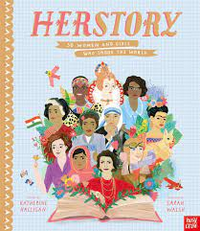  Week 3 – Gathering Content – Children will learn lots of facts about Walt Disney in order to gather enough information to be able to contribute to a Shared Write about him.  Week 4 – Scaffolded Write – Teacher will model writing each part of the biography about Walt Disney. Children should then have a go at writing their own biography about Walt. Children should use the same structure and similar information but try to make it their own. Teacher will model each part of the biography.  Week 5 – Independent Write – Children will write an independent biography all about William Shakespeare. |  | Mathematics - Maths No Problem  Dividing fractions by a whole number  Writing fractions as decimals  Dividing decimals with and with  And without renaming  Converting Units of length  Converting Units of mass  Converting Units of volume
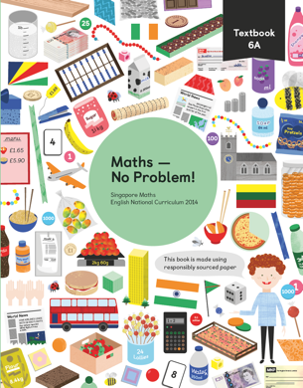
Religious Education  Life as a Journey (A study of different religions)  How do Christians prepare for Christmas?  Advent |  | Class Bible Verse  ‘Therefore go and make disciples of all nations, baptizing them in the name of the father, the son and the Holy Spirit.’  Matthew 28v19 |  | Science  Evolution/Inheritance  
Topics
Geography – UK Trade links with the rest of the world Computing - Spreadsheets
D.T – Making waistcoats

Excel | Trailblazer | Architecture
Import | Accomplishments | Hereditary
Characteristics | Advocate | Exploration
Adaption | Region | Advent
Export | Borders | Globalisation

