English –  The focus for this term will be the Legend Gelert. The children will learn the story in detail, with a view to writing their own Legend. Guided Reading – The children will continue reading, The Lion, The Witch and the Wardrobe, which they are all really enjoying. We will incorporate activities in order that the pupils will develop a deeper meaning of the book and start to develop inference and deduction strategies. Grammar, Punctuation & Spelling – The children will be learning how to construct a sentence using ed starters and relative clauses. They will continue using Ed Shed for their spellings. 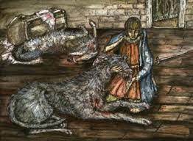 |  | Mathematics  We will begin this term with mental multiplication and division, this should link with their knowledge of tables to enable them to identify multiples and factors. They will be able to identify prime factors and recognise and use square numbers and the notation for squared (2). We will continue with problem solving to reinforce their understanding. The Maths No Problem scheme of work, introduces the children to lots of concrete apparatus, which they use regularly in their work, in order to help them to see mathematics visually. This should embed their learning and allow them to dive deeper creating a better understanding.  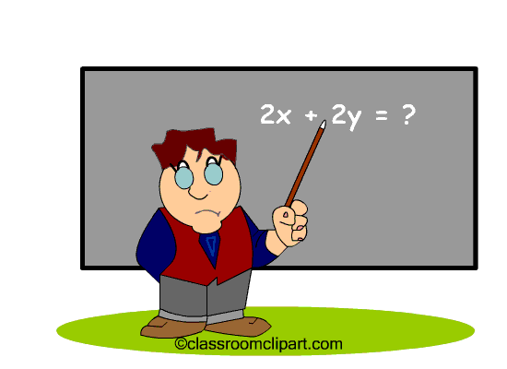
Science –  This term the children will be learning all about Material Properties - testing. They will complete their own experiments, to find out which materials can go through the process of reversible or irreversible changes.   |  | Religious Education ‘LIFE IN ALL ITS FULLNESS’ JOHN 10 V 10  Christmas – Matthew and Luke. The pupils will discuss the Christian values Hope, Humility and Faith. They will compare the two Gospel accounts of the birth of Jesus and discuss how these stories impact on our world today. They will develop an understanding of tradition and their link with the bible.. 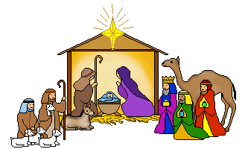  Class bible verse – Luke, chapter 4 verse 4 – ‘Jesus said that man shall not live by bread alone, but by every word of God.’ |  | PE  The children will continue their swimming lessons this term and will enjoy learning new skill in Gymnastics and Dance, which will be under a theme called Earthlings.  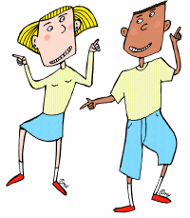
Design and Technology – The children will learn new sewing skills including, blanket stitch. They will be designing and making a soft toy. |  | Geography – We will be looking at the Amazon Basin and South America. The children will learn about the 5 major countries and cities of South America. |  | Computing – Our topic this half term will be spreadsheets. The children will learn how to collate information on a blank spreadsheet of their own.

Vocabulary for Autumn 2
Below are some key vocabulary that will help your child to understand what we are going to be learning about this half term. Please read the words with your child and talk about what the words mean.

Changes and Challenges – Autumn 2
Gelert | Legend | Matthew | Luke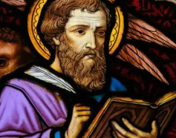
version | Blanket stitch  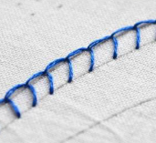 | Relative clause | Relative pronoun
Gospels | reversible | irreversible | materials

