Maths  Write number sequences counting forwards and backwards in 2s, 3s, 4s, 5s and 10s. Remember that the sequences don’t always have to start from 0!  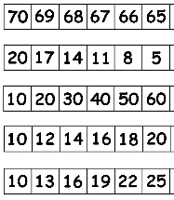 | GPS – Apostrophes for possession.  Use an apostrophe and an s to show that something belongs to someone or something else.  E.g.  Have you seen Sarah’s red, woolly hat?  Robert’s new shoes are dirty.  This is Amy’s shiny green car.  Think of your own 5 sentences using apostrophes for possession. Don’t forget to use capital letters and full stops. | Maths- Time  Make a poster about the days and the months.  Tell me facts e.g. which month is your birthday? How many days are there in a year?  Maybe you know a rhyme about the months?  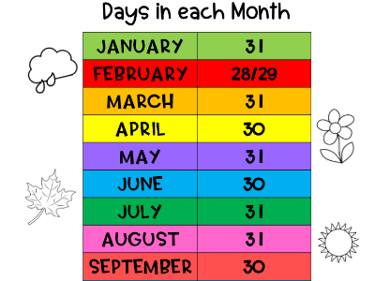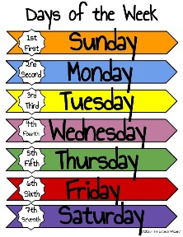

Holy Trinity CE Primary School
Homework grid for Year 2, Spring 1
~ Brilliant Burnley

Choose any one box per week and complete the English, Maths or Topic homework. Hand your homework book in every Wednesday for marking. Don’t forget to practice EdShed daily ready for a spelling test on Friday.
Science
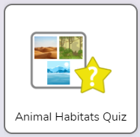

Complete the ‘Animals Habitat Quiz’ on Purple Mash. Don’t forget to submit your work to me!

DT/ICT
Log onto Purple Mash and see the activity called ‘2Design and Make’. Design a colourful, realistic vehicle using the templates and submit to me to mark.
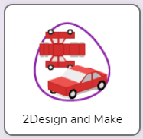
Handwriting-  Log into your handwriting account and practise the handwriting set. | DT  In DT we are learning about wheels and axles. Have a go and make a simple car at home- one is made from a wooden peg and four button wheels and the other is a piece of folded card.  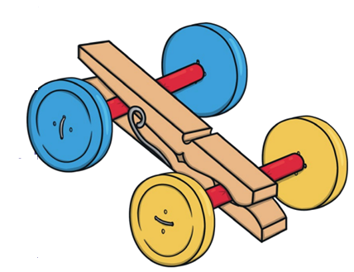 | English/ History  Write about the life of Alfred Victor Smith, a local hero. Tell me all about his heroic actions in WW1.  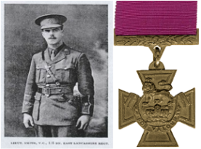
RE- The Big Question:
What are numbers?

Write down your ideas or draw some pictures. Think of at least 5 different ideas.
RE  In RE we have been learning about how Jesus was a friend to everyone. Draw a picture of you and your friends and label who they are. | English  Research 5 facts about one type of bird of prey. For example, you could write 5 facts about a vulture or 5 facts about a falcon. Write your facts in your neatest handwriting.  

