English- Amazing Birds  This half term we are focusing on short writing opportunities based on ‘Amazing Birds’ where we will build up to write a non-chronological report of our own all about a bird of our choice. We will identify how specific information is organised within a non-fiction text e.g. sub-headings, contents, bullet points, glossary, diagrams. We will also learn how to locate information from non-fiction texts using the contents page, index, labelled diagrams and charts. We will also learn skills such as making simple notes from non-fiction texts, e.g. highlighting and noting key words. We will then move on to reading ‘The Owl who was Afraid of the Dark’ as part our work on narrative texts. We will continue with this after the half term.  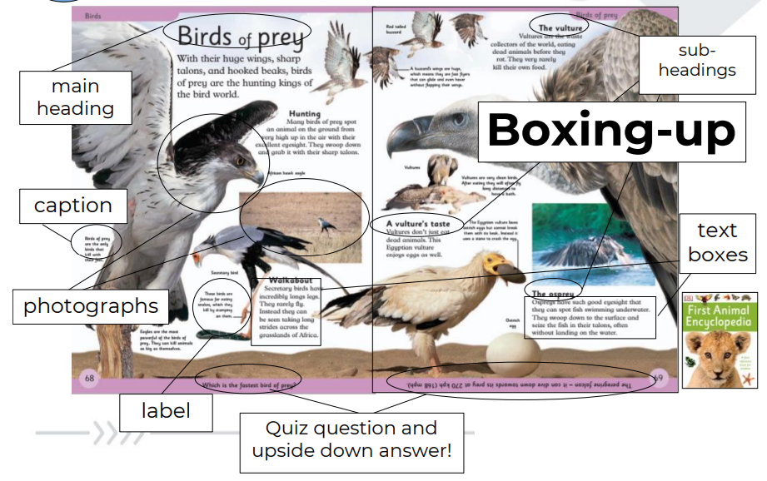  Home reading books will continue to be changed on Monday and Thursday. Our school library day continues to be every Wednesday.  *Please remember to read home reading books three times for fluency unless they are longer books. |  |  |  | Mathematics  Chapter 5: Length  This chapter helps children to get a better understanding of how to measure length (m and cm) and progress to measuring in real-life contexts.  Chapter 6: Mass  We will be measuring mass in kilograms and grams. We will be comparing the mass of two objects and answering word problems involving mass.  Chapter 7: Temperature  In the temperature chapter we will learn how to read and estimate different temperatures.  Chapter 8: Picture Graphs  This teaches children how to read a selection of picture graphs.  We will also be working through past Maths SATs papers. There are two Maths papers. Paper 1 is arithmetic and Paper 2 is reasoning. We will be sending home an example of a Maths SATs paper in the Easter holidays.
DT - Mechanisms & wheels  We will be designing and making a vehicle. We will then evaluate our vehicle. What does the vehicle transport? Do the axles work effectively? What is a chassis?  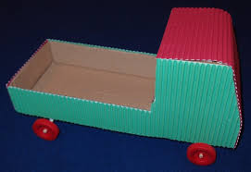 |  | Religious Education  Jesus, friend to everyone.  Christian values: Friendship, Compassion, Faith and Hope.  The aim of the unit is to enjoy a selection of stories of Jesus’ Miracles and to increase the children’s awareness that Jesus was an extraordinary person who welcomed everyone as a friend. |  |  |  | PE- Tuesday’s and Friday’s with Mr. Little  In our PE lessons we will be continuing to develop our fundamental movement skills of rolling a ball, catching a ball and bouncing a ball.  Please bring both an indoor and an outdoor PE Kit. Thank you.
Music – ‘I Wanna Play in a Band’ by Joanna Mangona is a rock song for children!
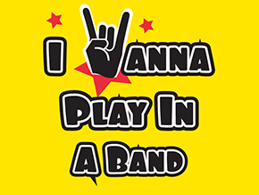

Computing- This term our topic is ‘Questioning’. This unit involves us using and creating pictograms and binary trees to answer questions. 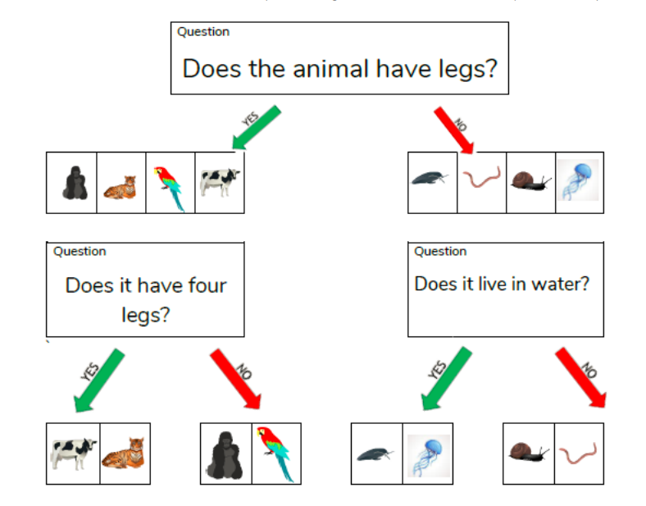
Science – Living things and their habitats

This term our Science is all about different habitats and how living things live in their own unique habitats. We will be describing the conditions in different habitats and micro-habitats (under a log, on a stony path, under the bushes). The children will learn that a food chain is an energy source for animals and will be constructing their own simple food chain that includes humans (e.g. grass, cow, human).

PSHE – Being my best.
In PSHE we will be discussing what we like and dislike, and understanding that they have choices about these things; some choices can be either healthy or unhealthy and can make a difference to their own health. We will also learn how our bodies work such as; naming major internal body parts (heart, blood, lungs, stomach, small and large intestines, brain) and describing how food, water and air get into the body and blood.
Life Education – ‘Harold the Giraffe’ will be visiting school on Thursday 12th and Friday 13th February 2026 to enhance both our Science and PSHE Curriculum.

Vocabulary for Spring 1
Please take some time to read these key words. This will help your child to understand what we will be learning this term.
wheels and axle  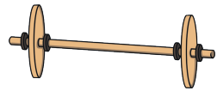 | chassis  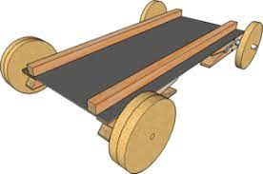 | hacksaw  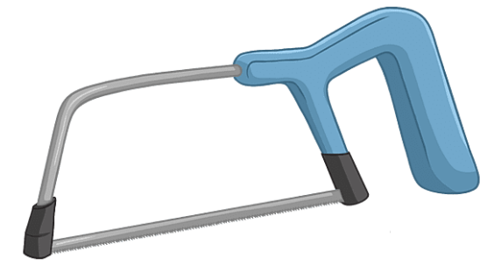
bench hook  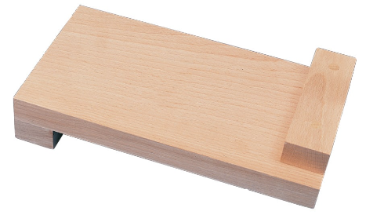 | vehicle  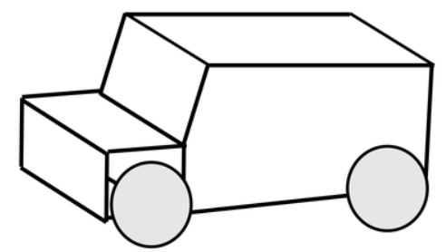 | food chain  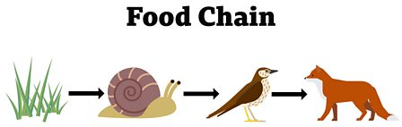
habitat  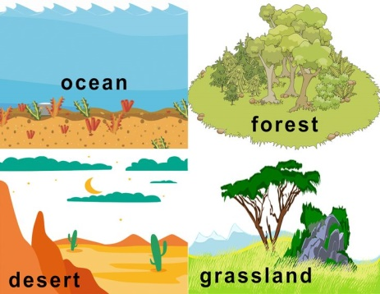 | micro-habitat  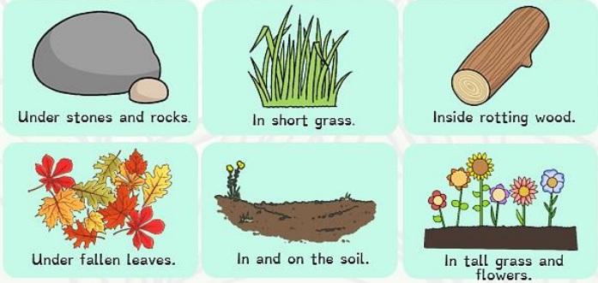 | Living/ Non- living  

