
Curriculum Overview 2026 Spring 1 Class: Year 1
Holy Trinity CE Primary School Theme: Brilliant Burnley Teacher: Mrs Scholes/ Mrs Knight
‘God saw all that He had made, and it was good’ Genesis Ch 1 v 31
English  Phonics children will use the RWI scheme to develop their phonetical knowledge.  Talk 1The Highway Rat  Children will be using the text The Highway Rat to write their own adventure stories with familiar characters and plot lines.  Reading books will be changed and sent home every Monday and Thursday. Please make sure your child's reading book and reading record are in their book bags on these days. |  | Mathematics  In Year 1 we take a practical approach to Maths, with the children having lots of opportunitities to explore number using concrete apparatus before transfering this knowledge to more abstract questioning.    Units covered this term:  Shape and patter  Height and Length  Number to 40  Addition and subtraction word problems |  | Science  This term we will be learning about ‘Seasonal Changes.’ We will identify and name the four seasons of the year. We will also identify clothing that can be worn in each season.  
RE  Unit 1.4 Jesus was special  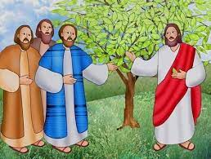  Children will read and discuss stories about Jesus and his disciples. They will investigate what made Jesus such a special person. |  | History  This term we will be exploring the life of the Towneley family and the home in which they lived, Towneley Hall.  Our key question is: How has Towneley Hall changed over the last 120 years?  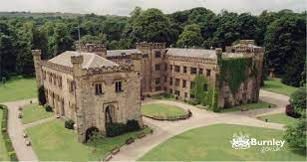 |  | DT  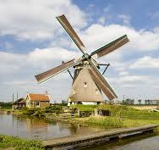  Structures. The children will be designing and making their own windmill with moving parts.  After designing their windmills, the  children will evaluate their  design and looking at ways to make  improvements.
PE  FMS- Rolling a ball  Gymnastics   | Music  We will be completing the Charanga Unit- ‘In the Groove!’   |  | PSHE  We will be developing our understanding of our how we can ‘Be our best’. We will be looking at how to keep our bodies and minds well.   |  | Computing  Online safety  Purple Mash Creative Computing    This unit gives children the opportunity to develop their mouse, keyboard and basic computing skills using creative tools. Children will use the 2DIY tools to paint, create jigsaws and make simple drag and drop games.

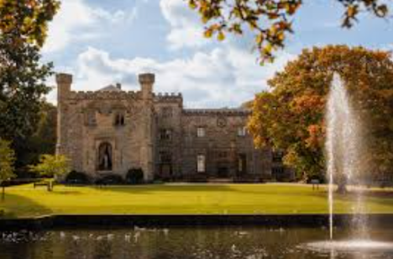  Towneley Hall | 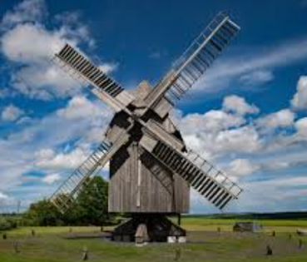  Windmill | 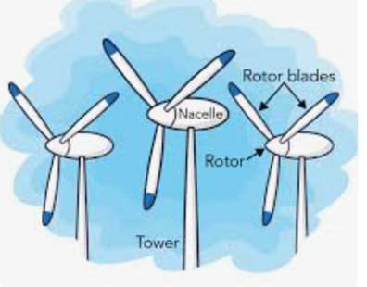  Structure
  Rotor blade |   Windmill tower | Autumn  
Winter   | Spring   | Summer  

