

Holy Trinity C of E Primary School
Autumn 2- Year 1- Homework Grid
Daily activities: Reading books/ spellings (Spelling Shed)
Weekly Activities: Phonics homework (Phonics Play), Daily 10 Maths Challenge and one piece from the grid.
Record your homework grid piece in this book. Feel free to be creative! Use colours, IT or photographs to present your work.
Photos of completed homework can be sent to: Mrsscholes@holytrinity.cofe.lancs.sch.uk

Phonics Play!  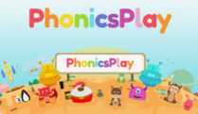  Practise reading words with Phase 2 and Phase 3 sounds on Phonics Play. You can play on Buried Treasure and Picnic or Pluto for free! To be completed at least once a week throughout this half term .https://www.phonicsplay.co.uk/ |   Spelling Shed  You will find your child’s login detail inside the front cover of their homework book.  e.g Username:  Password:  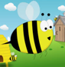  Weekly spelling activities will be set for your child. Attempt a few words from the list each day  https://www.spellingshed.com/en-gb/ | Maths      Scan the QR code to access Daily 10 challenges. Choose level 1 to begin with complete the addition, subtraction and ordering activities for each level before moving to the next Level. To be completed at least once a week throughout this half term.  https://www.topmarks.co.uk/
English- Words in a words  The children have been working hard to develop their Fred Fingers to help them with spellings. Practice using Fred Fingers to spell some words that can be made from the following word…  materials  e.g. mat, seal… | Geography- Design a map of your route to school  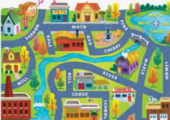  The children have been learning about our local area. We have been finding out about the different types of houses near our school. The children have been using simple mapping skills to plan routes around the classroom. Design a map showing the route your child takes to school. Remember to include some physical/ human features such as roads, houses, shops, parks. | PE- Dance  The children have been learning a dance routine in our PE lessons linked to our TALK unit of work on superheroes. Ask your child to try out their dance skills at home by following this Go Noodle activity.  https://www.youtube.com/watch?v=JdBlXPWM8AI  
Science-  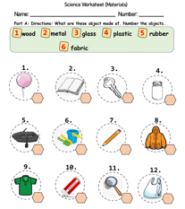  The children have been exploring different science concepts relating to materials. Discuss the different item on the worksheet and ask the children to describe what material they think the item is made from. | Handwriting- RWI  Compete the handwriting sheets that are stuck into this book. For guidance on our schools Handwriting style please see the back page of your child’s homework book.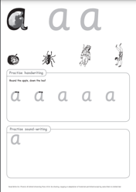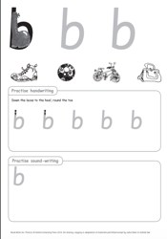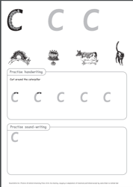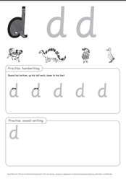 | PSHE-No 4- Build a den (indoors or out)  What will your den be? A meeting place for spies, a pirate hideout or maybe a fairy castle for the night? Why not read a story in your den or enjoy a cup of hot chocolate.  https://www.nationaltrust.org.uk/visit/50-things/no.-4-build-a-den  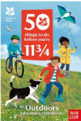  No one will protect what they don’t care about, and no one will care about what they have never experienced.'  - Sir David Attenborough

