
Holy Trinity C of E Primary School
Year 1 Homework Grid
Spring Term 1
Phonics Play  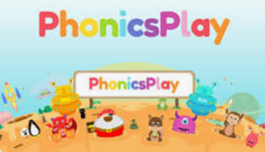  Practise reading words with Phase 5 and Phase 6 sounds on Phonics Play. You can play on Buried Treasure and Picnic or Pluto for free! To be completed at least once a week throughout this half term.  https://www.phonicsplay.co.uk/ | Spelling Shed    You will find your child’s login detail inside the front cover of their homework book.  e.g Username:  Password:  Weekly spelling activities will be set for your child. Attempt a few words from the list each day  https://www.spellingshed.com/en-gb/ | Maths  Scan the QR code to access ‘Blast off. It’s a mental maths can aimed at It's designed to help you identify and work with two-digit numbers.    To be completed at least once a week throughout this half term.    https://www.topmarks.co.uk/
English- Words in a word  Make as many smaller words as you can from the word:  Towneley Hall  e.g. town, hall, all  What is the longest word you can make? | History  We will be thinking about the following questions in our  lessons this term: How has Towneley Hall changed over the last 120 years?  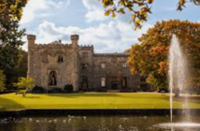  Can you draw a picture of Towneley Hall and write some sentences to describe it using the questions who, what, where, when and how? | DT  We will be making a simple structure of a windmill out of paper cups. We will be thinking about what we can do to strengthen our structures so that they can stand alone without support.  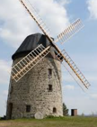  Can you make a different type of structure that can stand alone. Maybe you could make a bridge or a building. Bring you design into school to show your friends.
Science  We are looking at seasonal changes this term in science. Thinking specifically about Autumn and Winter.    Can you draw an Autumn picture showing how trees/ plants change. Then draw a winter picture showing the weather in winter. Think about any different clothes people might be wearing in the different seasons as well as the changes you can see. | Handwriting- Letter Join  We have decided to use Letterjoin as our handwriting scheme across school. www.letterjoin.co.uk  Pupil Login- ej33306  Tablet swipe a capital L starting at the top left.  Computer Password- home  Choose Year 1 and practice forming capital letters. | PHSE- Being My Best  In PHSE this term we are looking at a range of ways to keep our minds and bodies healthy.  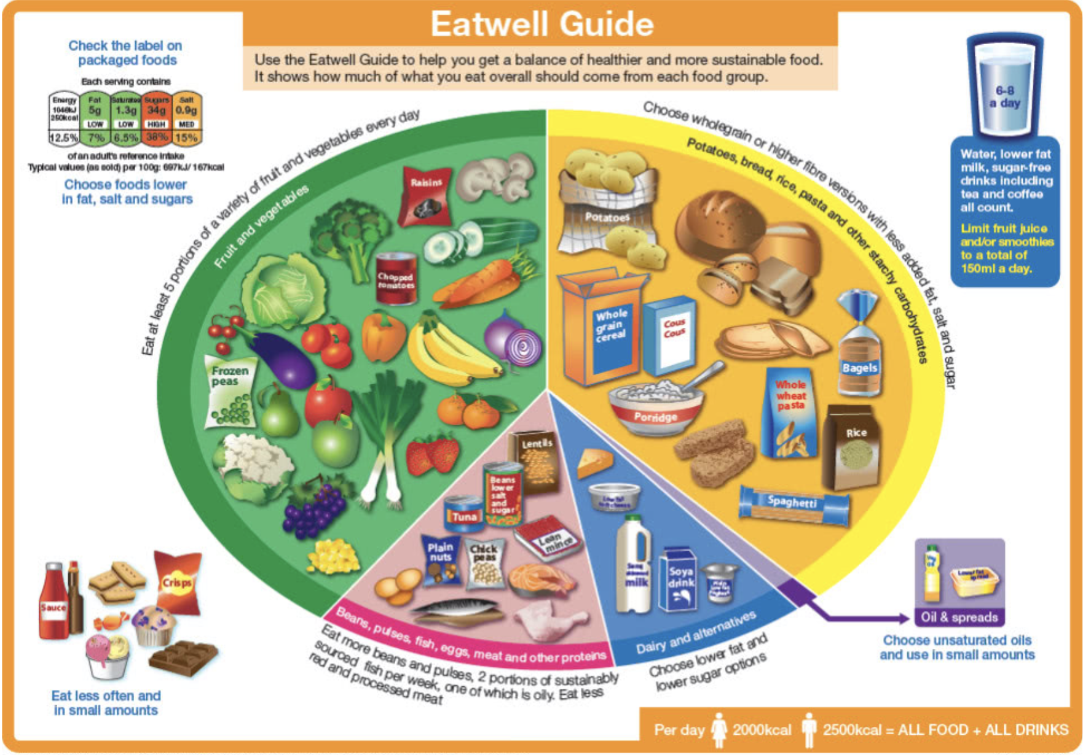  We will be looking at different foods and which we should try to eat more of. Use the eat well plate to make your own healthy meal. You can draw it in your book or make a model to show us all.

