
Curriculum Overview 2025 Autumn 2 Class: Year 1
Holy Trinity CE Primary School Theme: Changes and Challenges Teacher: Mrs Scholes/ Mrs Knight
‘God saw all that He had made, and it was good’ Genesis Ch 1 v 31
English    Phonics children will use the RWI scheme to develop their phonetical knowledge.  Talk 1 Supertato  Children will be using the text Supertato to write their own adventure stories with familiar characters and plot lines. They will also be completing a short unit on writing instructions.  Reading books will be changed and sent home every Monday and Thursday. Please make sure your child's reading books and reading record are in their book bags on these days. |  | Mathematics    In Year 1 we take a practical approach to Maths, with the children having lots of opportunitities to explore number using concrete apparatus before transfering this knowledge to more abstract questioning.  Units covered this term:  Positions  Numbers to 20  Addition and subtraction within 20 |  | Science  This term we will be learning about ‘Materials.’ We will identify and name a variety of everyday materials including wood, plastic, glass, water, rock, brick, paper, and cardboard. We will describe the properties of these materials and groups together a variety of materials based on their simple properties.  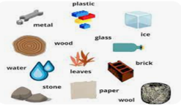
  RE  Unit 1.2 Creation  Children will learn about who Christians believe  created the world. They will develop their  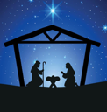  understanding of how people of other faiths believe creation happened.  Unit 1.3 Christmas  Children will learn what it means to give and receive  gifts and link this with the gift of Baby Jesus. |  | 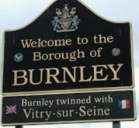  Geography  This term we will be learning about our local area. They will learn that Burnley is a town in Lancashire. The children will begin to understand the importance of maps and how these can inform us about the location of things. They will begin to learn simple compass directions and use these to navigate a simple route. We will discuss several significant landmarks in Burnley. |  | DT  This term we will be designing, making and evaluating puppets. The children will learn how to:  - Join fabrics together using pins, staples or glue.  - Design a puppet and use a template.  - Join their two puppets’ faces together as one.  - Decorate a puppet to match their design.    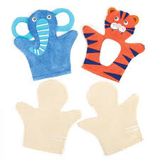
PE  Dance-Superheroes    FMS Under arm throw | Computing  Unit 1.1  Intro to PurpleMash  ESafety  Project Evolve   |  | Music  We will be completing the Charanga Unit- ‘Rhythm in the way you walk’ and ‘Banana rap’ - Rehearsing songs to perform. Playing simple instruments.   |  | 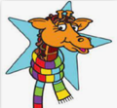  PSHE  We will be developing our  understanding of our  ‘Rights and Respect.’ Children will:  -Recognise how a person's behaviour (including their own) can affect other people.  -Explain the importance of looking after things that belong to themselves or to others.  -Explain where people get money from;  -List some of the things that money may be spent on in a family home.

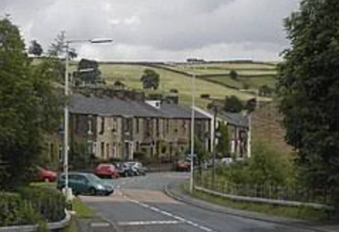  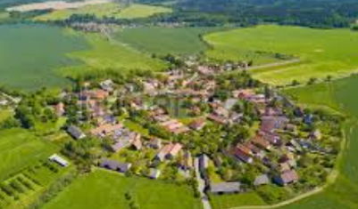  village | 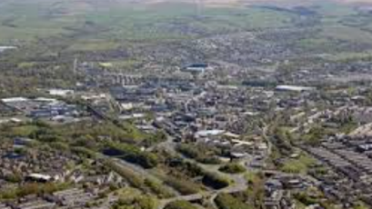  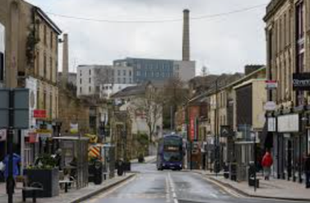  town | 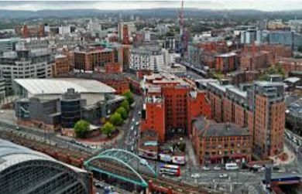  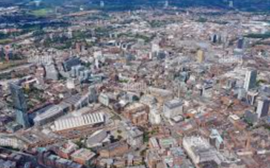  city
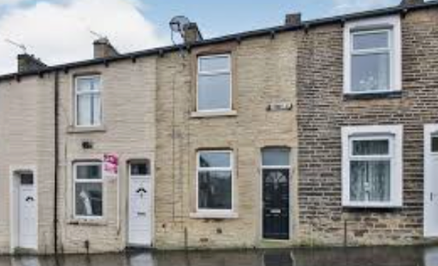  terraced house |   semi-detached house |   detached house
Singing ringing tree  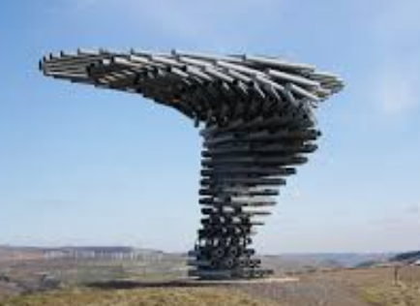 | 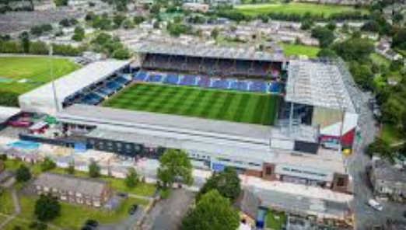  Turf Moor | Pendle Hill  

