
Curriculum Overview 2025/26 Spring 1 Year: 3
Holy Trinity CE Primary School Theme: Brilliant Burnley Teacher: Mrs G Scholes
Our Class Bible verse: Do to others what you want them to do to you.
English:
During this half term, we will be focusing on our key text The Iron Man by Ted Hughes. Using the story, and vocabulary from the text, there will be various exciting writing opportunities. These include writing a diary entry, a persuasive advert and using adverbs to focus on developing some exciting story settings. We will also continue to build upon grammar skills and spellings within our writing.
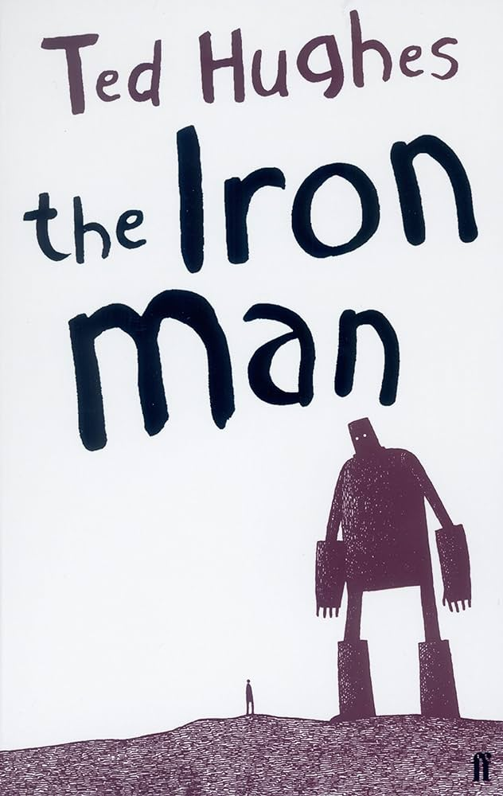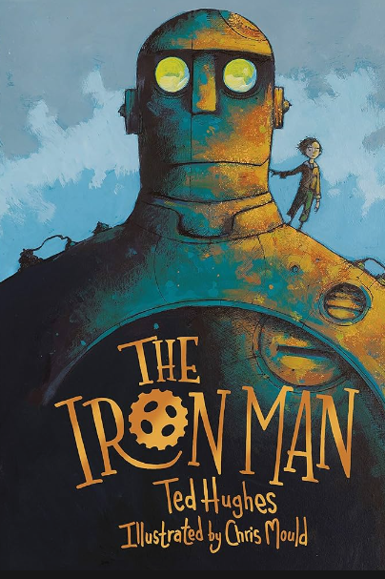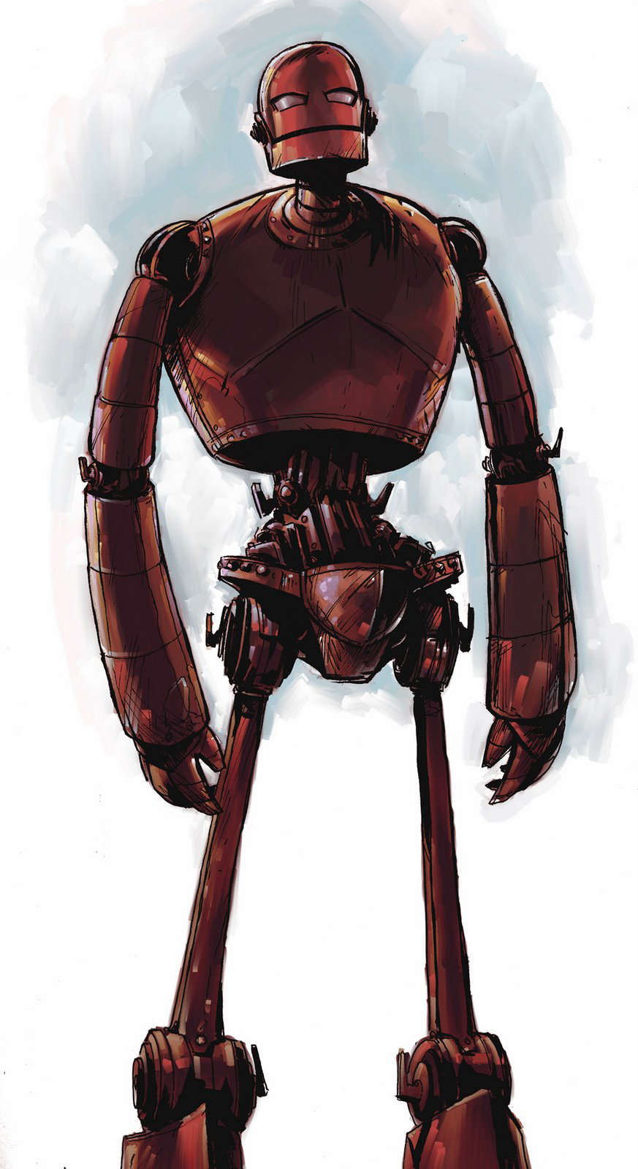

Maths:
We are continuing to use our scheme in mathematics called Maths No Problem.
Throughout this half term we will be looking at:
- Further developing multiplication and division skills.
- Counting, adding, and subtracting money.
- Telling time and exploring duration.
In addition, there will be a continued focus on the development of multiplication tables.

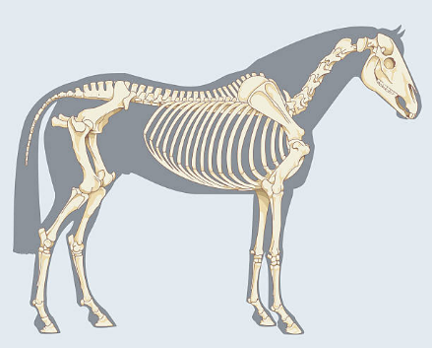
Science: Animals – Skeleton and Movement
Within this Science unit, we will identify that humans and some animals have skeletons and muscles for support, protection and movement. We will also learn about some animals without internal skeletons/backbones (invertebrates) and describe how they have adapted other ways to support themselves, move and protect their vital organs.

Topics
History – History of Scott Park
PSHE – Being my Best
Music – Let’s Go Sing songs
Design & Technology – Structures (building a castle)
Spanish – Shapes and Colours
P.E.:
In P.E. this half term, we will be developing our movement, catching and throwing skills in basketball and also extending our gymnastic skills.
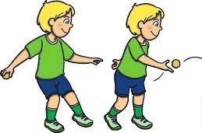
Religious Education: How Did/Does Jesus Change Lives?

During this R.E. unit, questions including the following will be explored:

- What does ‘change’ mean?
- How can our lives be changed? Is it easy to change?
- How did Jesus change lives?
- When did/does Jesus change lives?
- What happens when Jesus changes a person’s life?

Key Vocabulary
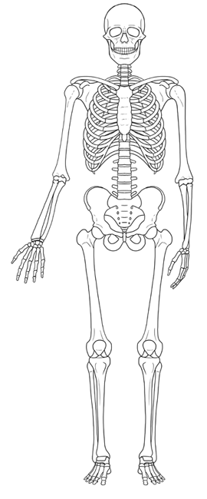  skeleton | change  | division  
coins  | muscles 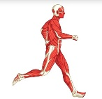 | poem 
memorial  | chronological 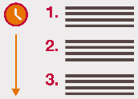 | structure 
empathise  | local 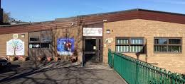 | duration 
Vocabulary for Spring 1
Here is some key vocabulary that will help your child to understand what we are going to be learning about this half term.
Please read the words with your child and talk about what they mean.

