English  Fantasy  Persuasion  Guided Reading  Fiction and Non-Fiction books  Grammar, Punctuation & Spelling  - extending the range of sentences with more than one clause by using a wider range of conjunctions, including when, if, because, although  - using the present perfect form of verbs in contrast to the past tense  - choosing nouns or pronouns appropriately for clarity and cohesion and to avoid repetition  Handwriting  - use the diagonal and horizontal strokes that are needed to join letters and understand which letters, when adjacent to one another, are best left un-joined increase the legibility, consistency and quality of their handwriting [for example, by ensuring that the down strokes of letters are parallel and equidistant; that lines of writing are spaced sufficiently so that the ascenders and descenders of letters do not touch]. |  |  |  | Mathematics  Maths No Problem!  Further Multiplication and Division  Solving Word Problems  Chapter Consolidation  Graphs  Drawing and Reading Pictograms and Bar Graphs  Drawing and Reading Bar Graphs  Chapter Consolidation  Fractions  Counting in Hundredths  Writing Mixed Numbers  Showing Mixed Numbers on a Number Line  Finding Equivalent Fractions  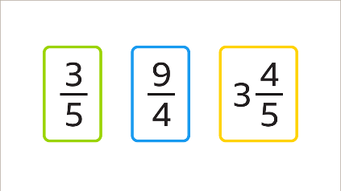  Simplifying Mixed Numbers  Simplifying Improper Fractions  Adding Fractions  Subtracting Fractions  Solving Word Problems  Chapter Consolidation
Design & Technology – Designing and making a torch  We will be using our scientific knowledge on electrical circuits to:  - Analyse and evaluate electrical products  - Identify the features of a torch and understand how it works  - Decide what is good and bad about different torches  - Understand what is important in torch design  - Design a product to fit a set of specific user needs  - Factor in who my product is for in my design criteria  - Design a torch which satisfies both the design and success criteria  - Make and evaluate a torch  - Make a working circuit with a switch  - Use appropriate equipment to cut and attach materials  - Assemble a torch according to and which satisfies my design criteria  - Test my torch to evaluate its success |  |   Religious Education  Unit 4.3: Jesus the Son of God.  How did Jesus show his power and authority?  - How do we know Jesus had power and authority?  - Where did Jesus’ power and authority come from?  - How do the actions of Jesus show that he is the Son of God?  - How do the actions of Jesus show his divine nature?  - How do these stories reveal Jesus to be the Son of God?  - What do Christians believe about Jesus and God because of these events?  Jewish Shabbat Non-Christian Faith Unit  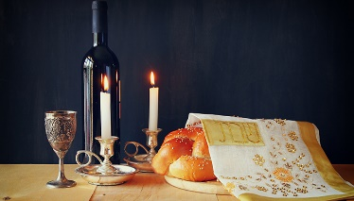 |  |  |  | Science – States of Matter  - Compare and group materials together, according to whether they are solids, liquids or gases  - Observe that some materials change state when they are heated or cooled, and measure or research the temperature at which this happens in degrees Celsius (°C)  - Identify the part played by evaporation and condensation in the water cycle and associate the rate of evaporation with temperature
History – Town Hall (Twin Town)
We will be finding out ‘What role did Burnley Town Hall play in local justice?’

Computing – E-Safety & Writing for different audiences – using simulated scenarios to write a news report and to write for a campaign.
Music (taught by Mr Fleming from Lancashire Music Service) – Learning how to play the keyboard
Spanish – Classroom Objects – To learn to say how to follow certain instructions in the classroom and also telling everyone what is in your school bag and in the classroom.
PSHE - Being My Best
PE – Invasion Games- "Netball" & Gymnastics

Key Vocabulary for this Half Term
artist | geometric shapes | exhibited | abstract
Cubism | minimalistic | primary colours | image
inspired | design | simple lines | right angles
collage | composition | template | balance
Town Hall | Sources | Chronology | Magistrates court
Crime | Punishment | Social | Society
Crank | Council | Artefacts | Evidence
Below is some key vocabulary that will help your child to understand what we are going to be learning about this half term. Please read the words with your child, find out and talk about what the words mean.

