  English  Classic Fiction - The Wonderful Wizard of Oz.  Purpose and Audience: We will be sharing our new story with another class (Y5) and displaying it in the library.  Outcome: Independent piece at the end of a unit creating a new version of ‘The Wizard of Oz.’ |  | Mathematics  Chapter 7 – Percentages  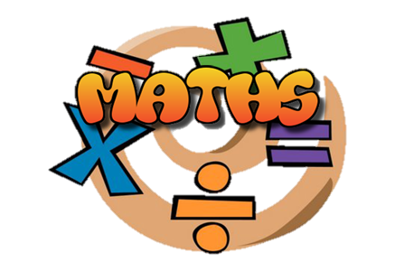  Chapter 8 – Ratio  Chapter 9 – Algebra
Topics
Science – Animals – Circulatory System
D.T - Make -Mechanical + Electrical Systems – Steady Hand Game

History – Transatlantic Slavery  Computing – Blogging   |  | Religious Education  Unit: 6.3 – Exodus  - Why did God choose Moses?  - Why is the Exodus such a significant event in Jewish and Christian history?  - What is freedom?  - Why is freedom important?  - What does it mean to be free?  - Why is it important to remember? |  | PE  Swimming + Invasion games - Netball  

Exodus | Passover | Seder
Literature | Transplantation | Mechanical
Circuit | Arteries | Plasma
Oxygenated | Electrical | Nutrients

