English –  During English lessons this term, we will be reading the Time Spinner by Roy App. The unit of work, will focus on science fiction which will begin will lots of different sci-fi texts. We will explore new and exciting vocabulary, that the children can include in their writing.  Grammar – We will be creating interesting noun phrases, and we will continue including relative clauses and openers.  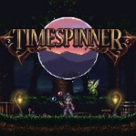 |  | Mathematics  In the New Year, the pupils will be learning fractions. They will add, subtract and order and compare fractions with the same and different denominators. This will lead onto decimals. The children will learn the relationship between fractions, decimals and percentages and how to convert between them.  Alongside their Maths No Problem work, the children will have daily 5 maths challenges, which will help to revisit old and new topics and embed learning.  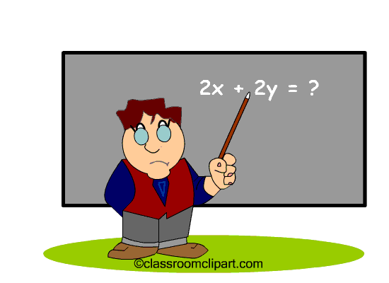
Science – Forces  The children will be able to:  Explain that unsupported objects fall towards the Earth because of the force of gravity acting between the Earth and the falling object.  Identify the effects of air resistance, water resistance and friction that act between moving surfaces.  Recognise that some mechanisms, including levers, pulleys and gears, allow a smaller force to have a greater effect.   |  | Religious Education ‘LIFE IN ALL ITS FULLNESS’ JOHN 10 V 10 Class bible verse – Luke, chapter 4 verse 4 – ‘Jesus said that man shall not live by bread alone, but by every word of God.’ The children will learn about Jesus as a teacher and the relationship between God and people through bible stories. They will be able to identify and explain how the parables answer questions about values and commitments. We will discuss what Jesus taught us that was so important and who we remember as being a great teacher in our own lives as a Christian.   |  | PE  The children will continue swimming lessons this term. Their topic this term is Netball and Gymnastics. They will learn lots of new skills, including attack and defence. They will also learn how to create a sequence in Gymnastics.  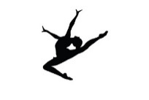
Design and Technology – The children will learn how to design and create a pop-up book. They will then evaluate their designs. |  | History – The children will be learning all about the Pendle Witches, who lived in the local area during the 1600s. They will also study James 1, who was the reigning King at the time. |  | Computing – Our topic this half term will be database. The children will learn how to create a database around a certain topic.

Vocabulary for Spring 1
Below is some key vocabulary that will help your child to understand what we are going to be learning about this half term. Please read the words with your child and talk about what the words mean.

Changes and Challenges – Autumn 2
Alien 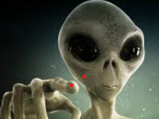 | Witch | Science Fiction  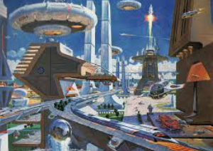 | Force
Gravity | James 1 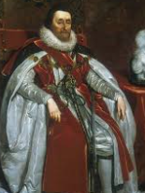 | Jesus the Teacher | Friend
preacher | invasion | Mechanism | lever

