English –  English – The focus for this term will be the novel Macbeth, by William Shakespeare. The children will use role play to develop a better understanding of this difficult historical literature and will learn how to write a play script linked to one of the main scenes in the book. They will also develop their creative writing skills by developing a revolting recipe from the famous poem, ‘The Witches Brew’. They will continue extended writing activities.  Grammar and Punctuation. We will continue including openers and relative clauses into our work. The children will use lots of extended noun phrases, which will include a prepositional phrase.  Guided Reading – This will be based on our class read. The children will complete short comprehension activities about the book.  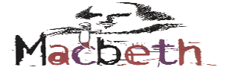 |  | Mathematics  This half term, the children will begin by learning decimals. They will write, order and compare them and then progress onto adding and subtracting decimals. Geometry will be a main focus this half term. They will learn all about angles on a line and around a point. They will learn the difference between regulary and irregular polygons. They will investigate shapes, understand the difference between, acute, obtuse and reflex angles.  Alongside their Maths No Problem work, the children will have daily 5 maths challenges, which will help to revisit old and new topics and embed learning.  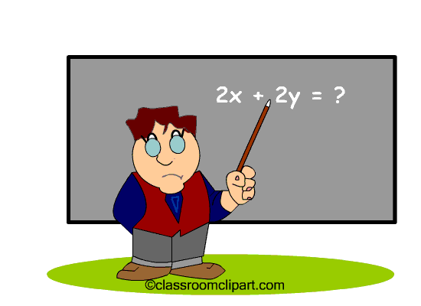
Science – Earth and Space  This term, the children will be exploring the Solar System. They will learn about all the different planets and how they are different. Through experiments, they will be able to understand the Phases of the Moon and why the moon is a different shape throughout a monthly period.  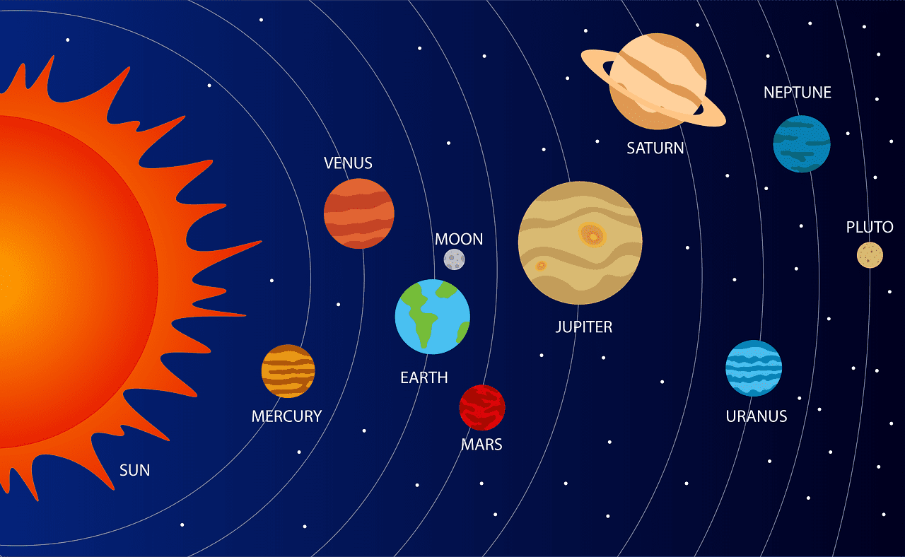 |  | Religious Education ‘LIFE IN ALL ITS FULLNESS’ JOHN 10 V 10 Class bible verse – Luke, chapter 4 verse 4 – ‘Jesus said that man shall not live by bread alone, but by every word of God.’  The unit this half term, explores the Easter story from the perspective of it being the story of Christ’s triumph and victory over death. The children will be able to understand why Easter is a celebration.   |  | PE  Net and Wall games will be the theme in PE. The children will try to outwit their opponent. Hitting a ball into a space.
Art and Design – The children will learn about the famous textile, Gunta Stolzl. They will learn how to weave, using their own loom and wool. |  | Geography – Following on from our History topic about the Pendle Witches. The children will enjoy walking up Pendle Hill and they will also complete map skills on their journey. |  | Computing – Our topic this half term will be Game Creator. The pupils will create their own game on paper and then try and recreate it online.

Vocabulary for Spring 2
Below is some key vocabulary that will help your child to understand what we are going to be learning about this half term. Please read the words with your child and talk about what the words mean.

Exciting Exploration – Spring 2
textiles | weaving | loom | Map reading
Field work | compass | Solar system | phases
moon | planet | gravity | Earth
sun | atmosphere | decimal | geometry

