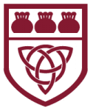
Curriculum Overview 2025/26 Spring 2 Year: 3
Holy Trinity CE Primary School Theme: Exciting Exploration Teacher: Mrs Scholes
Our Class Bible verse: Do to others what you want them to do to you.
English:

During this half term, we will be focusing on developing our knowledge and understanding of non-fiction texts. We will be exploring how these sources can help us to understand more about history and how past events have shaped the world we live in today. Our specific focus will be on the Stone Age and our aim will be to create our own information leaflets about this period of time.

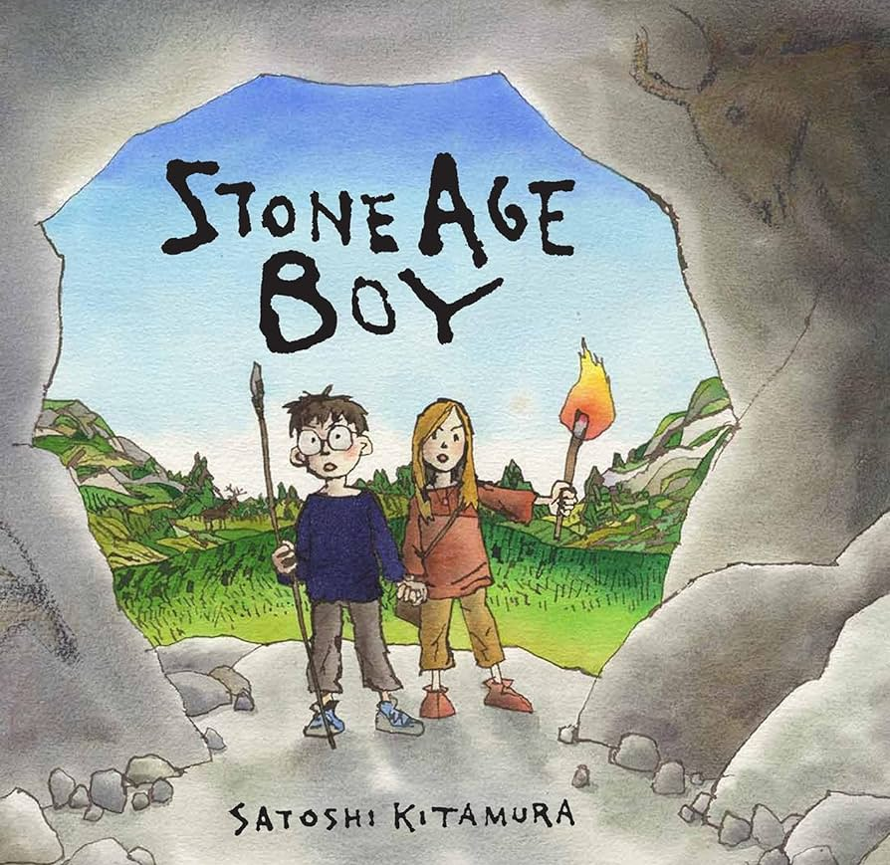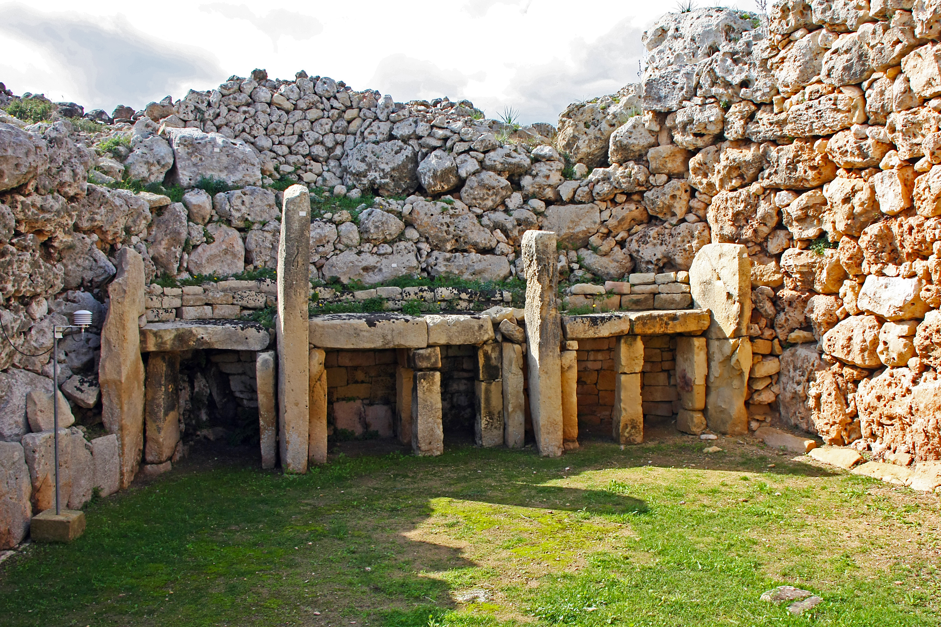

Maths:

We are continuing to use our scheme in mathematics called Maths No Problem.
Throughout this half term we will be looking at:
- Volume
- Money
- Time

In addition to this, there will be a continued focus on the development of the children’s knowledge of multiplication tables.

Science: Forces and Magnets
In Science, we will be looking at forces and magnets. This includes:
- Comparing how different things move.
- Raising questions and carrying out tests.
- Gathering and recording data.
- Making predictions and using experiments to find out more about magnets.

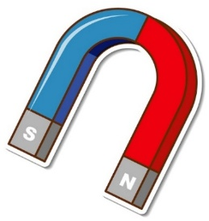

Topics

Art: Printing – Andy Warhol

Geography: Fieldwork – Scott Park trails and maps, including litter pollution and sustainability

Computing: Branching Databases

PSHE: Growing & Changing
Spanish: Classroom Objects

P.E.:
In our P.E. lessons this half term, we will be developing our throwing and catching skills in Dodgeball and getting creative by making up our own games!

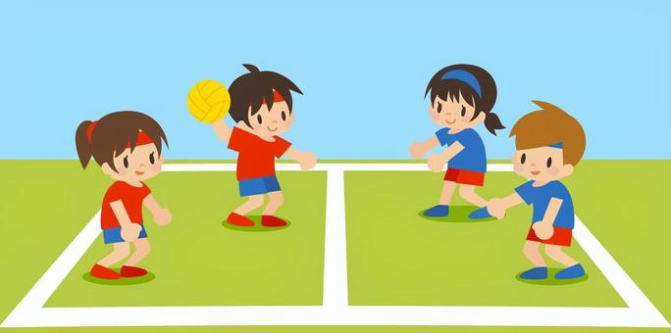
Religious Education: Easter

Is the cross a symbol of sadness or joy?

In this R.E. unit, we will be exploring the following questions:
- Is it possible to describe the events of Holy Week and Easter simply as events of joy or sadness? Why? Why not?
- Is the cross a symbol of sadness or joy?
- How do the services held in churches during Holy Week and Easter reflect the sadness and joy?
- Is Good Friday the beginning or the end?
- Is Easter Sunday the end or the beginning?

Key Vocabulary
Good Friday 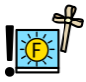 | Compass 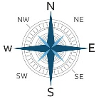 | The Stone Age 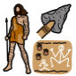
Easter Sunday  | Force 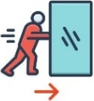 | Non-fiction 
Fieldwork 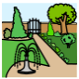 | Magnet 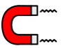 | Duration 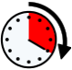
Map 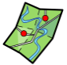 | Database  | Change 
Vocabulary for Spring 2
Here is some key vocabulary that will help your child to understand what we are going to be learning about this half term. Please read the words with your child and talk about what they mean.

