Science  Make a poster/ picture/ wheel to represent the 4 seasons. Remember to show which months are in each season.  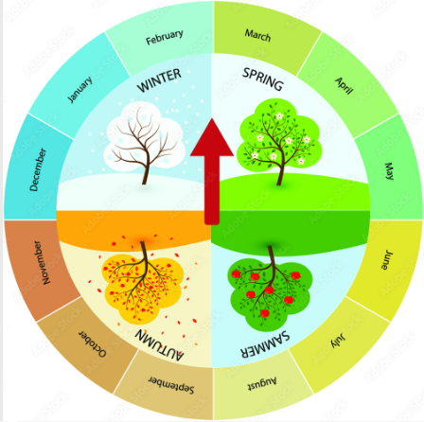 | Maths~ Exchanging Money  Exchange £1 into as many different ways as you can.  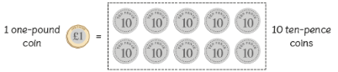  Draw around the coins you use and write the value inside each coin. | Maths  Use coins to make the different totals below. Draw around and label the coins you use.  £0.80  £0.93  £1.40  £.2.60  £4.10  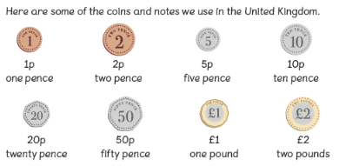

Holy Trinity CE Primary School
Homework grid for Year 2, Spring 2
~ Exciting Exploration
Choose any one box per week and complete the English, Maths or Topic homework. Hand your homework book in every Wednesday for marking.
Each week please also practice your TTRS and EdShed!
English/ RE  Write the Easter story in your own words.  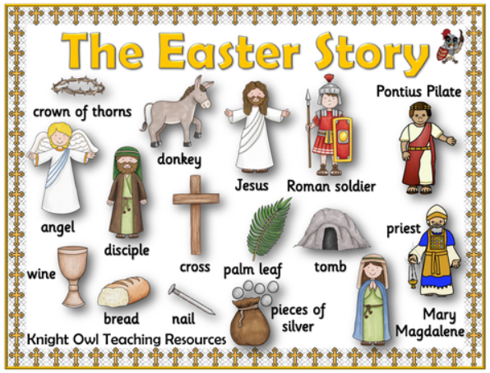 |  | Science/ ICT  Log onto Purple Mash. You will see that I have set you a science activity called ‘All About Seasons’. Write an informative text about everything you have learnt about the four seasons. Don’t forget to submit your work to me to mark.  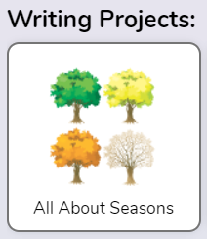
Geography

Discuss the key question How can we improve the school grounds? - create a spider diagram of ideas. Ideas could include planting more flowers, collecting rainwater to reuse for the flowers etc.

Art
Make and label a colour wheel to show what the primary and secondary colours are.
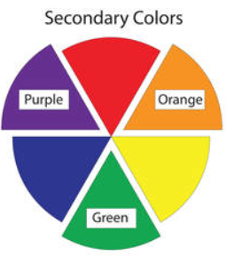
English- GPS
Think of and list:
5 adjectives
5 nouns
5 verbs
5 adverbs
Remember to use your best handwriting.
Geography/ DT

We want to make school more sustainable. Make a bug hotel or a bird feeder for our school grounds. There are lots of ideas on the interent e.g. coating a toilet roll tube in peanut buuter so bird seed sticks to it.

RE- The Big Question:

Why do we dream?
Write what you think in a mind map!

Handwriting
Log onto Letter-join and explore the ‘fun’ section of the website. Your password is stuck in the front of your homework book.

