English  This half term we will continue reading The Owl who was Afraid of the Dark. We will be writing in the role of Plop, the baby owl who is afraid of other nocturnal creatures. We will write a new chapter for the book where Plop is scared of something new. There will also be lots of opportunity for drama and role play.  We will then move on to a Persuasion unit where we will be using specific text type features for a range of audiences and purposes to create a persuasive leaflet on a fictitious bird sanctuary/nature reserve.  Home reading books will continue to be changed on a Monday and a Thursday.  *Please remember to read home reading books three times for fluency.  Our school library day continues to be every Wednesday.  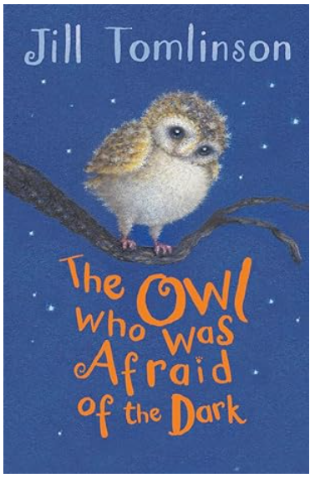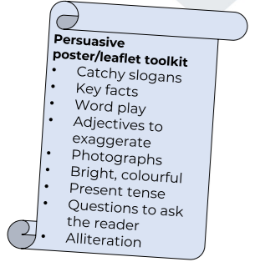 |  | Mathematics  Chapter 7: Temperature  In the temperature chapter we will learn how to read and estimate different temperatures.  Chapter 8: Picture Graphs  This teaches children how to read a selection of picture graphs.  Chapter 9: Word Problems  In this chapter, pupils will be looking at using addition and subtraction to help them solve word problems.  We will also be working through past Maths SATs papers. There are two Maths papers. Paper 1 is arithmetic and Paper 2 is reasoning.

Geography- Improving the sustainability of our school  What can we do to increase the biodiversity in our school grounds? How can we make it better for bees/ birds/ butterflies. Brainstorm ideas. E.g. plant more flowers for the bees and butterflies, hang more bird feeders for the birds, bat boxes, hedgehog boxes, minibeast houses. Can we green the walls? We want to increase the species we see/rewilding. |  | Religious Education  Easter: How do symbols help us to understand the story?  We will learn about how symbols are pictures or objects with a deeper meaning and a story to tell.  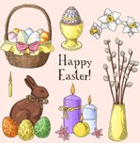 |  | PE  This half term our PE lessons are based around ‘games’. This will include developing our throwing and catching skills such as catching the ball at a low/high level. We will use the skills learnt to play team games. Our other PE lesson will be based on our athletics skills.  PE will continue to be on a Tuesday and a Friday. Please make sure you have the correct PE Kits in School (an indoor kit and an outdoor kit).

Science-Seasonal Changes
In Science we will learn about the seasonal changes and which months are associated with each season.
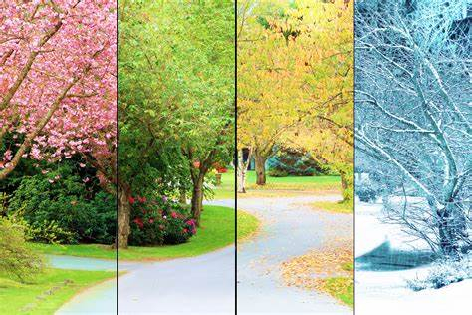
PSHE- Growing and Changing
In PSHE we will be thinking about how we can be a ‘helping hand’ and help others. We will also discuss how they have changed since they were babies. We will learn that we all grow at different rates and we all learn to do things at different times.
Computing - Unit 2.5-Effective Searching (This is a short unit)
These lessons allow the children to develop an understanding of what the Internet is. It will also give them the basic tools to help them search for information more effectively.
We will then move onto Unit 2.6- Creating Pictures- To look at the work of Impressionist artists and recreate them using the Impressionism template.
We will be looking at artists such as Seurat (to recreate pointillist art using the Pointillism template) Piet Mondrian (and recreate it using the Lines template), William Morris (and recreate it using the Patterns template).
Music- Zootime
Art- Our Art will be in the style of the artist Jackson Pollock, an abstract impressionist painter. We will also be learning about the primary and secondary colours.

Vocabulary for Spring 2.
Please take some time to read these key words. They will help your child to understand what we will be learning this term.
design | fabric | model
Spring 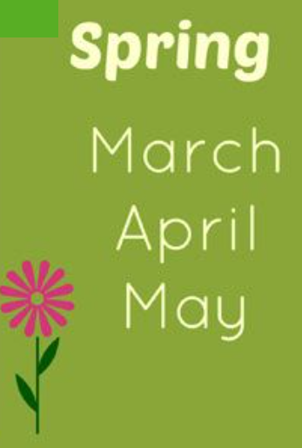 | Summer 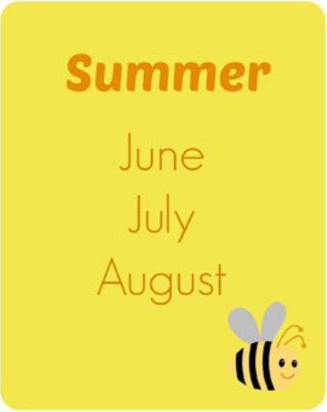 | Autumn 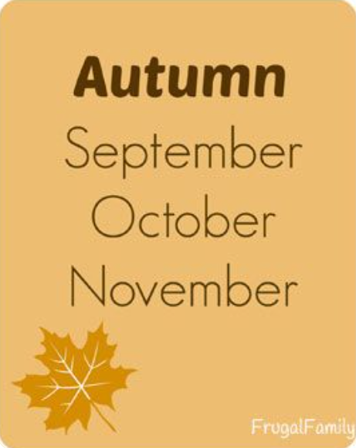
Winter 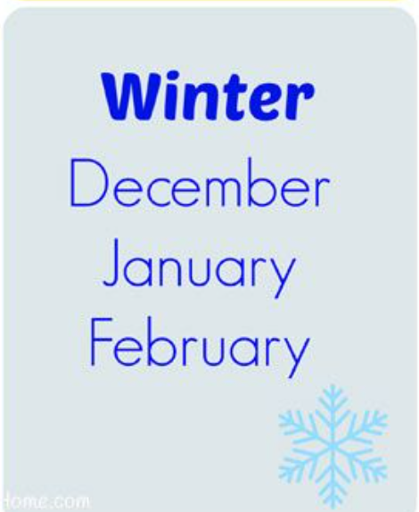 | Jackson Pollock 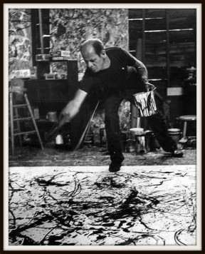 | Primary colours  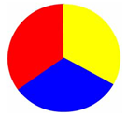
Secondary colours  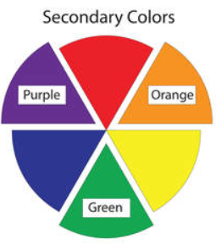 | Growing and Changing  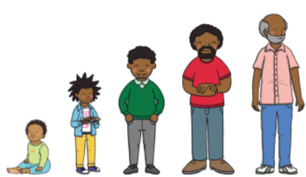 | Sustainability  

