English  In English our new text is Aladdin, (Animated Classics Disney Aladdin text adapted by Lily Murray in 2019).  We will be writing in role as some of the characters such as Aladdin, Jasmine and Jafar. We will write letters, leaflets and also write as though we are on our own magic carpet ride! We will use lots of oral rehearsal and drama to deepen our understanding.  In Grammar, Punctuation and Spelling we will be focusing on noun phrases linked to Aladdin. For example, in the scene where Aladdin parades to the palace there are golden camels, noisy drummers and a giant elephant. We will also be revising suffixes and subordination to join clauses (e.g. because).  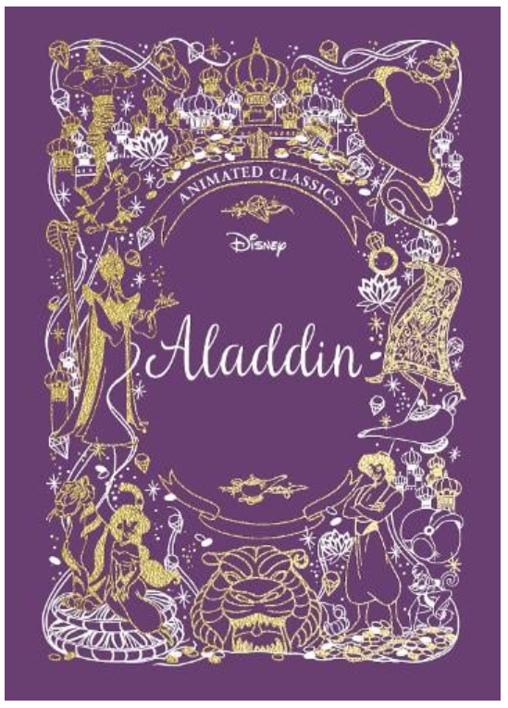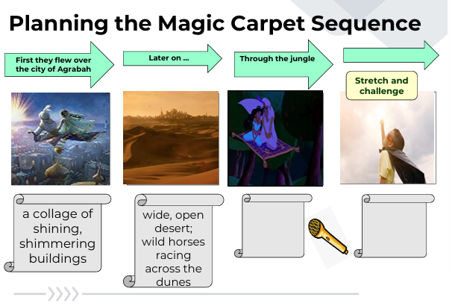 |  |  |  | Mathematics  Chapter 11: 2D shapes  This chapter focuses on 2D shapes and their different properties. It also explores how to draw shapes, make patterns with shapes and turn shapes.  Chapter 12: Three-Dimensional Shapes  In a similar manner to 2D shapes, children will be recognising, describing and grouping 3D shapes, forming structures with them and making patterns using 3D shapes.  Chapter 13: Fractions  We will learn about halves, thirds and quarters comparing and ordering fractions and counting wholes and parts.  Chapter 14: Time  By the end of this unit we will be able to tell time, sequence it and manipulate an analogue clock and finally, compare lengths of time.  Chapter 15: Volume  Volume involves children comparing volume, measuring in litres and millilitres and solving word problems associated with volume.
Science  Plants: Plant Growth  In Science we will be finding out and describing how plants need water, light and a suitable temperature to grow and stay healthy (and how changing these affects the plant). We will also learn that all plants are living and eventually die. |  | Religious Education  Why is the Church a Special Place for Christians?  In our RE lessons we will develop our understanding of ‘church’ as a holy place and a body of people. We will begin to understand what happens in a church and why. We will also be learning about other faiths and their place of worship. We will also be visiting the ‘Jewish Museum and Synagogue’ in Manchester on Wednesday 18th June.  Non-Christian Faith Unit – Places of worship. |  |  |  | PE-  This term we will be developing our striking and fielding and also net and wall ball skills. We will learn to:  - Catch a ball  - Strike a ball  - Throw a ball overarm when fielding  - Explain where the best place to strike a ball is  - Develop our simple tactics  - Encourage our team mates and honesty to keep score  - Listen carefully to instructions
ICT- Creating pictures in the style of different artists using ICT.
Computing – Online Safety and Unit 2.6 where we will be creating pictures in the style of different artists using ICT.

Music – Friendship Song

PSHE- Me and My Relationships

Design and Technology- Food- A Balanced Diet
- As part of our DT work we will be making a healthy wrap. This includes:
- Name the main food groups and identify foods that belong to each group.
- Describing the taste, texture and smell of a given food.
- Thinking of four different wrap ideas, considering flavour combinations.
- Constructing a wrap that meets the design brief and their plan.

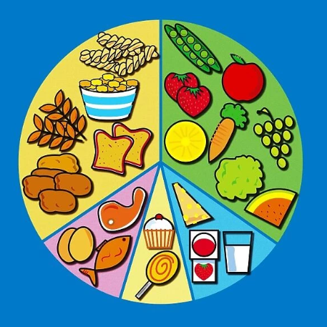

Dates for your diary:
Wednesday 22nd April – Class Assembly at 9am.
Wednesday 20th May- Jewish Museum and Synagogue Trip (Letters will be sent near out WC 27th April).

Vocabulary for Summer 1.

Please take some time to read these key words. They will help your child to understand what we will be learning this term.
carbohydrates  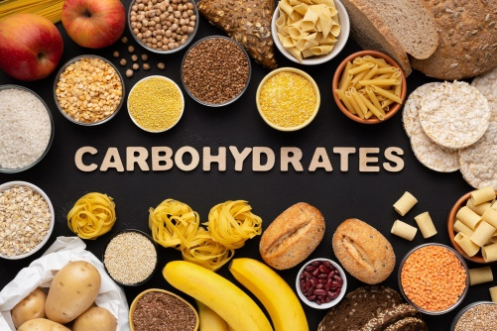 | protein  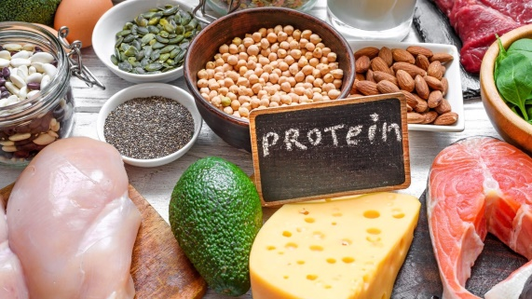 | fruits and vegetables  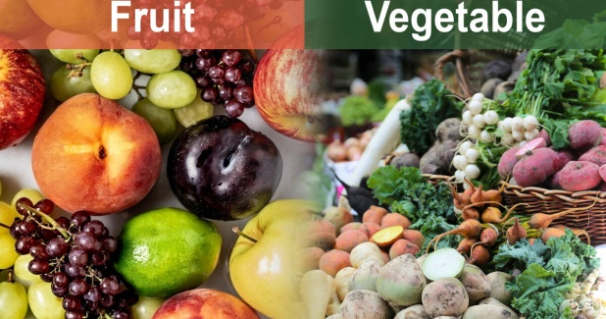
fats and sugars   | dairy  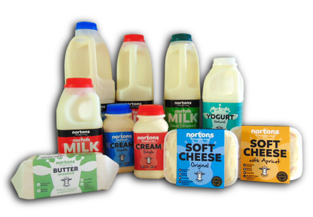 | flavour  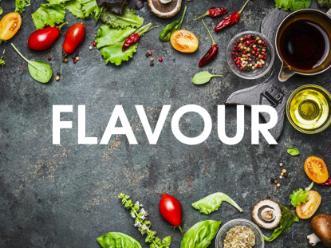
combinations  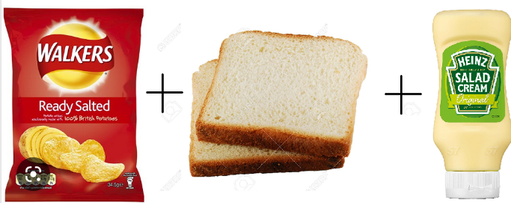 | design brief   | wrap  

