GPS  Write in your neatest handwriting;  - Two sentences which are statements.  - Two sentences which are questions.  - Two sentences which are both exclamations.  - Two sentences which are commands. | Science/ ICT  Log into Purple Mash and complete this cloze activity by dragging and dropping the missing words into the correct places.  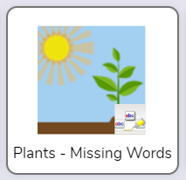 | Maths  - Use only £2 and £1 coins to make £10 and £11.  - Use only 50p, 20p, 10p and 5p to make 40p and 25p.  - Show 72p in three different ways. You can use any coins.
DT- Food *Adult supervision needed.
Have a go at making a healthy wrap/ sandwich at home. Write the ingredients in your homework book and a few sentences to say what you did. Don’t forget to take a photo for your homework book. If you can’t print your photo, email me at r.law@holytrinitycofe.lancs.sch.uk and I will print it for you.
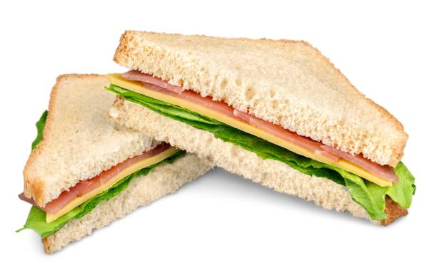
Maths
Draw 5 different patterns. Think about the shapes, sizes and colours. Label the shapes you use. Can you draw any 3D shapes in your pattern?



RE: The Big Question:

What is beauty?

Holy Trinity CE Primary School
Homework grid for Year 2, Summer 1
~ Gallant Growth
Choose any one box per week. Hand your homework book in every Wednesday for marking.
Each week also please try and practice your times tables on TTRS, your handwriting on Letterjoin and don’t forget your EdShed!
RE-
Write 2 lists- one of artefacts you would find in a Church and one of artefacts you would find in a Synagogue. Try and get at least 5 artefacts for each.

Music
Write your own song about ‘Friendship’.
Maybe you are brave enough to sing it to the class?

Science
Draw and label a plant. Then you need to write a definition for each of the following words:
- stem
- flower
- roots
- leaves

GPS
Write 10 sentences using an expanded noun phrase in every sentence.
e.g. The young girl sang loudly.
The friendly teacher talked quietly.
English- GPS
Think of and list:
10 adjectives
10 nouns
10 verbs
10 adverbs

