English  Talk 4 – Climate Change/The Last Bear  Unit 4: Narrative (Days 19-30) continued  Narrative with Poetic Devices  The Black Hat film clip  Guided Reading  Fiction and Non-Fiction books  Grammar, Punctuation & Spelling  - Use commas to mark clauses in complex sentences (using Y3 skill – using a range of conjunctions)  - Explore, identify and use Standard English verb inflections for writing e.g..We were instead of we was. I was instead of I were, I did instead of I done. She saw it instead of she seen it.  - Use paragraphs to organise writing in non-fiction texts.  - Use organisational devices in non-fiction writing, e.g. captions, text boxes.  - Proofread to check for errors in spelling, grammar and punctuation.  Handwriting  - use the diagonal and horizontal strokes that are needed to join letters and understand which letters, when adjacent to one another, are best left un-joined increase the legibility, consistency and quality of their handwriting [for example, by ensuring that the down strokes of letters are parallel and equidistant; that lines of writing are spaced sufficiently so that the ascenders and descenders of letters do not touch]. |  |  |  | Mathematics  Maths No Problem!  Money  Writing Amounts of Money  Comparing Amounts of Money  Rounding Amounts of Money  Solving Problems involving Money  Estimating Amounts of Money  Chapter Consolidation  Length, Mass and Volume  Converting Units of Length  Estimating Length  Converting Units of Mass  Estimating Mass  Converting Units of Volume  Estimating Volume  Comparing and Ordering Measurements  Chapter Consolidation  Area and Perimeter of Figures  Finding Perimeter  Understanding Area  Measuring and Comparing Areas of Figures  Comparing Perimeters and Areas of Figures  Finding Areas of Squares and Rectangles  Chapter Consolidation
Geography – The Water Cycle  - Locational knowledge – We will be locating the numerous rivers in the world and researching where the largest and the smallest are situated.  - Physical geography, including: the water cycle and how this journey takes place along with writing an explanation of our findings.  - Human geography, including: the distribution of natural resources including energy, food, minerals and water. This will include carrying out river studies with the whole class and looking at streams and rivers.  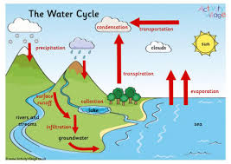  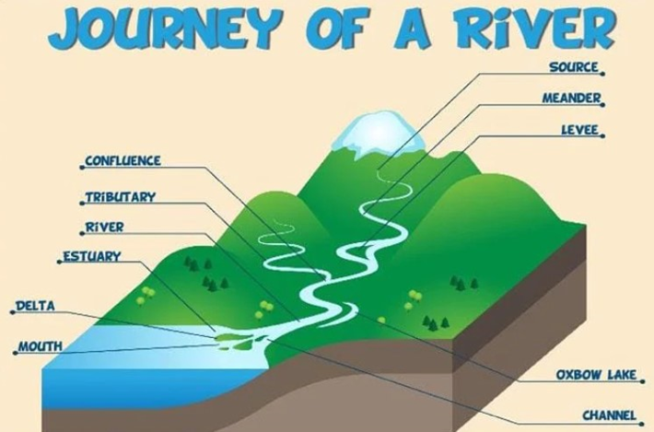     |  | Religious Education  Unit 4.5: Are all churches the same?  - What does ‘church’ mean? Are all churches the same?  - What does it mean to belong to a church?  - What have you learned about the church that you didn’t know before?  - Where do people of other faiths worship? Are they all the same?  - Are there any similarities between places of worship? What are the key differences?  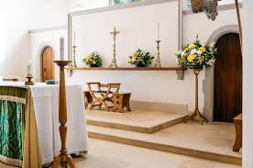 |  |  |  | Science – Living Things & their Habitats  We will be learning to to:  - Explore and use classification keys to help group, identify and name a variety of living things in their local and wider environment.  - Recognise that environments can change and that this can sometimes pose dangers to living things.  - Use and make identification keys for plants and animals.  
Computing – Online Safety & Animation
Music (taught by Mr Fleming from Lancashire Music Service) – Learning how to play the keyboard
PSHE - Me & my Relationships
PE – Striking and Fielding - Cricket & OAA – Trust and Trails.
Spanish – Kapow - Pets!
Design Technology - Cooking & Nutrition – Adapting a Recipe

Below is some key vocabulary that will help your child to understand what we are going to be learning about this half term. Please read the words with your child, find out and talk about what the words mean.
Key Vocabulary for this Half Term
Agriculture | Meander | Run-off | Streams
Precipitation | Evaporation | Condensation | Erosion
Freshwater | River | Tributary | Confluence
Levee | Source | Depth | Breadth

