
Curriculum Overview 2026 Summer 1 Class: Year 1
Holy Trinity CE Primary School Theme: Gallant Growth Teacher: Mrs Scholes/Mrs Knight
‘God saw all that He had made, and it was good’ Genesis Ch 1 v 31
English  Phonics children will use the RWI scheme to develop their  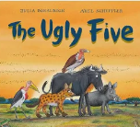  phonetical knowledge.  Talk 1 The Ugly (Big) Five  Children will be using the text The Ugly Five to  write character descriptions, innovate a story,  write a fact file and write a poem.  Reading books will be changed and sent home every Monday and Thursday. Please make sure your child reading books and reading record are in their book bags on these days. |  | Mathematics    In Year 1 we take a practical approach to Maths, with the children having lots of opportunitities to explore number using concrete apparatus before transfering this knowledge to more abstract questioning.  Units covered this term:  Multiplication  Division  Fractions  Number to 100 |  | Science  This term we will be learning about ‘Plants.’  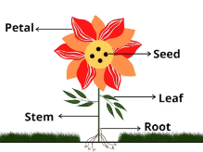  We will be focusing on identifying and naming common wild garden plants including deciduous and evergreen trees. We will begin to describe the basic structure of common flowering plants and trees.
RE  Baptism  1.7 Why is baptism special?  We will be looking at what Baptism is and why people choose to get baptised. We will talk about the differences between infant baptism and adult baptism.  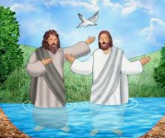 |  | DT  This term we will be designing, making and evaluating a fruit and vegetable smoothie.  The children will look at the benefits of eating 5 portions of fruit and veg a day. They will develop their cutting skills as they prepare the different fruit and veg for the smoothie.     |  | PSHE    We will be developing our understanding of our ‘Me and My Relationships’ we will be looking at:  - Why we have classroom rules  - What it means to be a good listener  - Thinking and naming different feelings  - Recognising that our bodies and feeling  can be hurt  - Discussing what it means to be a good friend
PE  FMS- over arm throw  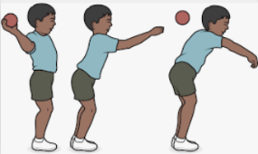 | Computing  Purple Mash – Creating and following instructions    ESafety- Project Evolve |  | Music  We will be completing the Charanga Unit- ‘Your Imagination’- Rehearsing songs to perform. Playing simple instruments.   |  | Geography  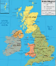  The children will be finding out about the United Kingdom. They will be using maps to locate the different countries that make up the United Kingdom and finding out about physical and human features that are unique to each country.  

plants  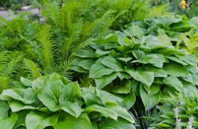 | seeds  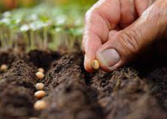 | stem  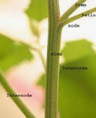
petal  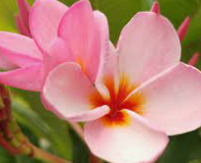 | leaf  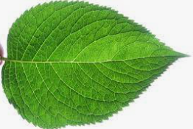 | roots  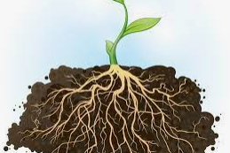
smoothie   | chopping   | bean  

