
Holy Trinity C of E Primary School
Year 1 Homework Grid
Summer Term 1
Phonics Play!  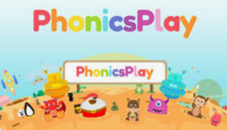  Practise reading words with Phase 4 and Phase 5 sounds on Phonics Play. You can play on Buried Treasure and Picnic or Pluto for free! To be completed at least once a week throughout this half term.  https://www.phonicsplay.co.uk/ | Spelling Shed    You will find your child’s login detail inside the front cover of their homework book.  e.g Username:  Password:  Weekly spelling activities will be set for your child. Attempt a few words from the list each day  https://www.spellingshed.com/en-gb/ | Maths  The children have been practicing their 2x, 5x and 10x tables in school. Challenge them to remember these fact by playing these games. Scan the QR code to access ‘Mental Maths Train’. To be completed at least once a week throughout this half term.      https://www.topmarks.co.uk/
English- Words in a word  Make as many smaller words as you can from the word:  The Ugly Five  e.g. glee, he,  What is the longest word you can make? | Geography  Make a fact file for 1 of the four countries in the UK.  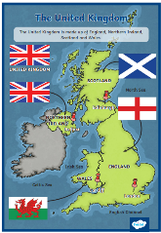  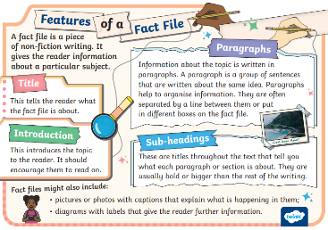 | DT  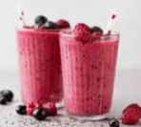  This term we will be designing, making and evaluating a fruit and vegetable smoothie. Try making your own smoothie at home using different fruits /vegetables that you might not have tried before. Remember o send a photograph of your smoothie to… mrsscholes@holytrinity.cofe.lancs.sch.uk  Don’t forget to help with the washing up!
Science  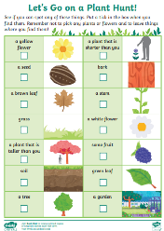  We will be learning about ‘Plants this half term. Why not go on a plant scavenger hunt in your garden or local park. See how many of the plants listed you can find. | PE  We have been developing our throwing and catching techniques our PR lessons. Practice your skills at home using these activity cards.  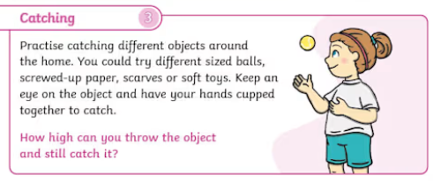 | PHSE No. 38 Bring up a butterfly  Watching a wriggly caterpillar turn into a magnificent butterfly is fun.  https://www.nationaltrust.org.uk/visit/50-things/no.-38-bring-up-a-butterfly  No one will protect what they don’t care about,  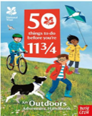  and no one will care about what they have never experienced.'  - Sir David Attenborough

