
Holy Trinity C of E Primary School
Year 1 Homework Grid
Spring Term 2
Phonics Play!    Practise reading words with Phase 4 and Phase 5 sounds on Phonics Play. You can play on Buried Treasure and Picnic or Pluto for free! To be completed at least once a week throughout this half term.  https://www.phonicsplay.co.uk/ | Spelling Shed    You will find your child’s login detail inside the front cover of their homework book.  e.g Username:  Password:  Weekly spelling activities will be set for your child. Attempt a few words from the list each day  https://www.spellingshed.com/en-gb/ | Maths    Scan the QR code to access ‘Caterpillar Ordering’. To be completed at least once a week throughout this half term.    https://www.topmarks.co.uk/
English- Words in a word  Make as many smaller words as you can from the word:  Exploration  e.g. rat, note  What is the longest word you can make? | Geography  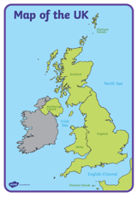  Make your own map of the UK and your own weather symbols. Role play being a weather reporter. Ask an adult to record your weather report and send it to:  mrsscholes@holytrinitycofe.lancs.sch.uk  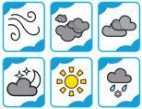  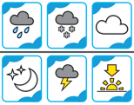 | Art  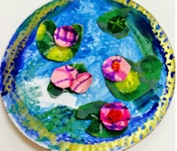  We will be studying the artist Monet in our Art lessons. He was famous for producing a piece of artwork called ‘Waterlilies.’ Try creating your own version of ‘Waterlilies’. Your child can use any media they wish e.g. felt tips, crayons, wax crayons, paint, craft material.
Science  We will be learning about ‘Animals including humans. We will be learning about the human body and learning more about our 5 senses.  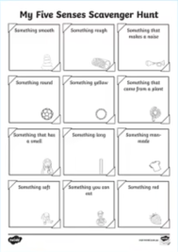  Complete the Five senses scavenger hunt worksheet that has been stuck in this book. | 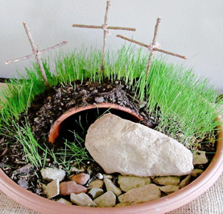  RE:  Design and make an Easter Garden.  Remember to include:  - the tomb  - the rock to roll away  - the cloth that Jesus’ body was wrapped in  - a cross. | 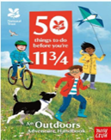  PHSE No. 43 Help a wild animal  No one will protect what they don’t care about, and no one will care about what they have never experienced.'  - Sir David Attenborough  In spring, collect things that birds can use to make a nest. Natural wool, twine and twigs all make excellent building materials. Leave your collection in the garden and check back on it a week later – have any of the materials gone?  https://www.nationaltrust.org.uk/visit/50-things/no.-43-help-a-wild-animal

