
Curriculum Overview 2026 Spring 2 Class: Year 1
Holy Trinity CE Primary School Theme: Exciting Exploration Teacher: Mrs Scholes/Mrs Knight
‘God saw all that He had made, and it was good’ Genesis Ch 1 v 31
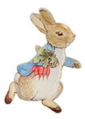  English  Phonics children will use the RWI scheme to develop their phonetical knowledge.  Talk 1 Peter Rabbit  Children will be using the text Peter Rabbit to write their own adventure stories with familiar characters and plot lines.  Reading books will be changed and sent home every Monday and Thursday. Please make sure your child's reading books and reading record are in their book bags on these days. |  | Mathematics  In Year 1 we take a practical approach to Maths, with the children having lots of opportunitities to explore number using concrete apparatus before transfering this knowledge to more abstract questioning.  Units covered this term:  Addition and subtraction word problems    Multiplication   |  | Science  This term we will be learning about ‘Animals including humans. We will be learning about the human body and learning more about our 5 senses. We will also talk about what we can do to look after our bodies and minds to keep these healthy.  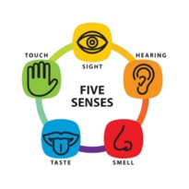
RE  Jesus Unit 1.5 Easter- Celebrating new life  In this unit of work, we will be thinking about the Easter story and the sacrifice that Jesus made when he died on the cross. We will think about feeling linked to loss. We will talk about life cycles and why Christians believe that Easter is a new beginning.   |  | Art  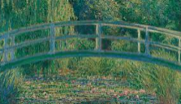  This term we will be exploring the skill of printing as part of our class work. We will be finding out about the famous artist Monet. We will try to replicate one of his paintings using a variety of printing techniques. |  | Geography  We will be thinking about the following questions in our Geography lessons this term:  - What is your favourite place in the school grounds?  - Does it change throughout the school year?  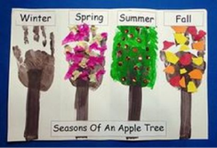  We will be exploring what a map is and how they can be used. We will be weather reporters, creating our own weather symbols and thinking about how the season change how our school looks throughout the year.
PE  Dance- Pirates   | Computing  Purple Mash  Data Explorers   |  | Music  We will be completing the Charanga Unit- ‘Round and Round’- Rehearsing songs to perform. Playing simple instruments.   |  | PSHE  We will be developing our understanding of our ‘Growing and changing’. We will talk about how humans change over time from being a small baby to being a fully grown adult.  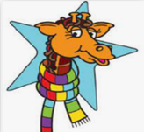
Senses   | Human  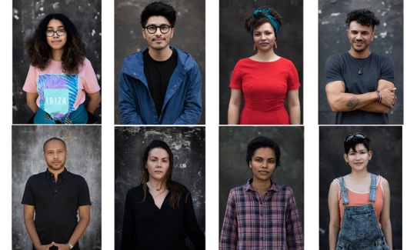 | Balanced diet  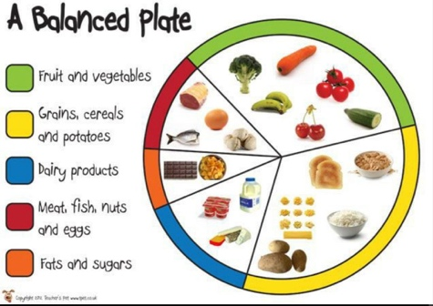
Monet  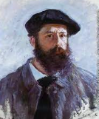 | Printing  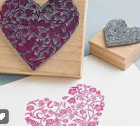 | Waterlilies  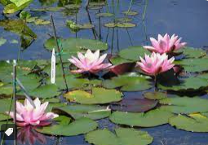
Map  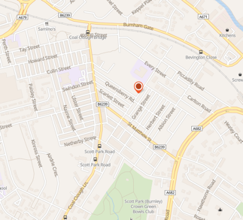 | 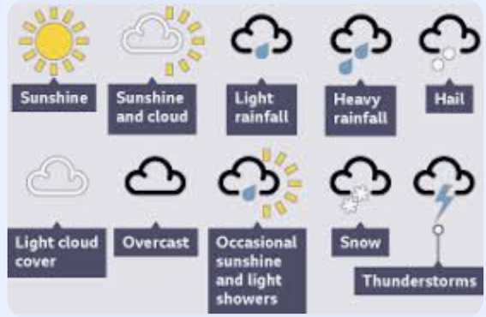  Weather symbols | 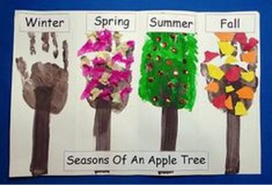  Seasons

