English – Persuasion  This term in English, we will be exploring powerful speeches by influential figures such as Martin Luther King Jr. and Greta Thunberg. We will compare how these speakers communicate their ideas and inspire others. As part of our grammar focus, we will learn about degrees of possibility and practise using modal verbs such as, might, could, must, and can’t. The children will also take part in debates about important topics, including discussions about how much gaming time children should be allowed, helping them to develop their speaking, listening, and reasoning skills.   |  | 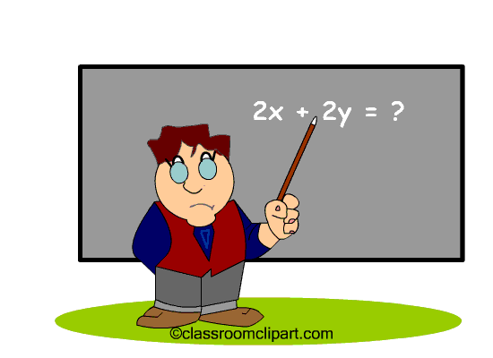 In Maths this term, the children will be learning about measure. They will develop a deeper understanding of Area and Perimeter, including rectilinear shapes. They will also learn how to plot points on a quadrant and find the value using coordinates. They will learn how to reflect and translate shapes within the quadrant.  The children will continue having 5-minute arithmetic questions, which is really helping with their mental maths ability. They will continue to use TT Rockstars as part of their homework and in school.
Science –  We will be researching different life cycles including the human life cycle. The children will be able to describe the differences in the life cycles of a mammal, an amphibian, insect, bird and reptile. They will use scientific vocabulary to describe different parts of the life cycle. |  | Religious Education ‘LIFE IN ALL ITS FULLNESS’ JOHN 10 V 10 Class bible verse – Luke, chapter 4 verse 4 – ‘Jesus said that man shall not live by bread alone, but by every word of God.’    The pupils will learn how the news of Jesus’ resurrection spread around the world. They will understand what happened after Pentecost. They will learn about the mission of Paul and the letters that he wrote. We will explore the journey that Paul went on to spread the word of Jesus. |  | PE  This term, striking and fielding will be the topic for PE. The children will begin with throwing and catching activities. They will be playing cricket and learn new ways of hitting the ball, in order to score runs.  
Geography . The children will be able to locate countries and cities of North America. They will be thinking about the question, How is the distribution of minerals in the UK, different to N America? |  | Design Technology - The children will enjoy cooking and preparing a traditional bolognaise sauce. They will develop an understanding of nutritional value and the importance of including the correct vitamins and minerals into their diet. |  | Computing – 3D Design. The pupils will adapt a 2D image in order to make it into a 3D image. They will use tools to make a car move and will change and edit their designs.

Vocabulary for Summer
Below is some key vocabulary that will help your child to understand what we are going to be learning about this half term. Please read the words with your child and talk about what the words mean.

Galant Growth – Summer 1

Habitat 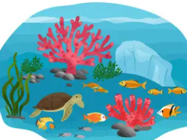 | Life Cycle | 3-dimensional | Martin Luther King
Amphibian 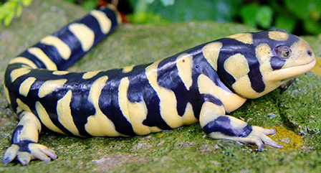 | Mission | Bolognaise | North America
States | Pentecost  | Mediterranean | Greta Thunberg  

