
Curriculum Overview 2025/26 Summer 1 Year: 3

Holy Trinity CE Primary School Theme: Gallant Growth Teacher: Mrs G Scholes

Our Class Bible verse is: Do to others what you want them to do to you.
English:

During this half term, we will be continuing to learn about The Stone Age in our English lessons. Our focus this term will be on narrative writing and our core text is The Golden Eagle, which is a Stone Age story set during Neolithic Britain. This unit will give the children a chance to explore this story in depth and help them to be inspired to write their own version of the story.
There will also be a focus on grammar and punctuation as we explore and learn how to use new skills in our writing!

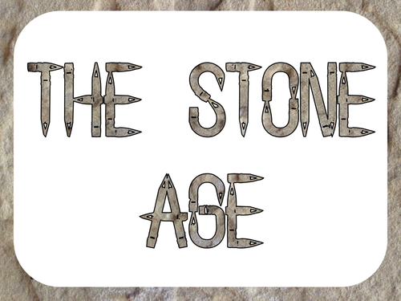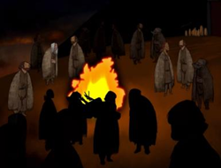

Maths:

We are continuing to use the scheme Maths No Problem for our Maths learning.
Throughout this half term, we will be looking at:
- Continuing to explore telling the time and exploring duration.
- Drawing and reading bar graphs and pictograms.
- Learning how to add, subtract, compare and order fractions.

In addition to this, there will be a continued focus on the development of multiplication tables.


Science: Functions of a Plant

During this unit, we will be learning about the functions of a plant. There will be opportunities to identify, locate and describe the functions of different parts of flowering plants and explore the requirements of plants for growth. We will also be investigating the way in which water is transported within plants and exploring the part that flowers play in the life cycle of flowering plants.

Topics

PSHE: Me & My Relationships

Design & Technology:
Food – Eating Seasonally

Geography: North West – Lake District including Lakes, Mountains and Hills

Computing: Simulations and Graphing

Spanish: Where do you live in Spain?

PE:

This half term in P.E., we will be exploring the skills needed for orienteering. We will be working on how to set clear instructions and following them accurately, as well as building trust and team working skills whilst working in groups.
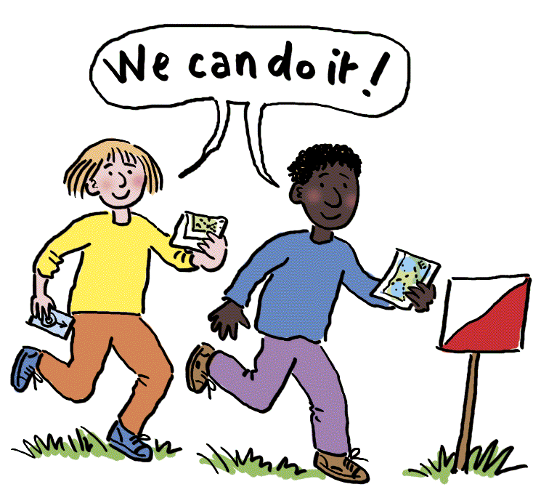
Religious Education: Which rules should we follow?

During this R.E. unit, the following will be explored:
- What are rules?
- Why do we have rules?
- Who makes the rules?
- Who keeps the rules?
- Is there a difference between rules and laws?
- Who makes the law?
- What would happen if there were no rules/laws?
- Are the ten commandments still as relevant today? Why? Why not?
- Why did Jesus bring a new commandment?
- Why do religions have rules?

Key Vocabulary
fraction 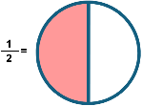 | graph 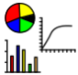 | seasonal 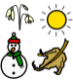
rule  | law  | nutrients 
pollination  | roots  | relationship 
growth  | duration  | function 
Vocabulary for Summer 1

Here is some key vocabulary that will help your child to understand what we are going to be learning about this half term.
Please read the words with your child and talk about what they mean.

