English  In English we will continue with our topic of Aladdin. We will focus on words of interest that we can ‘magpie’ to improve our own writing such as ‘a place of beauty and abundance….’ We will aim to build our writing stamina as the children prepare for Year 3 by writing for different reasons such as a persuasive letter in role as Jafar, pleading to be released from the lamp and a postcard from the Genie to Aladdin, sharing news of recent sights and adventures.  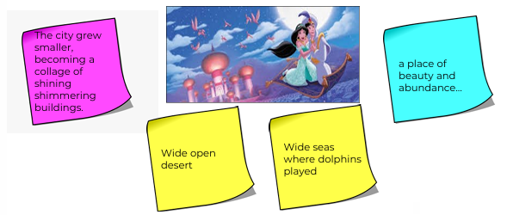 |  |  |  | Mathematics  Chapter 13 - Fractions  We will learn about halves, thirds and quarters comparing and ordering fractions and counting wholes and parts.  Chapter 14 - Time  By the end of this unit, we will be able to tell time, sequence it and manipulate an analogue clock and finally, compare lengths of time.  Chapter 15 - Volume  Volume involves pupils comparing volume, measuring in litres and millilitres and solving word problems associated with volume.  We will then consolidate everything we have learnt over the past year.  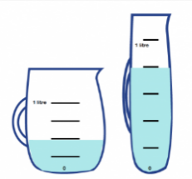
Science ~ Health  This term we will be learning about human health through exercise, a balance of food types and hygiene. We will also learn how medicines can make us feel better when we are ill and how medicines can be harmful when not used properly.  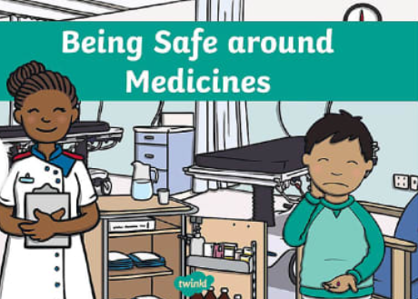 |  | Religious Education  Unit: 2.6 What happened at the Ascension and Pentecost?  In RE lessons, we will begin to develop the children’s knowledge and understanding of these two very significant events. We will learn how Christians believe that 40 days after the resurrection Jesus ascended into heaven. We will give children an opportunity to begin to explore the concept of God as three in one (Father, Son and Holy Spirit). |  |  |  | PE- Athletics and Fundamental Movements  This term we will be orienteering around the school grounds. This involves; recording answers on a control card, sharing ideas and agreeing on a plan, recalling with accuracy what they observed on a trail and finally being able to work successfully with a partner.  There will also be an end of KS1 assessment on the 10 fundamentals. These include bouncing a ball, catching, hopping, jumping, kicking a ball, overarm throw, rolling a ball, running fast, skipping and underarm throw).  We also hope to have a ‘Sports Day’, and we will keep you updated on this.  *Our PE day continues to be Tuesday and Friday.

Computing –Our ICT unit is called ‘Unit 2.8, Presenting Ideas’.
We will be learning how to present information in different ways such as a quiz, a presentation and a non-fiction fact file.

History- The Great Fire of London
In History we will be finding out about the causes of the Great Fire of London. We will develop our historical enquiry skills finding out about the past through artefacts, books and the internet. The question we will focus on will be ‘What features of London, a long time ago, might have helped cause the Great Fire of London?’

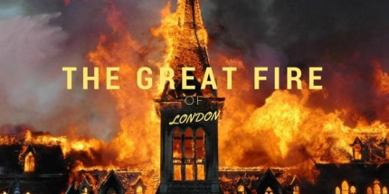
Art
In Art we will be using the malleable material of clay. We will begin by learning techniques to join pieces of clay together including a technique called ‘score and slip’ in order to make a clay pinch pot and also a textured tile their face.
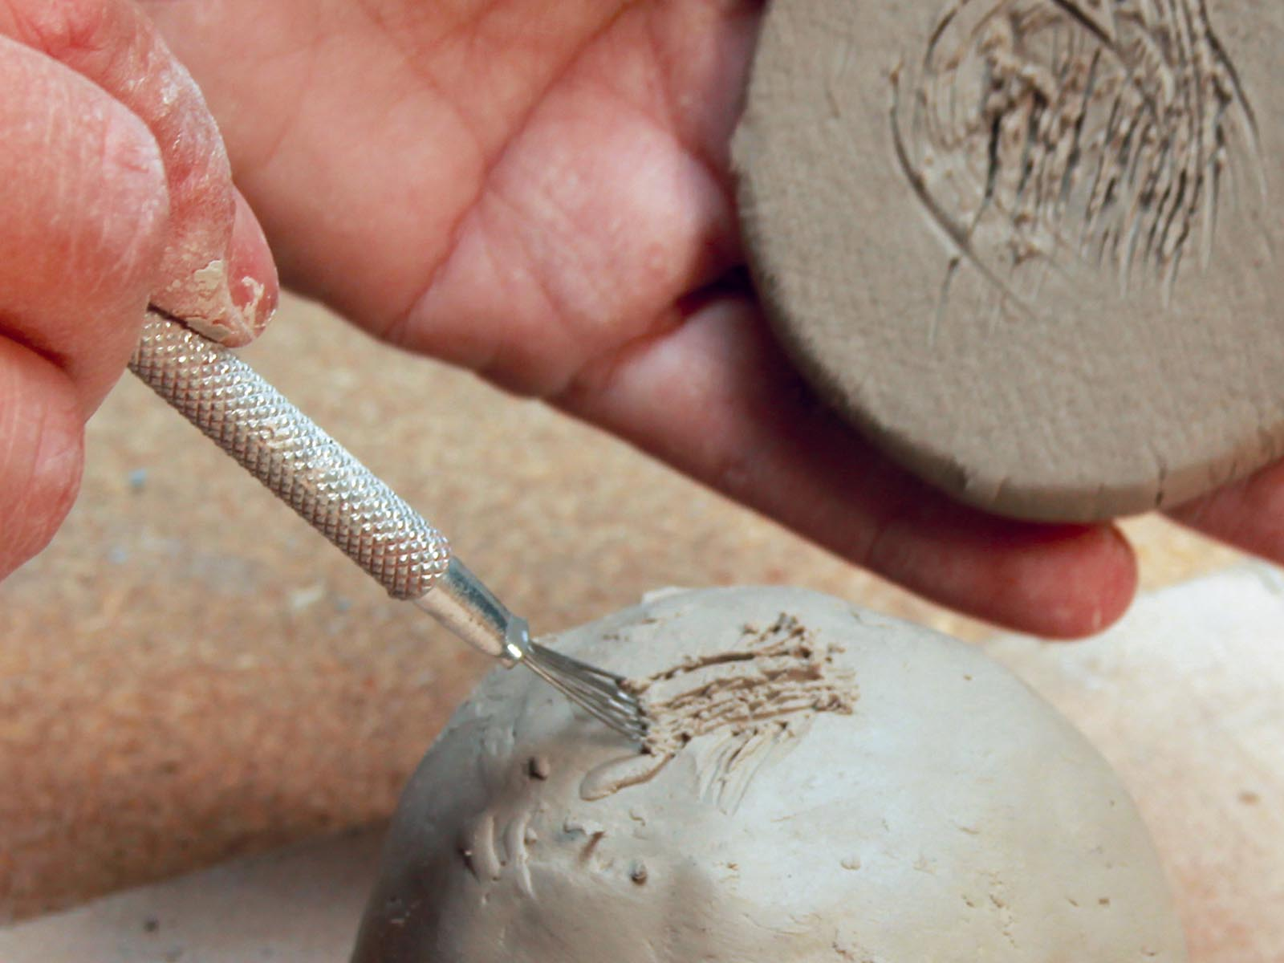

Music – Reflect, Rewind and Replay (Review)

PSHE- Keeping Safe (Taught by Miss Reid).

Vocabulary for Summer 2

Please take some time to read these key words. They will help your child to understand what we will be learning this term.
Fire  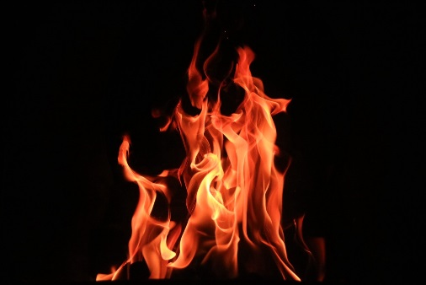 | King Charles II  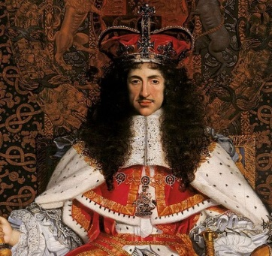 | Samuel Pepys  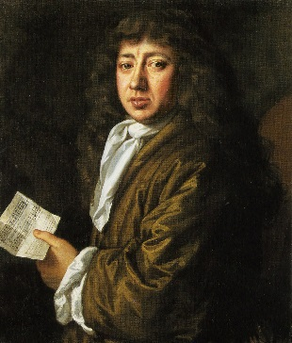
Bakers  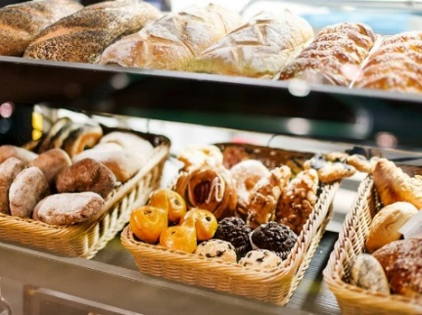 | Ascension  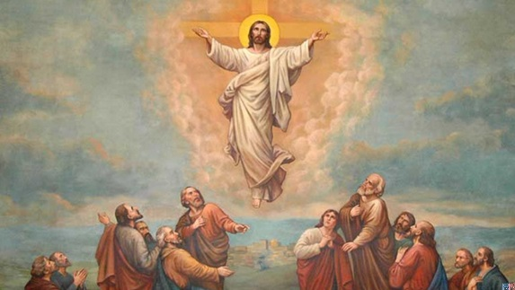 | Pentecost  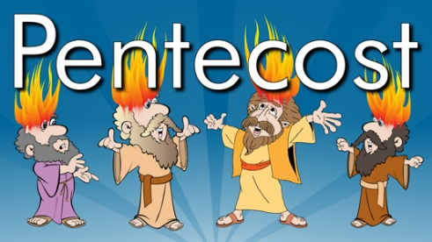
Trinity  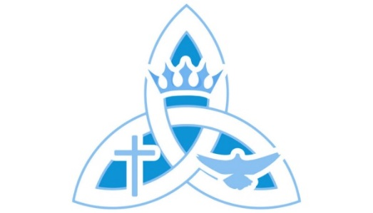 | Ascended  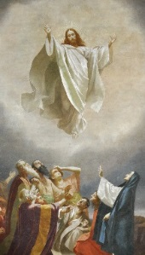 | Heaven  

