History  Write about 3 of the causes of the Great Fire of London in detail.  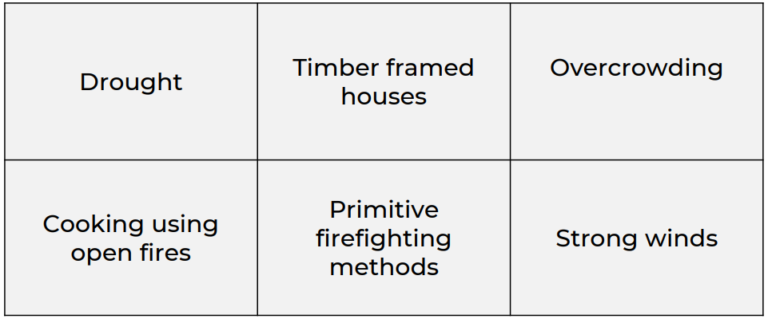 | Maths  Complete the time activity which has been set on Purple Mash.   | English  Write a diary entry in role as Jasmine or Aladdin. What have you done today? Did you go to the bustling market? Did you fly on the magic carpet?  
GPS- Contractions
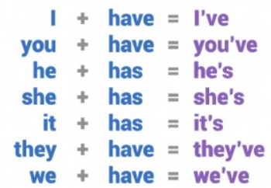

Think of 10 contractions and write them into your own sentences, e.g.
Well done that’s super work; I’ll get you a sticker.
That is= that’s
I will= I’ll

Holy Trinity CE Primary School
Homework grid for Year 2, Summer 2
~ God’s Wonderful World
Choose any one box per week and complete the English, Maths or Topic homework. Hand your homework book in every Wednesday for marking.
English

Write a description of one of the characters from the story Aladdin. Remember to use lots of noun phrases.

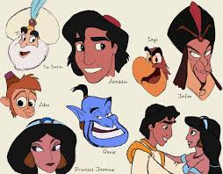

RE: The Big Question~

What will happen at the end of the world?

Write down your ideas!

Science  Create a poster explaining that medicine is a type of drug, it should be clearly labelled, stored on a high shelf, be given by a trusted adult who must always read the instructions before administering the medicine.  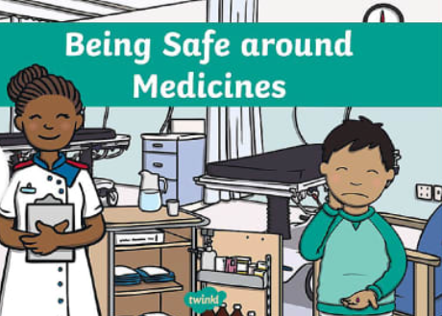 |  | History  Create an information poster or a quiz about the ‘Great Fire of London’.  Think about questions such as ‘When did the Great Fire of London start?’  ‘The fire started in what kind of shop?’  ‘Why did the fire spread so quickly?’  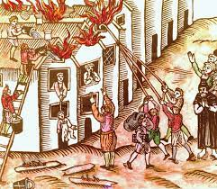
RE~ Pentecost

Draw and write about the symbols of the Holy Spirit.

