English - In English, we will be looking at the poem Jaberwocky. The children will develop an understanding of the unusual vocabulary and its meaning. They will create a story map to help them understand the sequence of the story. There will be opportunities for the children to change the plot and create a different ending to the original version. Grammar will continue, this will be woven through their topic and as a daily starter.  Guided reading – This will continue as a daily activity, including comprehension activities. The children will complete reading and daily tasks, which will help to embed their understanding of the text.  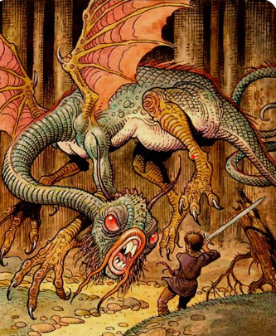 |  | Mathematics  The pupils will continue their topic about Area and Perimeter. They will then move on to Volume and their final topic for the year, will be Roman Numerals.  The pupils will continue their Daily 5 mental maths challenges, which will improve their general Math’s ability.  TT Rockstars will be how the children learn their times tables and this will continue. throughout school  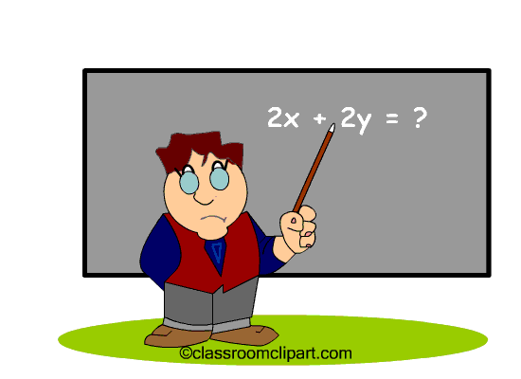

Science  The children will learn that you can plant seeds, tubers, root cuttings and bulbs, in order to grow plants. They will develop an understanding of pollination and how this occurs.  They will be able to name, locate and describe the functions of the main parts of reproductive system of plants (stigma, stamen, petal, sepal, pollen, ovary).  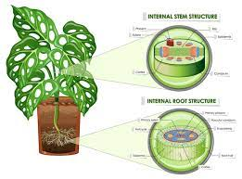 |  | Religious Education  This term the pupils will learn more about the women in the bible. What some of them went through and Why? How they would feel in the same situation? What would they do? We will cover the Christian values: wisdom; justice and perseverance.  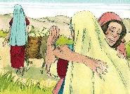 |  | PE  Athletics will be the topic this term. Year 5 will be learning how to throw the javelin, short and long running races and long jump.  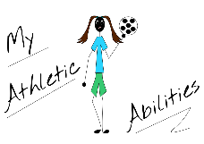

History – Crime and Punishment in the local area will be our topic this term. The pupils will see the extreme punishments that were given to children, who committed petty crimes. | Art - We will be using clay to create a design for Incarnation connected to God’s Big Story. They will learn lots of techniques including, slab, slip and coil. | Spanish- The children will continue learning Spanish this term. The topic will be Food and Drink.

KEY STAGE 2
Vocabulary for Summer 2
Below is some key vocabulary that will help your child to understand what we are going to be learning about this half term. Please read the words with your child and talk about what the words mean.

Crime   | Punishment   | Treadmill  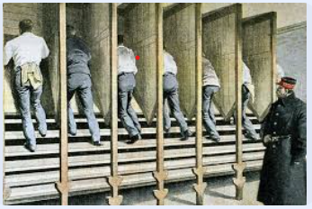
Pollination  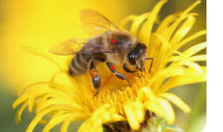 | Reproduction  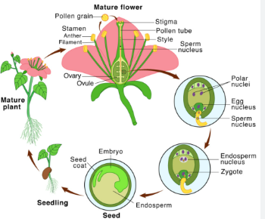 | Dispersal  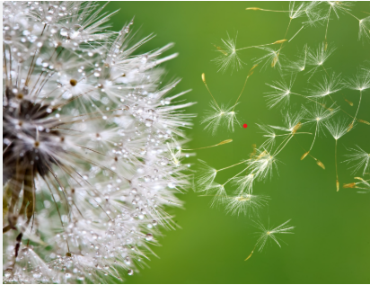
Victorian  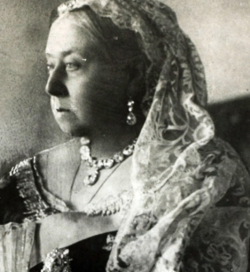 | Plantlet  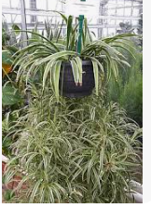 | Sculpture  

