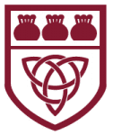
Curriculum Overview 2025/26 Summer 2 Year: 3

Holy Trinity CE Primary School Theme: Gallant Growth Teacher: Mrs G Scholes

Our Class Bible verse is: Do to others what you want them to do to you.

Maths:
We are continuing to use our scheme in mathematics called Maths No Problem.
Throughout this half term, we will be looking at:
- Learning how to add, subtract, compare and order fractions.
- Exploring angles, lines and shapes.
- Measuring and calculating perimeter.
In addition, there will be a continued focus on the development of multiplication tables through consistent practice.

English:
During English this half term, we will be focusing on a poem by Mary Howitt called The Spider and The Fly. We will explore a range of grammar skills with an aim of writing a narrative including the grammar we have focused on throughout Year 3. This unit also provides an opportunity for the children to explore and learn from informational non-fiction texts. This helps develop writing skills across a variety of styles of text. There will be some exciting writing opportunities throughout the unit, allowing the children to use the new vocabulary they have learnt.
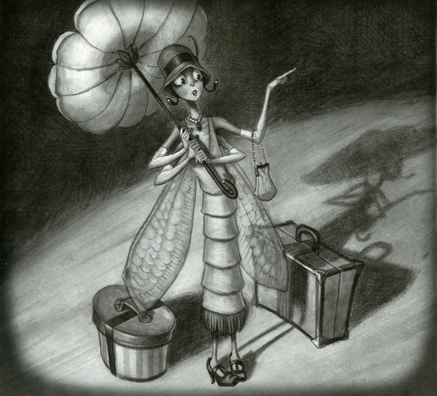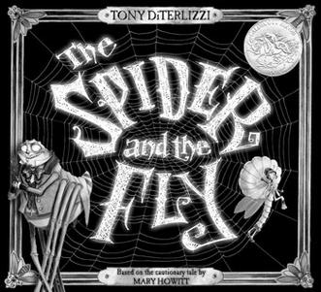

Science:
In our Science learning this half term, we are focusing on healthy bodies. We will be learning about the importance of nutrition and a balanced diet, as well as regular exercise and how this effects our bodies in a positive way.
We will also be exploring the nutritional needs of animals.



Topics

PSHE: Keeping Safe

Art: 3D Design

Computing: Graphing/Simulations

History: Stone Age to Iron Age

Spanish: Where do you live in Spain?

PE: Striking, fielding and athletics
In our P.E. learning this half term, we will be using our throwing and catching skills to develop our fielding skills. There will also be a focus on striking and athletics.
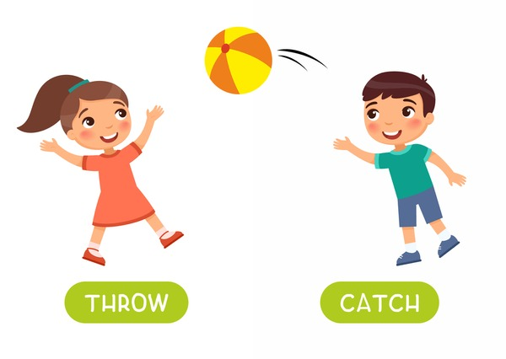
Religious Education: Which rules should we follow?

During this R.E. unit, the following will be explored:
- What are rules?
- Why do we have rules?
- Who makes the rules?
- Who keeps the rules?
- Is there a difference between rules and laws?
- Who makes the law?
- What would happen if there were no rules/laws?
- Are the ten commandments still as relevant today? Why? Why not?
- Why did Jesus bring a new commandment?
- Why do religions have rules?

Key Vocabulary
fraction 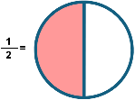 | perimeter  | 3D 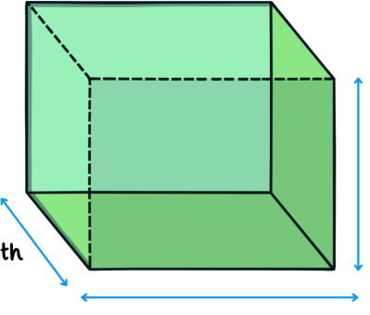
rule  | law  | nutrients 
healthy 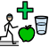 | religion 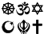 | safe 
angles 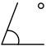 | Gospel  | unsafe
Vocabulary for Summer 2

Here is some key vocabulary that will help your child to understand what we are going to be learning about this half term.
Please read the words with your child and talk about what they mean.

