Holy Trinity CE Primary School
School Uniform and Jewellery Policy

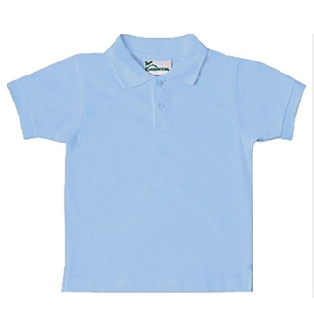
Wearing the correct uniform is extremely important. It fosters as sense of belonging, equality and team spirit. At Holy Trinity, we feel very strongly that if children look and feel smart, they achieve better and respond to higher expectations. It is our policy at School if children do not come wearing the correct uniform they will be given spare uniform to change in to.

Boys (Required)
Burgundy Holy Trinity badged sweatshirt
Pale blue polo shirt (formal school shirts are not allowed)
Dark grey school trousers (jogging bottoms or black trousers are not allowed)
Grey or black socks
Black school shoes (no trainers)
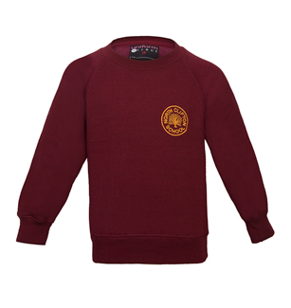
Summer Term (Optional)
There will be an option for boys to wear dark grey (charcoal) school shorts with dark grey socks.

Girls (Required)
Burgundy Holy Trinity badged sweatshirt or cardigan
Pale blue polo shirt (formal school shirts are not allowed)
Dark grey (charcoal) school skirt, pinafore or school trousers (fashion style trousers and jogging bottoms are not acceptable)
Knee length dark grey school socks or dark grey tights (no coloured socks or tights
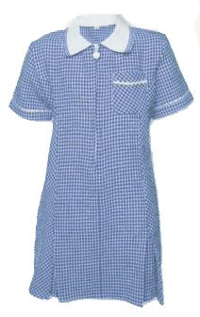
allowed)
Black School shoes (no trainers)

Summer Term (Optional)
There will be an option for girls to wear a pale blue checked dress (other colours are not permitted). If girls are wearing a Summer dress they can wear white or grey socks.

PE kit (Boys and girls) (Required)
Plain white polo shirt
Black shorts
Black slip on pumps
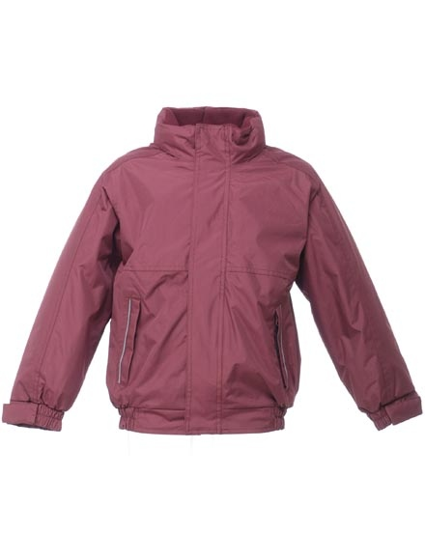
Additional Reading bags with straps are available from Moonline, Standish Street, Burnley at a cost of £7.00 each.

Trainers are not an acceptable item of our School uniform, if children come to School wearing them they will be asked to change in to their black PE pumps and if these are not in School you will be contacted and asked to bring their shoes to School.

Earrings and facial jewellery are not allowed for health and safety reasons (this applies to both girls and boys). If you are thinking of getting your child’s ears pierced please do this at the start of the Summer break so that they have time to settle down and they not be at risk at healing up when we return to School in September. The only item of permitted jewellery will be a small watch.

We ask that all children with hair longer than shoulder length have it tied up for School at all times, this is to avoid the spread of head lice.
Boys should not have any patterns cut into their hair and extreme haircuts or any hair colour is not allowed.

Thank you for support in this important matter. Please contact us at the school office if you need any further assistance.

Uniform can be purchased from:

Moonline Uniforms

33/37 Standish Street, Burnley BB11 1AP ·

01282 423030

Second Hand Items of uniform are available free of charge in our main school entrance.

