English  In English lessons we will be reading the book called ‘Way Home for Wilf’ by Rachel Bright which is a story all about friendship. We will use this text to help us do lots of short writing activities such as a character profile, a page for an information book and a poster.  Our English lessons will also include a daily Grammar lesson. Here we will revisit Year 1 objectives before moving onto Year 2 Grammar skills:  -Make singular nouns plural using ‘s’ and ‘es’ e.g. dog, dogs; wish, wishes. (Y1)  -Identify and use question marks and exclamation marks. (Y1)  -Use commas to separate items in a list. (Y2)  -Secure the use of full stops, capital letters, exclamation marks and question marks. (Y2)  -Say, write and punctuate simple and compound sentences using the joining words and, but, so and or (co-ordination). (Y2)  Our home reading books are changed every Monday and Thursday. We ask that you read the home reading books 3 times to help increase your child’s fluency.  Our class library day is every Wednesday. |  | Mathematics- MNP (Maths No Problem)  Chapter 1: Counting to 100 including; counting to 100 using concrete objects. Counting in ones and tens, forwards and backwards.  Chapter 2: Addition and subtraction using number bond diagrams as well as the standard column method.  Chapter 3: Multiplication of 2, 5 and 10 including; multiplying by 2, 5 and 10. The children will have opportunity to look for the patterns in multiplication and fully understand what the term ‘multiplication’ means.  Chapter 4: Multiplication and division of 2, 5 and 10 including looking at different ways of sharing and grouping before investigating the links between multiplication and division and odd and even numbers.
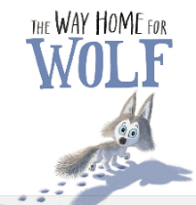
Science  Animals Survival and Growth  This term we will be learning about animals and their offspring. We will investigate if all animals look like their parents or if they change as they grow (metamorphosis). We will also be finding out the basic needs of animals for survival (water, food and air).  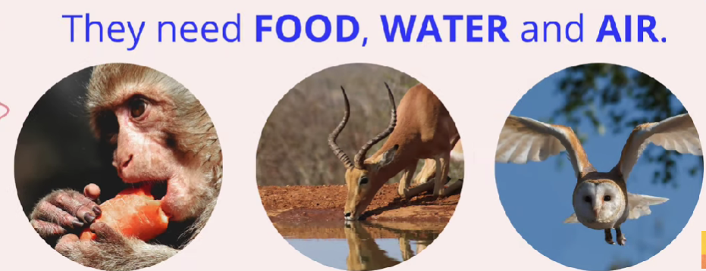 |  | Religious Education  The Bible – Why is it such a special book?  Do people of other faiths have holy books?  In RE we will be widening the children’s understanding of the Bible, its contents, presentation and its importance to Christians. We will also be beginning to develop children’s understanding of holy books from faiths other than Christianity and their significance in the lives of believers.  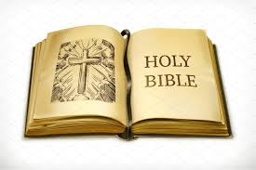 |  | PE with Mr. Little is every Tuesday and Friday.  In PE we will be developing our accuracy in our overarm and underarm throwing skills. Mr Little will be teaching the children simple tactics to outwit an opponent and skills to develop their determination and concentration.  Please ensure PE kits are in school and that each item of the PE kit is clearly labelled with your child’s name.  Thank you.
History – This term, as part of our school topic ‘Colourful Characters’ we will be looking at the lives of significant people who have contributed to national and international achievements. We will be studying the lives of Florence Nightingale (1820- 1910) and Mary Seacole (1805-1881) who made a significant improvement to hospitals and were both inspirational nurses.
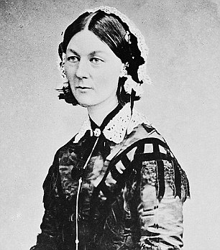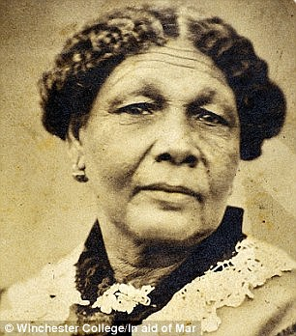
Art – In Art we will be building up to draw a portrait of Florence Nightingale. We will begin by exploring different media for drawing such as ballpoints, chalk, charcoal, crayon, pencils and pastels. We will also learn about textures and tones (through pattern and shapes).
Music– This term one of the songs we are learning to sing is called ‘Hands, Feet, Heart’ by Joanna Mangona.
Computing – Coding
We will be using Purple Mash to help us understand what an algorithm is and how it follows a sequence. We will be creating a computer program using a timed and sequenced algorithm. We will also be discussing E-safety.

PSHE – Valuing Difference
In PSHE we will be recognising and describing acts of kindness and unkindness; explaining how these impact on other people's feelings; suggesting kind words and actions they can show to others.

Homework is given out on a Thursday, to be returned the following Wednesday.

Vocabulary for Autumn 1

Please take some time to read these key words. They will help your child to understand what we will be learning this term.

Algorithm-  A precise step by step set of instructions used to solve a problem or achieve an objective.  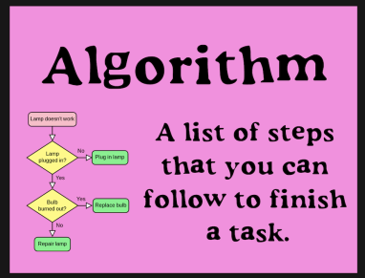 | Programmer-  A person who writes computer codes.  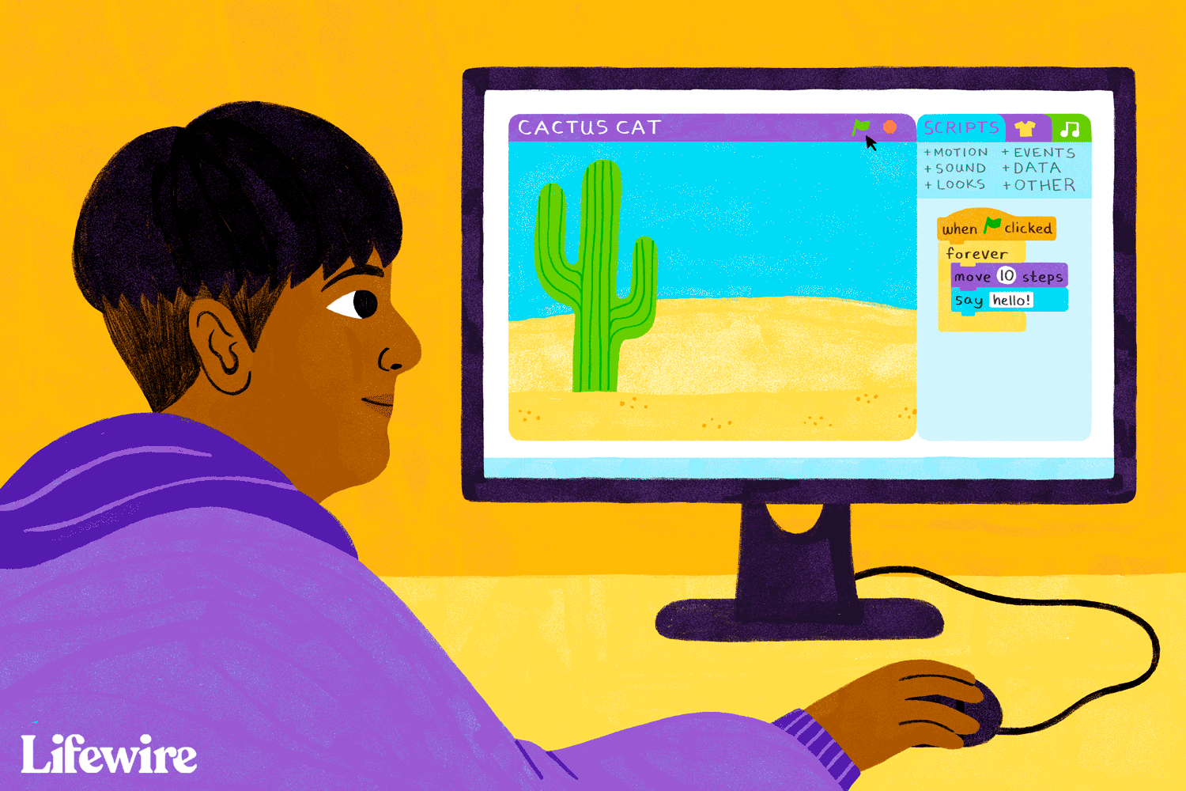 | Debug-  Looking for any problems in the code, fixing and testing them.  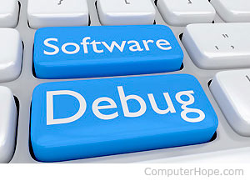
Command-  A single instruction in a computer program.   | Coder-  A person who writes computer codes.  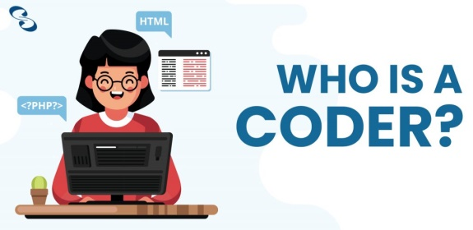 | Texture-  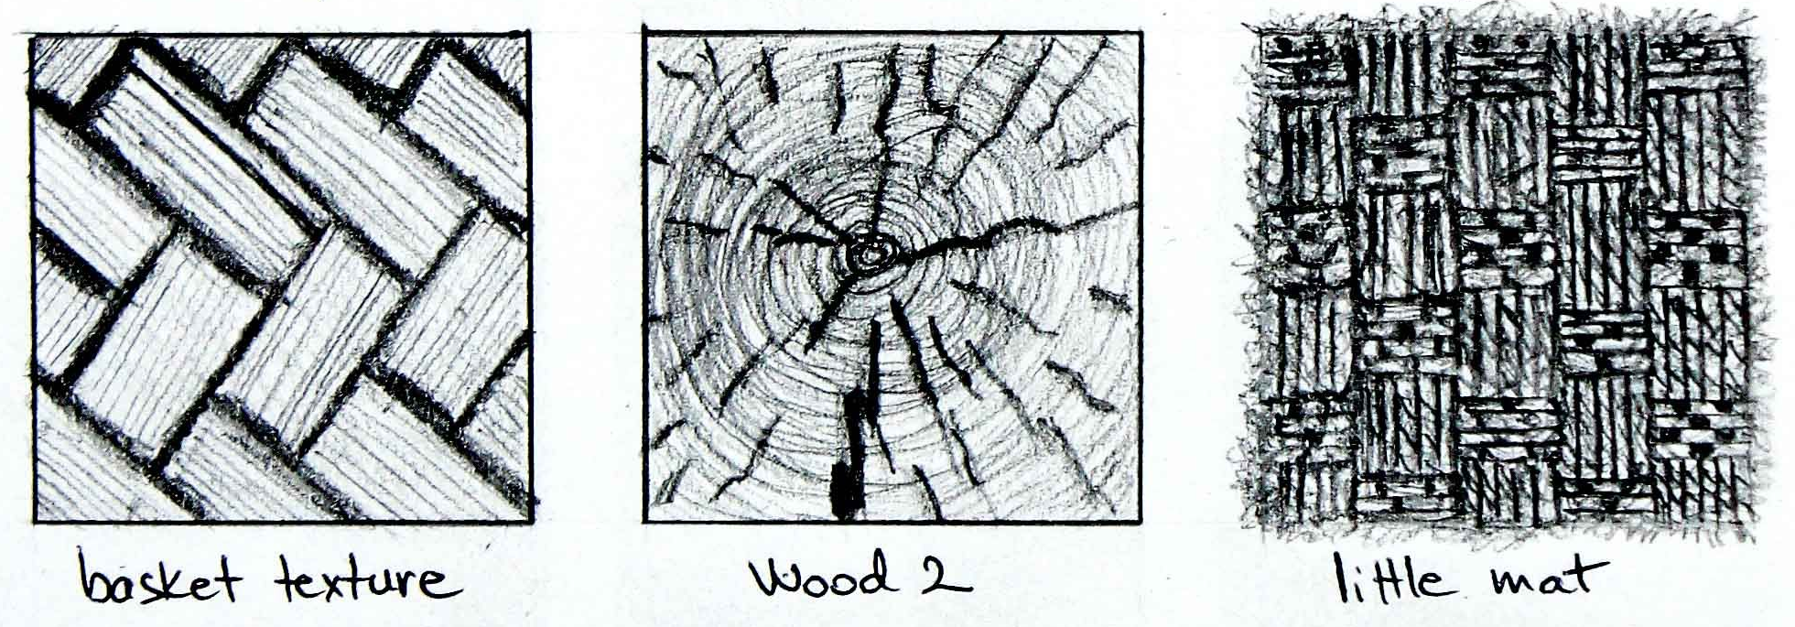
Tone-   | Offspring-  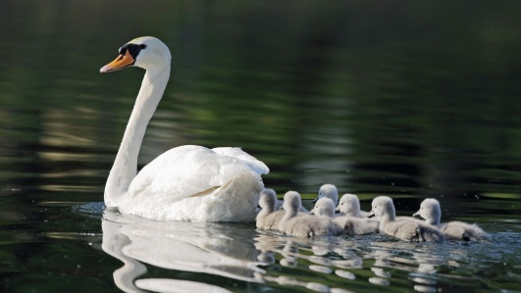 | Metamorphosis-  

