Science  Draw and explain two life cycles; the lifecycle of a frog and also a butterfly. Remember to write a sentence for each stage using scientific words e.g. frogspawn and chrysalis. | RE  Make a colourful poster to show all of the Christian values you can think of such as honesty, hope, faith, trust, happiness, peace and forgiveness. | DT  Board Game Creator: Create a board game based around the ‘Florence Nightingale’/’Mary Seacole’/’War’ theme. It could be a snakes and ladder style game or board game where you have to answer questions about the topic.
Science  Draw and label 5 different animals and their offspring e.g.  - A cow and a calf.  - A sheep and a lamb. | History- Florence Nightingale and Mary Seacole  Make a fact sheet which tells about Mary Seacole and Florence Nightingale and how they are both significant. What did they both do? You could even draw a picture! | History- Florence Nightingale or Mary Seacole  Create a simple timeline for either Florence Nightingale’s life or Mary Seacole’s.
English- Way Home for Wolf  As part of our story based on a friendship, draw a picture of one of your friends and write a few sentences about them. |   Holy Trinity CE Primary School  Homework grid for Year 2, Autumn 1  ~ Colourful Characters  grid for Year 2, Autumn 1.  Choose any one box per week and also complete the additional maths homework stuck into books each week.  Hand your homework book in every Wednesday for marking. | English/History- Florence Nightingale  Imagine you are Florence Nightingale, working in a Scutari hospital. Write a letter to the government, describing the poor conditions and ask for further support to improve the hospital.  Underline (with a ruler) the adjectives you use.
GPS

Write 5 sentences using a different noun phrase in each to describe Wilf, our character from our English lessons.
Remember a noun phrase using an adjective to describe the noun e.g. Wilf had bright blue eyes.


GPS

Write 2 sentences that need an exclamation mark.
That was a great goal!

Write 2 sentences which are questions.
What time is it?

Write 2 sentences that need full stops.
I have a pet rabbit called Carrots.
Maths

Partition the following numbers in 2 different ways.
37, 65, 72, 85 and 99
e.g. 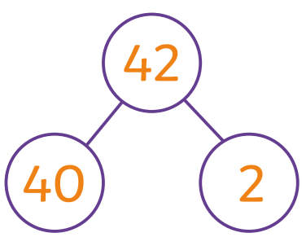 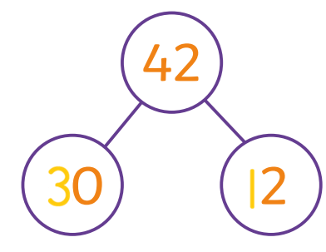

Handwriting

Log onto Letter-join and explore the section called ‘Fun’
English/ History- Florence Nightingale  Pretend you are a solider in the hospital in Scuarti. Write a letter to Florence thanking her for all the positive changes she has been making such as a clean hospital, sleeping in beds and making healthier food. | RE Big Question  Why am I special/unique?  Write your ideas down! | GPS  Write sentences using a different conjunction (joining word) in each sentence.  and, but, so, because, if that, when, or  *Remember to write on the line with letters such as y, g and p under the line.

