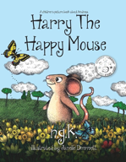  ENGLISH  Talk 1- Harry the Happy Mouse. The children will be exploring the book Harry the Happy Mouse.  End Outcome:  - Innovated poem based on a structure  - Innovated story based on a plot pattern  - An information poster based on an animal |  |   MATHS  The children having lots of practical opportunities to explore number using concrete apparatus before transferring this knowledge  to more abstract questions.  Units covered this half term:  - Numbers to 10.  - Number Bonds  - Addition within 10 |  | 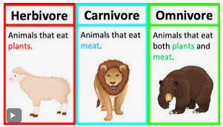  SCIENCE  The children we will be learning about ‘Animals, including humans.’ They will identify and name common animals and their structures. They will also begin to understand the difference between a carnivore, herbivore and omnivore.
  RE  Unit 1.1 Harvest- The children will be exploring the question ‘How and why do people of faith celebrate and give thanks for the harvest?’  Unit 1.2 Creation- The children will be exploring the question ‘What do people of faith believe about God as creator? They will explore what people of Muslim and Hindu faith believe about how the world was created. |  | 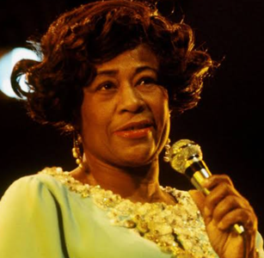  HISTORY  The children will be exploring the life of a significant person, Ella Fitzgerald and looking at her place in History. The children will be learning about racial equality. |  | 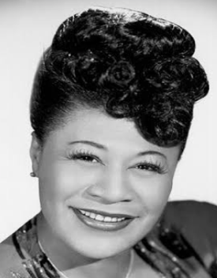  ART  The children will be exploring and experimenting with drawing skills this term. Our explorations will accumulate in a portrait drawing of Ella Fitzgerald.
  PE  FMS-The Great Outdoors OAA  FM- Baseline-Lost and Found |   COMPUTING  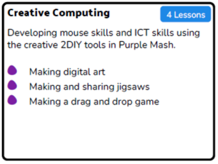  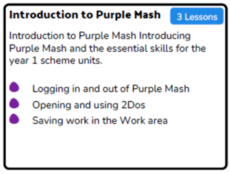 |  |   MUSIC  We will be completing the Charanga Unit- ‘Rhyming in time’- Rehearsing songs to perform. Playing simple instruments. |  |   PHSE  Valuing  Differences  We will talk about the differences between teasing and bullying.

Racial equality   | Jazz   | Portrait  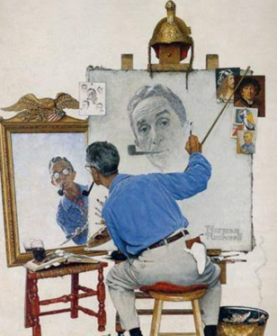
Reptiles  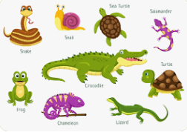 | Amphibians  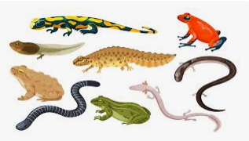 | Birds  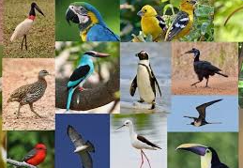
Mammals  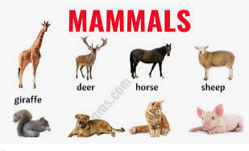 | Fish  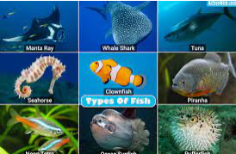 | Crops  

