English  This term the pupils will by learning all about Narnia, from the book, The Lion, The Witch and The Wardrobe, by C.S, Lewis. They will begin by understanding The Blitz and why children were evacuees. They will learn all about Mr Tumnus, who is a faun.  Guided Reading  The children will have class guided reading sessions. They will develop their vocabulary and improve their comprehension skills.  Grammar, Punctuation & Spelling - The focus this half term will be relative and subordinate clauses. They will continue using more interesting openers which will include; fronted adverbials; -ed, -ing and –ly openers. Spellings will continue to be incorporated into their daily lessons. |  | Mathematics  The pupils will begin Autumn Term with the topic Place Value using the scheme – ‘Maths No Problem’. This will broaden their number skills, by identifying and comparing numbers up to 1 million. This will include decimals and they will develop their addition and subtraction skills, by using much larger numbers and will include problem solving.  Times tables tests will be a big focus during mental math’s activities, which will improve their general Math’s ability.  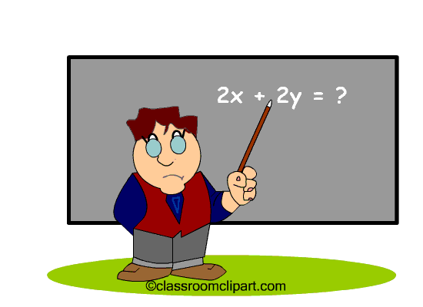

Science –   Children will learn all about States of Matter - Properties of Materials. They will learn, that Materials have different uses depending on their properties and state. (Solid, Liquid, Gas). Properties include, hardness, transparency, electrical and thermal conductivity and attraction to magnets. Some materials will dissolve in a liquid and form a solution, while others are insoluble. |  | Religious Education  ‘LIFE IN ALL ITS FULLNESS’ JOHN 10 V 10  We will be discussing The Bible and asking questions;    How and why is the Bible used? Why is the Bible holy?  Why is the Bible a best seller?  Why are there so many versions of the Bible?  The children will also find out how the bible is compiled and will develop an understanding of bibles from other faiths. |  | PE –  The year will begin with Gymnastics in the Autumn term. They children will also complete problem solving activities.  They will also start weekly swimming lessons each Thursday, at the local Sports Centre.  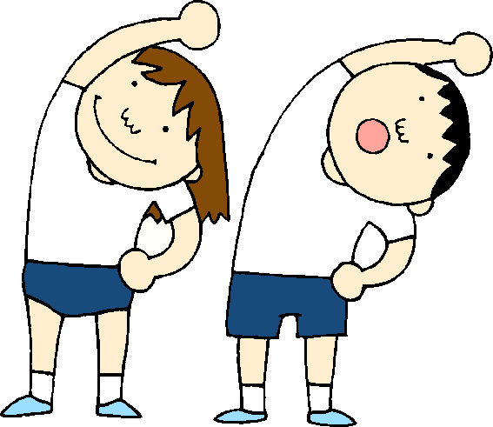
Topic 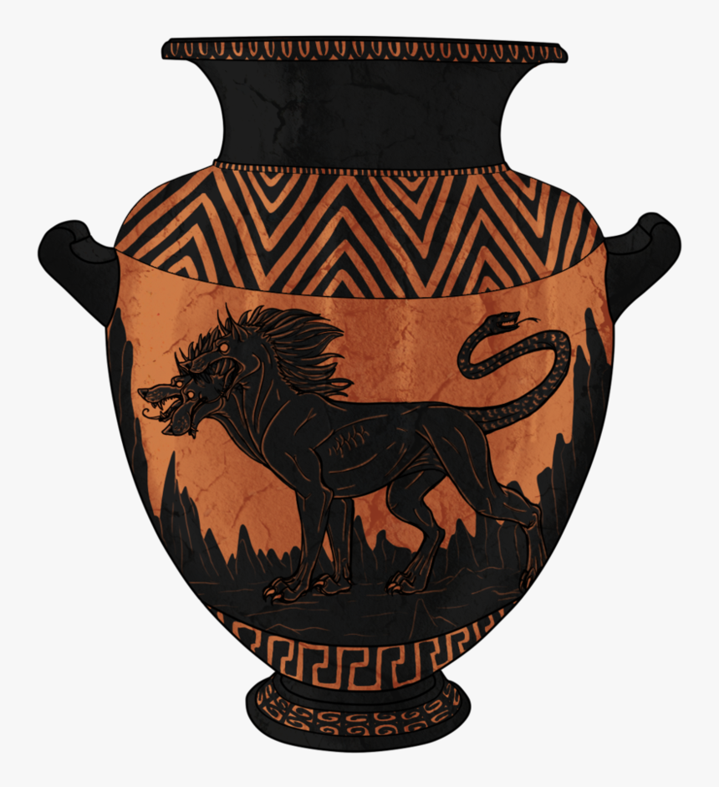In History, the pupils will develop an understanding of Ancient Greece. They will learn about City States and why these were important to Greek life. In Art, the pupils will be working towards sketching the Greek God Zeus. They will develop their shading, blending and hatching techniques, in order to enhance their work. The children will continue to learn about e-safety in computing and their main topic this half term is coding. The children will begin learning new songs for the Let’s Go Sing Concert.

Vocabulary for Autumn 1
Below is some key vocabulary that will help your child to understand what we are going to be learning about this half term. Please read the words with your child and talk about what the words mean.
Colourful Characters – Autumn 1
Aretefact  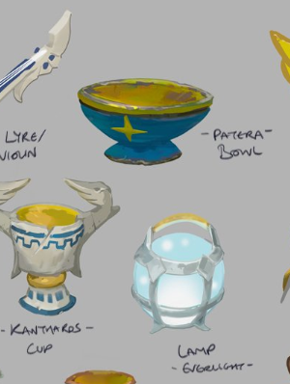 | Cit y states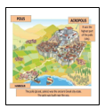 | Sparta  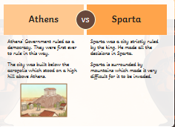 | Athens  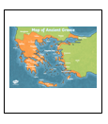
Zeus   | View Finder  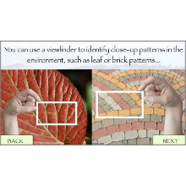 | Democracy   | Blend  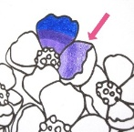
City State  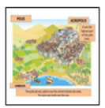 | Texture  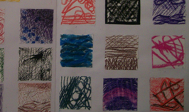 | Cross-hatching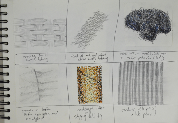 | Warrior  

