

Holy Trinity C of E Primary School
Autumn 1- Year 1- Homework Grid
Daily activities: Reading books
Weekly Activities: Phonics homework (Phonics Play), Daily 10 Maths Challenge and one piece from the grid.
Record your homework grid piece in this book. Feel free to be creative! Use colours, IT or photographs to present your work.

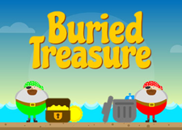  Phonics Play!  Practise reading words real and alien words with Phase 2 and Phase 3 sounds on Phonics Play.  You can play on Buried Treasure and Picnic or Pluto for free!  To be completed at least once a week throughout this half term. https://www.phonicsplay.co.uk/ | 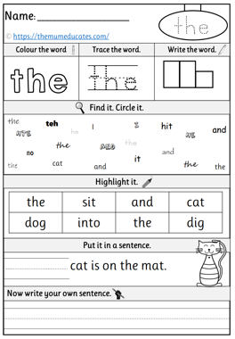  Spelling  The children are learning to read and write red words. Red words are word that cannot be Fred Talked. These words need to be sight read by the children.  Please spend some time with your child completing these weekly worksheets that have been stuck into your child’s homework book. | 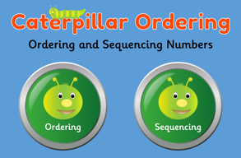  Maths    Scan the QR code to access the activities. The children have been working on numbers up to 20 so start with these activities first. If your child confident with these numbers, then move on to the next activities.  To be completed at least once a week throughout this half term.  https://www.topmarks.co.uk/
English/RE- Words in a words  The children have been learning about Harvest in RE lessons this half term. We have talked about what we are thankful for and thought about how we can help people left fortunate as ourselves.  Have fun with your chid making as many smaller words as you can from the word:  Harvest  e.g. sat, vest. | 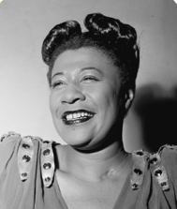  History- Ella Fitzgerald  The children have been learning about Ella Fitzgerald. Ella Fitzgerald was an American singer. She became famous all over the world. Ella was known as the ‘First Lady of Song’.  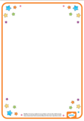  Design a poster to celebrate the life of Ella Fitzgerald. Draw a picture of Ella showing what she was famous for. Add these key words to your poster: American singer, music, jazz, 100 albums. |   Art  The children have been learning about portraits this half term in our Art lessons. The children know that a portrait is only the shoulders and the head of a person and NOT the body.  Draw a self-portrait using pencil only. Remember to use your pencil to shade light and dark. Draw your portrait on the photo frame worksheet that has stuck into your homework book.
PE  The children are learning to use an underarm throw in their PE lessons this half term.  Help your child to practice this skill at home using everyday equipment such as balled up socks and a washing basket.  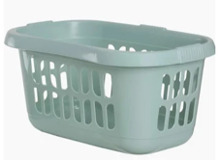   | 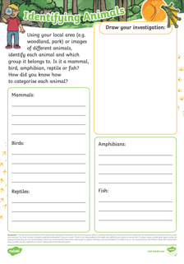  Science  During our science lessons this half term the children have been looking at different animals and sorting them into groups.  Have fun exploring your local area looking for an example of each type of animal. Write you findings on the worksheet that has been stuck into your homework book.  e.g. I saw a cat. I know that it is a mammal because it gives birth to kittens. | PHSE- No.18 Create some wild art  No one will protect what they don’t care about, and no one will care about what they have never experienced.'  - Sir David Attenborough  Use leaves, sticks, mud or anything you find to create a work of art. How many different textures and colours can you use?  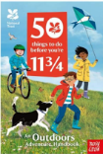  https://www.nationaltrust.org.uk/visit/50-things/no.-18-create-some-wild-art

