Holy Trinity Church of England Primary School

Policy on Sexualised Behaviour in School
Written by: | Ksenia Driver | Date: 07/07/2026
Next review due by: | 09/07/2027

Purpose
This policy sets out how Holy Trinity Church of England Primary School responds to sexualised behaviour within our primary school setting. We recognise that children may display a wide range of sexual behaviours, from those that are developmentally appropriate to those which may be concerning, problematic, or harmful. Our approach is informed directly by the AIM Project’s guidance: Understanding and Managing Sexual Behaviour in Educational Settings (Carson & Aujla, 2021; AIM Practice Notes, 2024).

Principles
- All children have the right to be safe, supported, and educated in an environment free from sexual harm.
- We are committed to a child-centred, whole-school approach to prevention, identification, and response.
- Every case will be dealt with individually, using proportionate and evidence-based responses in line with AIM Project guidance.
- We follow statutory safeguarding duties as outlined in Keeping Children Safe in Education (DfE, 2023).

Prevention
We provide age-appropriate teaching through Personal, Social and Health Education (PSHE) and Relationship and Sex Education (RSE) lessons on consent, healthy relationships, and online safety. Staff create a safe and respectful culture where harmful behaviours are challenged, never dismissed or normalised. We consider the physical environment of the school to reduce risk of harmful behaviour (e.g. safe spaces, supervision, awareness of hotspots).

Identification and Response
All staff have a professional responsibility to challenge inappropriate sexualised behaviour and report concerns to the Designated Safeguarding Lead (DSL) or Deputy DSLs.
Staff receive training to recognise the difference between developmentally expected behaviour and those that require concern or intervention.
The DSL will use AIM Checklists and associated resources to support proportionate, measured, and defensible decision-making.

5. Assessment and Intervention
The DSL (or DDSL) will lead on assessment using AIM resources, in consultation with senior leaders and external agencies where required.
Where intervention is needed, this will be guided by AIM’s recommended approaches, including age-appropriate group or 1:1 work, pastoral support, and liaison with parents/carers.

6. Risk Management
Where behaviour presents a potential risk to self or others, a Risk Assessment and Management Plan (RAMP) will be developed in line with AIM guidance. Plans will balance safeguarding duties with the child’s right to education, ensuring that measures are proportionate and supportive. Risk management will include strategies to protect all children, as well as to support the child displaying sexualised behaviours to learn, repair, and move forward.

7. Record Keeping
All incidents, decisions, and interventions will be recorded securely in line with safeguarding procedures. Records will clearly show how AIM guidance has informed the school’s response.

8. Partnership Working
The school will work closely with parents/carers, children’s social care, health professionals, and other relevant agencies when responding to concerning sexualised behaviour. We will ensure that all actions are taken in the best interests of the child and with due regard to confidentiality and safeguarding protocols.

9. Training
Relevant staff will access specialist AIM training on harmful sexual behaviour. Whole-staff training will ensure all staff are confident in recognising and responding to sexualised behaviour.

10. Monitoring and Review
This policy will be reviewed annually, or sooner if new guidance emerges from the DfE, Ofsted, or the AIM Project. Implementation will be monitored through safeguarding audits and reported to governors.

Responding to Sexualised Behaviour – Staff Procedure
Step 1: Initial Identification
- Observe the behaviour.
- Refer to the Hackett Continuum (below).
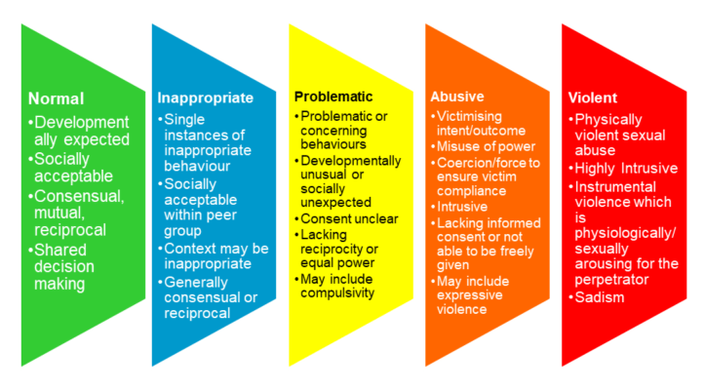
If behaviour is…
- Normal (age-appropriate):
  - Speak with the child.
  - Inform parents/carers. No formal action needed beyond record of conversation.
- Inappropriate:
  - Record and report to DSL or DDSL.
  - Put in place a short-term 1:1 intervention plan using guidance from the AIM Education textbook.
  - Inform parents/carers.
- Problematic / recurrent inappropriate / abusive / violent:
  - Immediately inform the DSL.
  - DSL to complete the AIM Checklist.

Step 2: DSL Action – AIM Checklist
- DSL completes the checklist.
- If behaviour is problematic and incidents are recurrent:
  - Begin a Pattern Mapping Incident Recording Form.
  - Develop a Risk Management Plan (RAMP).
  - Put in place a short-term 1:1 intervention plan guided by AIM resources.
- If behaviour is abusive/violent:
  - DSL to refer to Children’s Social Care and/or Police in line with safeguarding procedures.
  - Record all actions taken.
Key Reminders for Staff:
- Never dismiss sexualised behaviour as “just curiosity” – always respond.
- Record and report all incidents to the DSL or DDSL.
- Follow safeguarding procedures at all times.
- Responses must be proportionate, child-centred, and consistent with AIM guidance.



