English    In English lessons we will be reading the book called ‘A Bear Called Paddington” by Michael Bond.  We will be looking at character descriptions using a range of adjectives and writing letters back to Aunt Lucy. We will then use our extended writing skills to create a narrative based on Paddington and his mishaps.  Using the knowledge about London gained from Paddington’s adventures, we will also create a tour guide for some of the main attractions.  Handwriting will focus on making sure all letters are being formed correctly and securing knowledge of capital letters.  Spelling will be taught using Red Rose Spelling.  Guided Reading will focus on the novel The Hodgeheg by Dick King-Smith. To develop our reading and understanding skills. |  | Mathematics- MNP (Maths No Problem)  Through the first half term we will be looking at:  - Number and place value, reading, writing and ordering numbers to 1000  - Mental calculations, strategies for addition and subtraction.  - Written addition and subtraction, formal written methods.  In addition, there will be a continued focus on the development of multiplication tables through consistent practice.
  Science  We will study different sources of light, how shadows are formed and their properties. We will study how light is reflected from surfaces, how light from the sun can be dangerous, when shadows are formed, and even learn the patters and sizes of shadow change. |  | Religious Education  Unit 3:6  Why do many people celebrate and give thanks at Harvest time?  Reflecting upon their own experiences of Harvest Festivals. Learning about harvest celebrations around the world. Exploring the Harvest Festivals of Pongal and Sukkot.  Unit 3:1  What is the role of a faith leader who has been called by God?  Exploring the stories of Old Testament Prophets. Interviewing Faith Leaders to explore their daily life. |  | PE with Mr. Little is every Monday and Mrs. Knight every Wednesday  In PE with Mr Little, we will be focussing on Rugby and developing skills in throwing and passing, attacking and defending strategies.  Our other unit will focus on completing a range of challenges to develop our skills working as teams and problem solving.
PHSE Valuing Differences.
We use the SCARF PHSE materials to explore how we are all different and why this is important.
Computing – Coding
Children will explore timers, the repeat command and the importance of nesting code. They will build up to using design documentation to code a program.

History- Ancient Civilisations.
We will look at timelines of Ancient Civilisations before focussing on Ancient Egypt and the discoveries from Tutankhamun’s tomb.
Music- Charanga and Let’s Go Sing.
We will start learning the songs ready for our performance in March as part of the Let’s Go Sing concerts.

Art- Drawing Skills
Looking at tone and shading to draw a portrait of Tutankhamun.
Using pencils to create different effects.
Spanish
Unit 1 Spanish Greetings.
Learning how to greet people in Spanish.

Vocabulary for Autumn 1

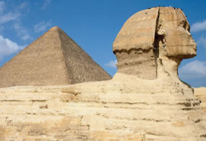  Ancient  Something that is very, very old and existed thousands of years ago. | Civilisation  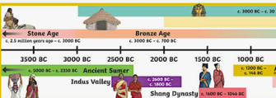  A large group of people who share certain advanced ways of living and working. | 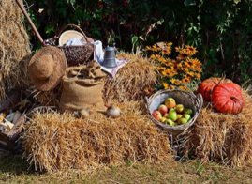  Harvest  A time to celebrate the gathering of food from farms.
  Shadow  A dark shape that appears on the ground, wall or floor when a solid object blocks a light source. | 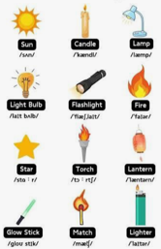  Light Source  Anything that makes its own light, letting us see things in the dark. | Program-  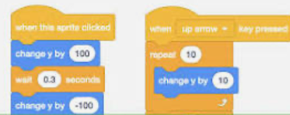  A detailed, step-by-step set of instructions that tells a computer exactly how to perform a specific task.
  Tone-  How light or dark a colour is. | Texture-  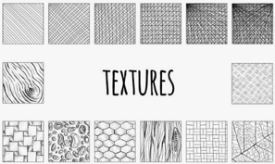  The way a surface looks like it would feel. | 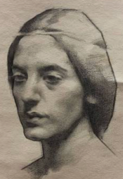  Portrait-  A drawing usually focussing on a person’s face.

