Holy Trinity is striving to be a fully inclusive School that serves our local community. Through the love of Jesus Christ, we are preparing our children to be future caring, responsible citizens in a diverse society. Our children will be given every opportunity to grow spiritually, academically and socially to achieve their full potential within a safe, happy, Christian school family.

'Life in all it’s fullness' - John 10 V 10

 | Autumn 1  Colourful Characters | Autumn 2  Changes and Challenges | Spring 1  Brilliant Burnley | Spring 2  Exciting Exploration | Summer 1  Gallant Growth | Summer 2  God’s Wonderful World
Christian Value | Courage | Perseverance | Respect | Joy | Forgiveness | Compassion
English | The Lion, The Witch and the Wardrobe  Non-Chronological Reports  Classic Narrative | The Legend of Gelert  Legends | Earthlings  Science Fiction  Narrative  Poems with a Structure | The Chocolate Touch  Persuasion  Adverts | Macbeth  Playscript | The Jabberwocky  Narrative based on a classic poem.
Maths | Numbers to 1000000  Whole Numbers: Addition and Subtraction  Whole Numbers: Multiplication and Division  Graphs  Fractions |  |  | Decimals  Percentages  Geometry  Position and Movement  Measurements  Area and Perimeter  Volume  Roman Numerals
Science | Properties of Materials  What properties make a material suitable for a specific job (e.g., waterproof coat)? | States of Matter: Reversible/Irreversible  How can we separate and combine materials based on their properties? | Forces  How do gravity and air resistance affect falling objects? | Earth and Space  How does the tilt of the Earth affect the seasons we experience? | Living Things – Life Cycles of Animals  How do humans change as they develop and grow? | Environment: Life Cycles of Plants  How do plants make their own food?
R.E. | Holy Books  5.1 Why are there several Holy Books and not just one? | Christmas  5.2 How does the birth of Jesus fit into God’s Big Story? | Jesus  5.3 Why do Christians believe Jesus was a great teacher? | Easter  5.4 Why do Christians believe that Easter is a celebration of victory? | Women of Faith  5.5 Did she make the right choice? Why? | 5.6 Is death an ending or a beginning?
History | Ancient Greece  How did leadership differ between city states in Ancient Greece? |  | Pendle Witches  Who were the Pendle Witches and was their trial just? |  |  | Crime and Punishment in Lancashire  How and why have punishments in Lancashire changed over time?
Geography |  | South America and the Amazon Basin  (Recap Sao Paulo the mega-city)  Qu: What are the cause and effect of deforestation? |  | Land-use patterns of UK and the World (including settlement)  Fieldwork – Pendle Hill  Qu: Why does population change? | North America- minerals there and worldwide  including Time Zones  Qu: How is the distribution of minerals in the UK different to North America?
Art | Drawing and Exploring Ideas |  |  | Textiles:  Gunta Stozl |  | Printing:  God’s Big Picture
Design and Technology |  | Textiles: Stuffed Toys | Make: Pop Up Books |  | Cook: What Could be Healthier?
Computing | 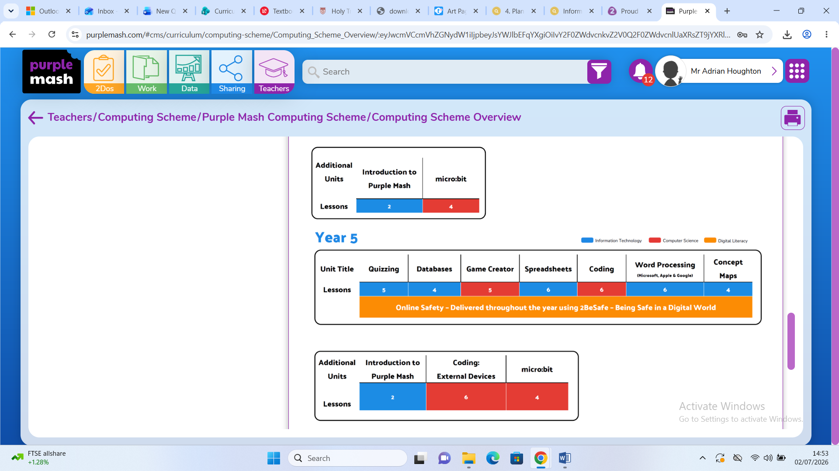
PSHE | Valuing Difference | Rights and Respect | Being My Best | Growing and Changing | Me and My Relationships | Keeping Safe
Music | Let’s Go Sing | Let’s Go Sing | Let’s Go Sing | Let’s Go Sing | Let’s Go Sing | Chranga
P.E. | OAA – Teambuilding  Invasion Games - Rugby | Gymnastics Activities 1  Dance - Earthlings | Invasion Games – Netball  Gymnastics Activities 2 | Badminton  Net and Wall - Tennis | Creative Games  Athletics | Striking and Fielding - Rounders
MFL  Spanish | Unit 1  Describing Family and Friends | Unit 2  Spanish Portraits | Unit 3  Sports | Unit 4  Food and Drink | Unit 5  A Trip Across Spain | Unit 6  Saving South America

