Holy Trinity is striving to be a fully inclusive School that serves our local community. Through the love of Jesus Christ, we are preparing our children to be future caring, responsible citizens in a diverse society. Our children will be given every opportunity to grow spiritually, academically and socially to achieve their full potential within a safe, happy, Christian school family.

'Life in all it’s fullness' - John 10 V 10

 | Autumn 1  Colourful Characters | Autumn 2  Changes and Challenges | Spring 1  Brilliant Burnley | Spring 2  Exciting Exploration | Summer 1  Gallant Growth | Summer 2  God’s Wonderful World
Christian Value | Courage | Perseverance | Respect | Joy | Forgiveness | Compassion
English | The Nowhere Emporium  Story as a theme  Information Hybrid (Magazine Page) | Biography: Who Was Walt Disney  Biography  Song/Poetry | Classic Fiction: The Wizard of Oz  Classic Narrative | Play: Romeo and Juliet  Older Literature  Play as a Theme | Last Push Pack: The Lion and Albert  Poetry  Short Stories with Flashback | Key Stage Production  Playscript
Maths | Numbers to 10 Million  Four Operations on Whole Numbers  Fractions  Decimals  Measurements  Word Problems |  |  | Percentages  Ratio  Alegebra  Area and Perimeter  Volume  Geometry  Position and Movement  Graphs and Averages  Negative Numbers
Science | Electricity  How can we change the brightness of volume in an electrical circuit? | Evolution and Inheritance  How does the way our bodies work to help us stay healthy? | Animals – Circulatory  How does the heart work and why is it important? | Light  How do shadows change size and shape during the day? | Living Things Habitats – Classification  How do plants adapt and evolve to survive in changing in environments? | Classification  Why do scientists use classification systems to organise living things?
R.E. | Why is life sometimes described as a journey? | How do Christians prepare for Christmas? | What are the connections between the Last Supper and the celebrations of Jewish Passover and Christian Eucharist? | Who was Jesus? Who is Jesus? | How do the events of Ascension and Pentecost contribute to distinctive Christian beliefs? | What is the nature and characteristics of God?
History | Vikings and Anglo Saxons  Is it fair to call all Vikings ‘brutal invaders’ / Is it fair to describe all Vikings as brutal invaders? |  | The Transatlantic Slave  Why (and how) did people fight to abolish the Transatlantic Slave Trade? |  |  | Islamic Civilisations  What did Baghdad ever do for us?
Geography |  | How does the UK trade industry link to the rest of the world?  What do we import and export and why?  What is a sustainable trade? |  | UK Locational Unit  Why do people visit Burnley town centre? /  Why don’t people want to visit Burnley? | Distribution to energy both in the UK and Worldwide including Climate Change  Qu: What evidence have we got that the climate is changing?
Art | Drawing and Exploring Ideas |  |  | Painting: LS Lowry |  | Printing:  God’s Big Picture
Design and Technology |  | Textiles: Waistcoats | Make: Mechanical and Electrical Systems – Steady Hand Game |  | Cook: Come Dine with Me
Computing | 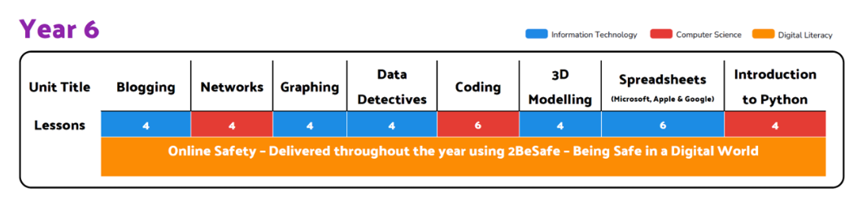
PSHE | Valuing Difference | Rights and Respect | Being My Best | Growing and Changing | Me and My Relationships | Keeping Safe
Music | Chranga  Happy | Chranga  Classroom Jazz | Chranga  A New Year Carol | Chranga  You’ve Got a Friend | Chranga  Music and Me | Chranga  Reflect, Rewind and Replay
P.E. | OAA – Teambuilding  Creative Games | Athletics  Dance - Earthlings | Invasion Games – Netball  Gymnastics Activites | Net and Wall Games – Tennis  Dance – Heroes and Villains | Creative Games  Atheletics | Striking and Fielding – Rounders  Invasion Games - Rugby
MFL  Spanish | Unit 1  Clothes | Unit 2  School Life | Unit 3  Household Tasks | Unit 4  Shopping | Unit 5  Free Time in Spain | Unit 6  Maya City Treasure

