Holy Trinity is striving to be a fully inclusive School that serves our local community. Through the love of Jesus Christ, we are preparing our children to be future caring, responsible citizens in a diverse society. Our children will be given every opportunity to grow spiritually, academically and socially to achieve their full potential within a safe, happy, Christian school family.

'Life in all it’s fullness' - John 10 V 10

OLD VERSION | Autumn 1  Colourful Characters | Autumn 2  Changes and Challenges | Spring 1  Brilliant Burnley | Spring 2  Exciting Exploration | Summer 1  Gallant Growth | Summer 2  God’s Wonderful World
Christian Value | Courage | Perseverance | Respect | Joy | Forgiveness | Compassion
English | A Bear Called Paddington  Story as a theme, Information text: Leaflet/Guide, Letters | The Night Gardener/The Greenling  Folk Tales, Instructions, Recount: Letters | The Iron Man  Persuasive Writing, Diary | Stone Age  Non-Fiction, Information texts, Booklets | Narrative: Stone Age – The Golden Eagle (short story)  Story as a theme | The Spider and The Fly  Integrated unit including reports, menus, persuasive letters, story openings and narrative based on a classic poem
Maths | Maths No Problem 3A  Numbers to 1000, Addition and Subtraction, Multiplication and Division, Length, Mass, Volume. |  |  | Maths No Problem 3B  Money, Time, Pictograms and Bar Graphs, Fractions, Angles, Lines and Shapes, Perimeter of Figures.
Science | Light and Shadows  How is a shadow formed? | Rocks and Soils  What are the three main types of rock? | Animals – Skeleton and Movement  Why do animals need a skeleton and muscles? | Forces and Magnets  How is a magnetic force different to other forces? | Functions of a Plant  How do the different parts of a flowering plant help it to grow, survive and reproduce? | Health and Nutrition  How do animals including humans get the nutrients that they need?
R.E. | Harvest  Why do many people celebrate and give thanks at Harvest time?  Called by God  Why is the role of a faith leader who has been called by God? | Christmas  Why do Christians believe that Jesus was Emmanuel, God with us? | Jesus, the Man Who Changed Lives  How did/does Jesus change lives? | Easter  Is the cross a symbol of sadness or joy? | Which Rules Should We Follow?  Is the ‘golden rule’ agreed by everyone?
History | Ancient Civilisations: Egypt  What does Tutankhamun’s tomb reveal about ancient Egyptian royal burials? |  | Scott Park  How has Scott Park improved the lives of people in Burnley? |  |  | Stone Age  What do ancient sources reveal about life in the Stone Age?
Geography |  | Volcanoes, Earthquakes and Tsunamis |  | Fieldwork: Scott Park | Place Study  North West – Lake District
Art | Drawing and Exploring Ideas |  |  | Printing: Andy Warhol |  | 3D: God’s Big Picture (Gospel)
Design and Technology  Kapow |  | Textiles: Cushions | Make: Structures - Castles |  | Cook: Eating Seasonally
Computing  Purple Mash | 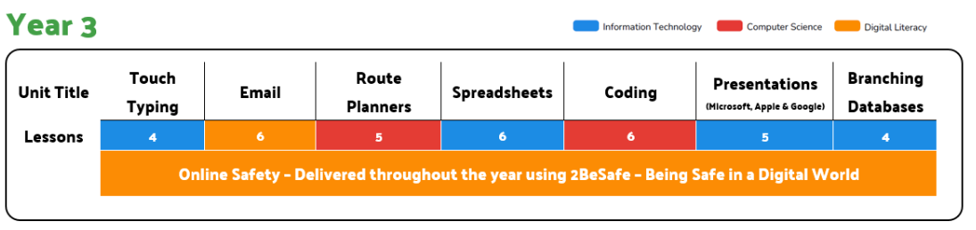
PSHE  SCARF | Valuing Difference | Rights and Respect | Being My Best | Growing and Changing | Me and My Relationships | Keeping Safe
Music  Kapow | Let’s Go Sing | Let’s Go Sing | Let’s Go Sing | Let’s Go Sing | Charanga Creative Curriculum | KS2 Concert
P.E. | OAA – Teamwork and Problem Solving  Invasion Games - Rugby | Gymnastics  Invasion Games - Handball | Creative Games – Tag and Target  Dance - Superheroes | Target Games – Dodgeball  Games – Net and Wall | Striking and Fielding – Cricket  OAA – Trust and Trails | Striking and Fielding – Rounders  Athletics
MFL  Spanish  Kapow | Spanish Greetings | Numbers and Ages | Shapes and Colours | Classroom Objects | Where do you live in Spain? | Journey around Latin America

